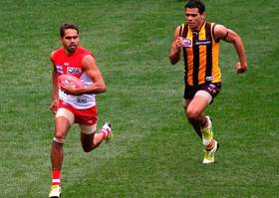

Coaching Wingers
Friday, April 04, 2014
By Aaron Davey
Modern wingers are an integral part of the midfield. There are two wing roles in the team on game day. Wingers have a very important role to play within the team, with the fact that games are won and lost from stoppages/midfield. There is not one specific type of person or player required to play the wing. Ideally, it is a quick, medium sized player, who is a good ball user and breaks the lines.
A winger will have numerous roles to play on game day, so knowledge and understanding of performing and playing the role is crucial. Players must be educated both from a theoretical and practical point of view. The role of the wingers and expectations from players who would go through the wing should be explained to the whole team through PowerPoint presentations, handouts and diagrams of the roles and also questions to the players in meetings. From a practical point of view, it is developed on the training track by game simulations and scenarios.
Four examples of the winger's roles are outlined in the following diagrams. A centre bounce setup, around the ground stoppage setup, the wing as a spare in defense and the wing as an attacking option; third man up.

1 – Centre Bounce
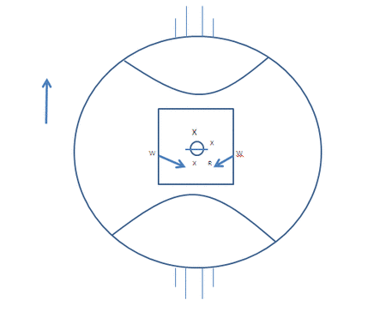
The starting positions of the wingers in this structure are shown as "W". Both wingers will have a defensive mindset and will run a defensive pattern as shown in the diagram.
- They cover defensively if the centre bounce is won by the opposition.
- If the stoppage is won they can assist the inside midfielders as a handball receive option.

2 – Between the Arc Stoppages
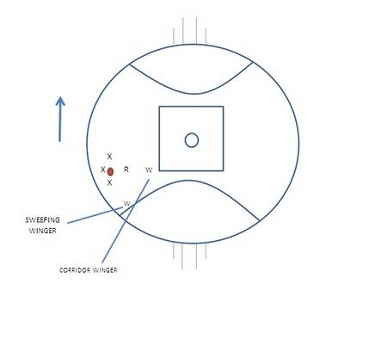
The terminology “between the arc” means the middle of the ground between the 50m arcs. The diagram shows a boundary throw in with the starting position of both wingers. Both have names and the terminology used can be whatever the coach chooses. My terminology here is sweeping (ball side) wing and corridor (non-ball side) wing. On this occasion, the winger who started the game on left side of the centre bounce is the sweeper (ball-side) wing and the right side wing is corridor (non-ball side) wing.
The sweeping wing (ball side) is a defensive protection sweeper but can also be used as an attacking option and the corridor cover wing (non-ball side) is corridor protection. If the opposition win the ball, the corridor wing is there to defend, and can also cover if the ball spills over the back.

3 – Centre Bounce Spare Man Behind the Ball
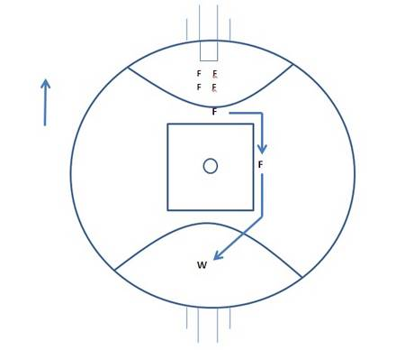
This is a scenario/option in which the winger can be used tactically.
This option includes:
- Using the winger (preferably tallest/good marking) to push around the 7th defender and a forward to push around to the wing and replace the winger as shown to stop an opposition run on (2-3 goals in a row).
- This tactic could also be used to win a game (protect a lead), take the pace/momentum out of the game. These situations and when to go into this mode or when to end it would be decided by the coaching group in the box.

4 – Around the Ground Stoppage
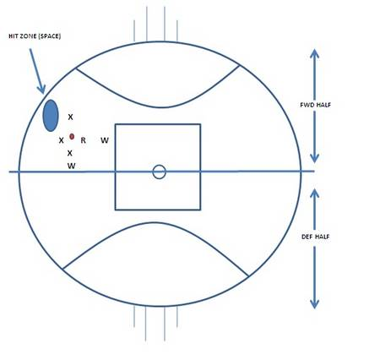
In this scenario, the team is a goal down and wants to win the game so a call is made "3rd man up". In this diagram the corridor winger's starting position shows where the 3rd man up will come from. The corridor wing is positioned behind the ruck, and will time the run up to compete with both rucks. The aim is to hit the ball forward into the hit zone (space) for a midfielder running onto it. It is very important that the third man up communicates with the midfielders, and also impacts the contest by making contact with the other rucks and the ball.

Important Factors in Coaching Wingers:
Key points to get across to the players:
- Play the specific role, play it well
- Knowledge – clear understanding of the specific role
- Communication
- Always ask questions if not sure
Specific Training for Positioning:
- Diagrams – explain roles
- Work on roles/Structure
- Game Simulation/Match Play
Specific Pre-Match Prep:
- Statistics
- Vision on the opposition/individual players
Key hints to becoming a better player in the position:
- Watch vision with your coaches on your own game to find areas of improvement
- Watch vision of training
- Training the position on the oval/game simulation/game.

