TOOLEYBUC MANANGATANG FOOTBALL NETBALL CLUB

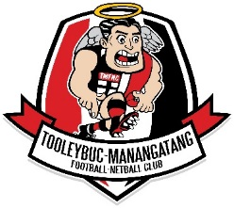

Sun Protection Policy

Tooleybuc Manangatang Football Netball Club (TMFNC) will provide an environment which provides education and tools to assist players, supporters and volunteers to minimize the risks associated with exposure to solar UVR.
Aims
This policy aims to provide ongoing education and support to reduce exposure to solar UVR by implementing appropriate sun protection control measures.
Our Commitment
• TMFNC will attempt reduce exposure to solar UVR by supplying sun protection measures.
• Where practical TMFNC will inform players and supporters when it is necessary to use sun protection control measures while outdoors.
• TMFNC will ensure injury reporting procedures are followed when an incident or sunburn or excessive exposure to solar UVR occurs at the ground.
The Committee will:
• Provide shaded areas or temporary shade where possible
• Provide indoor areas and shaded outdoor areas
• Encourage volunteers to rotate between indoor/shaded and outdoor tasks where UV exposure is extreme • Provide and ensure use of appropriate sun protective PPE in line with SunSmart guidelines including sun protective hats and sunscreen.
Members, Players, volunteers will:
• Co-operate with all measures introduced by the Club to minimize the risks associated with exposure to solar UVR
• Comply with instructions and advice in regards to use of sun protection control measures.
• Participate in sun protection education programs
• Act as positive role models
• Be responsible for their own sun protective practices at football.
Policy Review
To ensure this policy continues to be relevant for club operation and that it reflects community expectations, the policy will be reviewed annually.

Reviewed December 2018
To be reviewed December 2019

