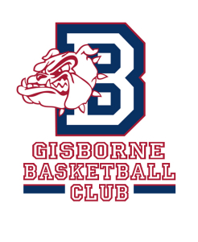
Player Uniform Order Form – Summer Season 16/17

Player’s Name:
Team (Winter 2016):
Parent’s Name: Mobile:

Please return order by Friday, 5th of August to bartandgaye@hotmail.com

 | Item | Size | Singlet number  (Only if they wish to keep the same number) | Quantity | Price | Total
1 | Singlet  Size 8-14, S-3XL |  |  |  | $35.00
2 | Shorts  Size 10-14, S-3XL |  |  |  | $35.00
3 | Polo Shirt  Size 8-16, S-3XL |  |  |  | $35.00
4 | Zip Hoodie  Size 8-14, S-3XL |  |  |  | $45.00
5 | Pullover Hoodie  Size 8-14, S-3XL |  |  |  | $45.00
6 | Back Pack  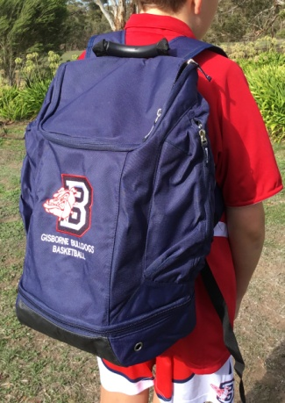 |  |  |  | $50.00
 |  |  |  |  | Total | $

Pick Up : 'Bulldogs Uniform Shop' on Monday, 3rd of October at The Stadium (GSC).
Payment : Upon pick up - EFTPOS or Cash
Please note - If there is a clash of singlet numbers within your team next season,
players will need to change numbers.

If you have any questions, please let me know, ph. 0417 314 988
Thank you, Gaye Barnes.

-------------------------------------------------------------------------------------------------------------------Bulldogs Records: Date Order received -
Player's name - Team - Total $ - Payment Method - EFTPOS or CASH Pick up Date -

