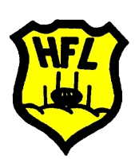
MODIFIED RULES
FOOTBALL COMPETITION

2019 TEAM NOMINATION FORM

Team nominations MUST be made via this form.
Final nominations to be received no later than SUNDAY 24TH MARCH.
Email Team Nomination Form to: hflinc@bigpond.com

Please direct enquiries to Belinda Marsh, HFL Modified Football Coordinator
Belinda.marsh@internode.on.net or phone 0438 408 305

New nomination Change to nomination

CLUB NAME:

CLUB MODIFIED COORDINATOR/CONTACT NAME:

PHONE:

EMAIL:

* Please be advised the above information will be included in a directory circulated to all clubs

TEAM NOMINATIONS
Age group | Number of teams | Team name/colour (if more than one team per age group)
Under 8
Under 9
Under 10
Under 11

FIXTURE PREFERENCES
Please advise of any preferences. These will be considered but are not guaranteed.

