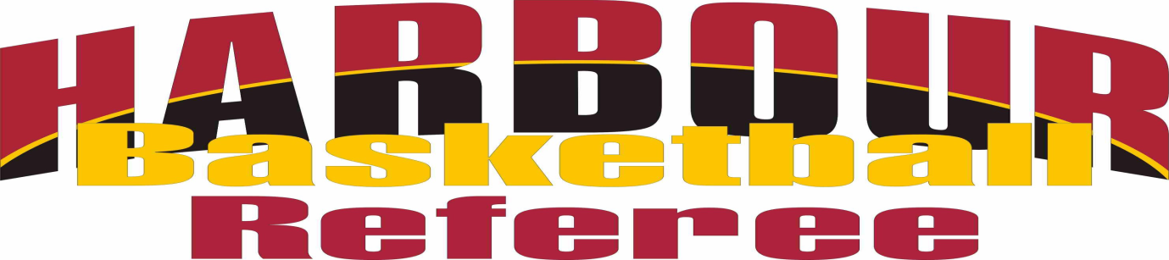
LEVEL 1 REFEREE COURSE
Why not learn how to be a referee where you can
earn $$$, make new friends and its only $10!!
Dates; 15th ,22nd,29th Oct
Time; 6pm-7.30pm
Venue; NSEC, Silverfield Lane, Glenfield
Participants must attend all 3 sessions and it includes both theory and practical sessions.

Register now; 4433854 or admin@harbourbasketball.co.nz

