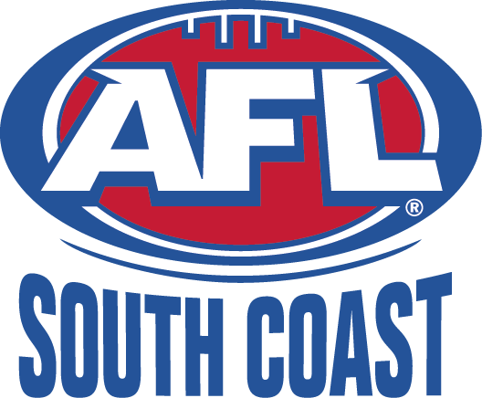
ILLAWARRA JUNIORS

AFL South Coast Incorporated
ABN: 83 986 595 815
Minutes of the Illawarra Juniors Administration Committee Delegates Meeting
held at the Dapto Leagues Club on Thursday 17 July 2014 at 7pm

MINUTES

- Present Committee: Mike Christie, Peter Gamble, Dave Johnson,
Present Delegates: Glen Bachelor (Swans), Simon Williams, Wayne Barrett (Lions).
Guests: None
Apologies: Jessie Mulholland, Bill Reid, Hawks, Roos, Tigers, Port/Dapto,

- Correspondence: none tabled

- Chairman’s Report:
- Shellharbour Swans U/16 asst coach has been suspended until 31/12/15 for pushing an umpire. Glen confirmed this is being appealed.
- Mid season review is on at Dapto Leagues at 6.30pm Wed 23/7. 2015 U/18 comp will be discussed. Clubs urged to attend.

- Competition Manager Report:
- No report

- Youth Girls Manager:
- Illawarra girls competed as South Coast United at girls carnival in Nowra on 28/6. Team drawn from Illawarra to Eden and Cowra.

- Representative Manager Report:
- U/12’s, 14’s and 16’s played at South Coast Carnival 27-29 June. U/12’s didn’t make finals. U/14’s won and U/16’s were runners up.
- U14’s playing 8/7 at Cherrybrook. Won 1 and lost 3.
- U/12’s came 3rd at Hunter Invitational against very strong opposition.
- All rep teams are now wearing red and white rep uniforms.

- Umpires Coordinators Report:
- No report

- Football Operations Manager:
  - Affiliation fees are now due.
  - Merit award nominations for volunteers with 10+ years service are due 31/7.
  - Achievement award recipients for all clubs are due 31/7.
  - Mid season review 23/7. All clubs to attend.

- AFL Development Manager Report:
  - Now in busiest term for school development. DJ will distribute list of where development staff will be.
  - NEAFL day was a big success but very challenging.
  - A/K volunteer of the year to be announced this week.
  - A/K coordinators function at SCG on Saturday night.
  - Half time A/K for Illawarra juniors is Swans v St Kilda game.
  - St Therese Primary School girls have made Paul Kelly Cup finals at SCG in August.
  - AFL 9’s save the date to be sent.

- Lions Liaison Report: No Report

- Club Issues
  - Affiliation fee invoices. Allan asked invoices can show more detail on how affiliation fee is calculated. All delegates supported this request. It was confirmed invoice is generated locally by Virginia/Jesse. Mike will forward request for more detail. Suggestion that Mike also contact Adam Gulliver of South Coast Juniors to find out what is on their invoices.
  - Glen advised Swans will be appealing Nick Bretherton decision. Jessie advised this will require payment of $300 of which $150 is non-refundable. Glen advised bylaws state $250 pmt all of which is refundable. Jessie to confirm correct amt.
  - Glen Batchelor asked how Jessie was appointed to Football Op’s role. DJ advised it is a temporary appointment due to Gin’s extended sick leave to cover essential admin tasks.
  - Dave advised there have been 21 CoC incidents since Jessie has been in the role. Simon Williams asked for break down into junior and senior to allow analysis of junior incidents. Glen brought up the severity of penalties for relatively minor breaches, i.e the “nice game blondie” comment.

- Strategy discussion
  - Simon delivered the current version of the strategy document he has prepared. Clubs resolved to discuss the document at club level and identify improvements or additions to document and the strategy area they feel the RC should pursue. The RC will nominate 2-3 areas identified in the strategy doc to be auctioned.
  - It was moved that Mike email all clubs and AFLSC board to provide feedback on the info included in the document and provide suggestions on the best strategy options to pursue by 7 August. Feedback to be discussed and next stage of strategy action to be decided at the next delegates meeting.

- Committee Discussion/Decisions
  - Finals hosting.
  - Lions and reps have applied to host GF at NDP.
  - Mike to email PG and BR with applications from clubs to host finals and decision to be made by next week.
  - Reps request to do raffle or other fundraising at GF
  - Mike suggested reps could host PF at ground tba.
  - Hosting clubs to be advised that only relatively new good quality balls to be used for finals

- Next Meeting: 21 August at 7pm – delegates invited from 7pm to 8.30pm.

- Meeting Closed: 9.15pm

