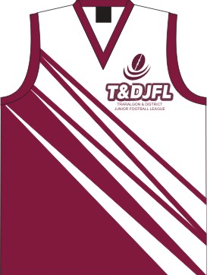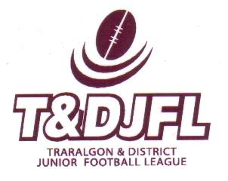
2010
LOY YANG POWER
TRARALGON & DISTRICT JUNIOR FOOTBAL LEAGUE

FAIREST AND BEST VOTE COUNT AND
AWARD PRESENTATIONS

DATE: SUNDAY 15TH AUGUST 2010
VENUE: TRARALGON FOOTBALL AND NETBALL CLUB
SOCIAL ROOMS, WHITTAKERS ROAD, TRARALGON

- 10:00am Under 10s Fairest & Best Award
- 10:30am Under 12s Fairest & Best Award
- 11:00am Under 14s Fairest & Best Award
- 11:30am Jason Boulton Memorial U14 Goal Kicking Award
- 11:35am Chris Zotti Memorial U16 Goal Kicking Award
- 11:40am T&DJFL Club Code of Conduct Award
- 11.45am Under 16s Fairest & Best Award

The Social rooms will be available for soft drinks and snacks.

The T&DJFL Awards activity is an alcohol free and non-smoking event

The T&DJFL Executive extends this invitation to all players, families, club officials, umpires and sponsors to attend the formal conclusion to the 2010 home and away season.
