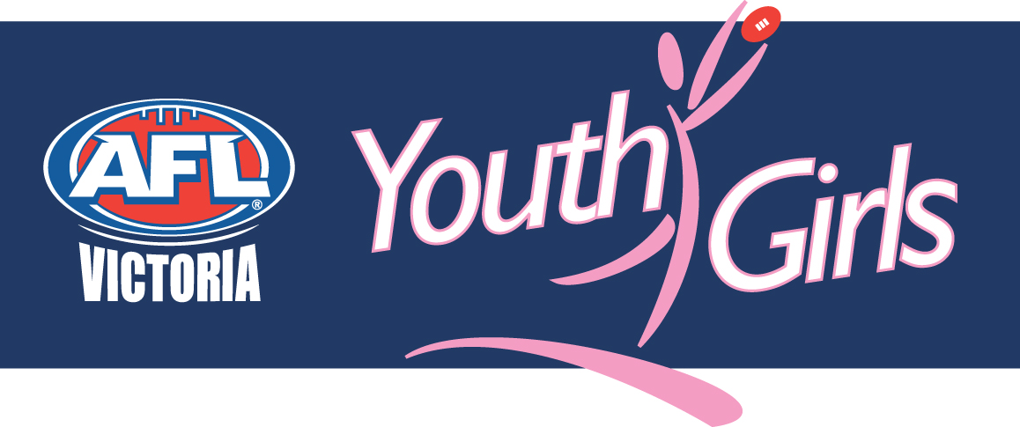
YOUTH GIRLS VICTORIAN TEAM PLAYER SELECTION POLICY

Summary:
AFL Victoria’s Youth Girls Representative Player Selection Policy will be adhered to by coaches and selectors in selecting players to all Youth Girls representative teams.

Training sessions will be held on the following dates and locations:
- Selection training 1 - Monday July 26
- Selection training 2 - Monday August 2
- Selection training 23- Monday August 9 - FINAL SQUAD SELECTED
- Final Squad Training - Monday August 16
- Final Squad Training - August 17-20 (date/venue to be confirmed)
- Final Squad Training - Monday August 23
- Final Squad Training - August 24-27 (date/venue to be confirmed)
- Final Squad Training - Monday August 30
- Final Squad Training - August 31- September 3 (date/venue to be confirmed)

The AFL National Youth Girls’ Under 18 Championships will be held from September 7-12

Principles Guiding Selection
The Victorian Youth Girls team extends the talented player pathway to Youth Girls participants, providing them with opportunities to develop their abilities and demonstrate them in front of family, friends and selectors. The Youth Girls principle of providing girls with an all female football environment that is fun and friendly will be emphasised throughout the training, selection and competition phases. Teams will be selected to maximise the development of successful and unsuccessful participants, providing them with knowledge and skills that can be distributed to their club team mates throughout the remainder of the year.

Representative Team Composition
Each representative team will comprise:
- Twenty-seven (27) players

Representative Team Structure
The maximum number of players per team on the field at any one time will be eighteen (18), with four (4) interchange players, and three (3) emergency players. Emergency players will fill Runner and Water Runner duties.

Selection Eligibility
To be eligible for selection, players must:
- be registered with a Youth Girls team in the participating competitions;
- have played at least three (3) Youth Girls games;
- not have played more than five (5) games in the Victorian Women’s Football League, excluding representative games;
- have completed and returned all relevant paperwork, including Parent/Guardian Consent forms;
- have attended at least one of the first two SELECTION training sessions, and the final SELECTION training session; and,
- not have been suspended in the relevant season.

Selection Criteria
Players will be selected according to the following:
- selection eligibility;
- attitude;
- training intensity;
- willingness and ability to make changes to improve their game;
- leadership;
- initiative;
- punctuality;
- attendance, including communication for absences;
- skills;
- fitness;
- active encouragement of other players;
- willingness to follow team plan as outlined by coach/selectors;
- positional needs of team; and,
- match form.

Selection Timeframe
The first and final selection of players will occur following the final selection training session.

