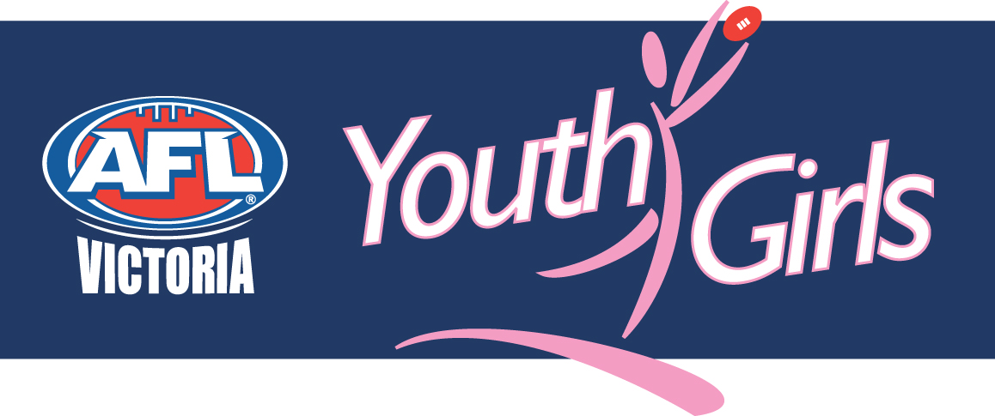
YOUTH GIRLS VICTORIAN CHAMPIONSHIPS PLAYER SELECTION POLICY

Summary:
AFL Victoria’s Youth Girls Victorian Championship Player Selection Policy will be adhered to by coaches and selectors in selecting players to represent the Youth Girls competitions.

Training sessions will be held on the following dates and locations:
Eastern | West @ TBC - 7-8:30pm | Northern
Wed May 5 | Mon May 3 | Wed May 5
Wed May 12 | Mon May 10 | Wed May 12
Wed May 19 (selection) | Mon May 17 (selection) | Wed May 19 (selection)
Wed May 26 | Mon May 24 | Wed May 26
Wed June 2 | Monday May 31 | Wed June 2

The Youth Girls’ Victorian Championships will be held:
Round 1 – Saturday June 12
Round 2 –Monday June 14
Round 3 – Wednesday June 23 (PM)
Grand Final – Saturday July 3

Principles Guiding Selection
The Youth Girls’ Victorian Championships extends the talented player pathway to Youth Girls participants, providing them with opportunities to develop their abilities and demonstrate them in front of family, friends and selectors for the 2010 Victorian team and the 2011 Youth Girls Academy. The Youth Girls principle of providing girls with an all female football environment that is fun and friendly will be emphasised throughout the training, selection and competition phases. Teams will be selected to maximise the development of successful and unsuccessful participants, providing them with knowledge and skills that can be distributed to their club team mates throughout the remainder of the year. The Championships will involve all teams from participating Youth Girls’ competitions.

Representative Team Composition
Each representative team will comprise:
- Twenty-five(25) players;
- At least one (1) player from each Youth Girls team, providing they meet the selection criteria

Representative Team Structure
The maximum number of players per team on the field at any one time will be eighteen (18), with four (4) interchange players, and three (3) emergency players. Emergency players will fill Runner and Water Runner duties.

Selection Eligibility
To be eligible for selection, players must:
- be registered with a Youth Girls team in the participating competitions;
- have played at least three (3) Youth Girls games;
- not have played more than five (5) games in the Victorian Women’s Football League, excluding representative games;
- have completed and returned all relevant paperwork, including Parent/Guardian Consent forms;
- have attended at least one of the first two training sessions, and the final training session; and,
- not have been suspended in the relevant season.

Selection Criteria
Players will be selected according to the following:
- selection eligibility;
- attitude;
- training intensity;
- willingness and ability to make changes to improve their game;
- leadership;
- initiative;
- punctuality;
- attendance, including communication for absences;
- skills;
- fitness;
- active encouragement of other players;
- willingness to follow team plan as outlined by coach/selectors;
- positional needs of team; and,
- match form.

Selection Timeframe
The first and final selection of players will occur following the final selection training session.

