
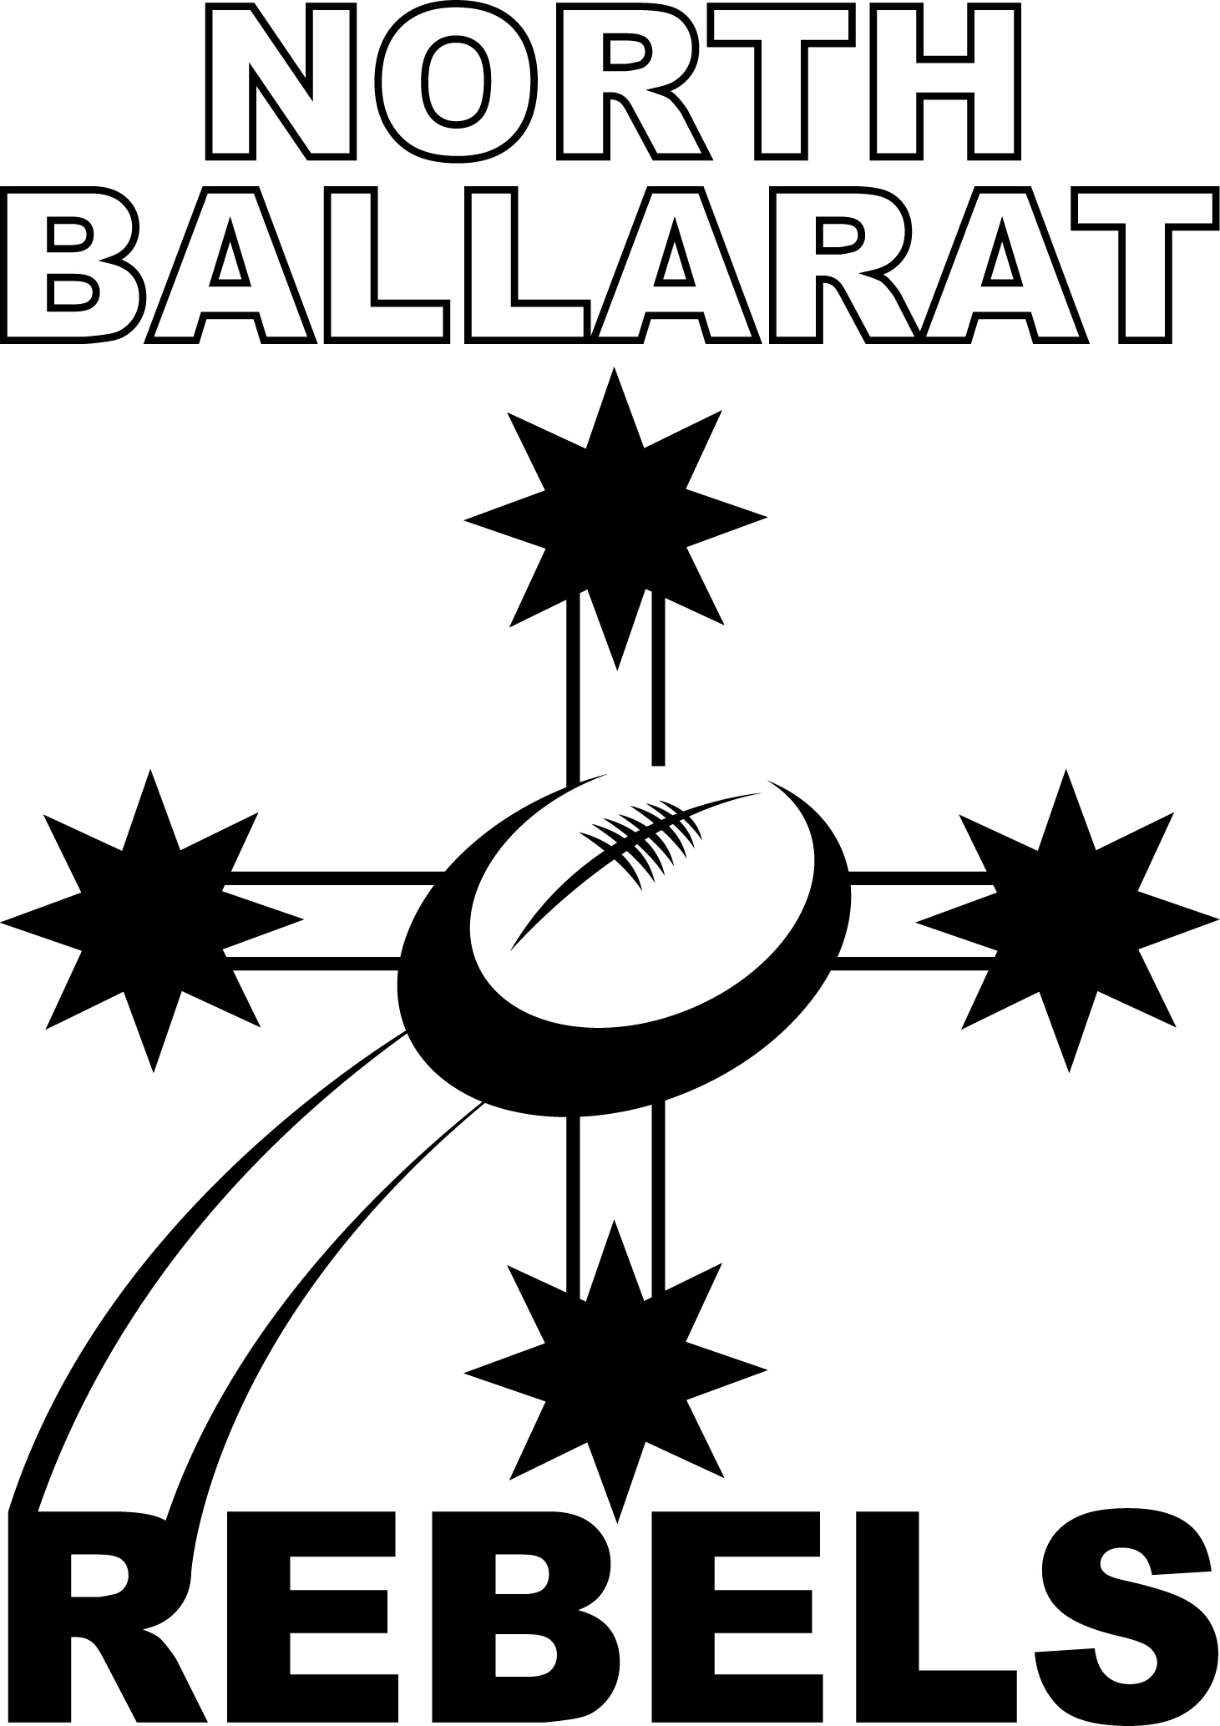
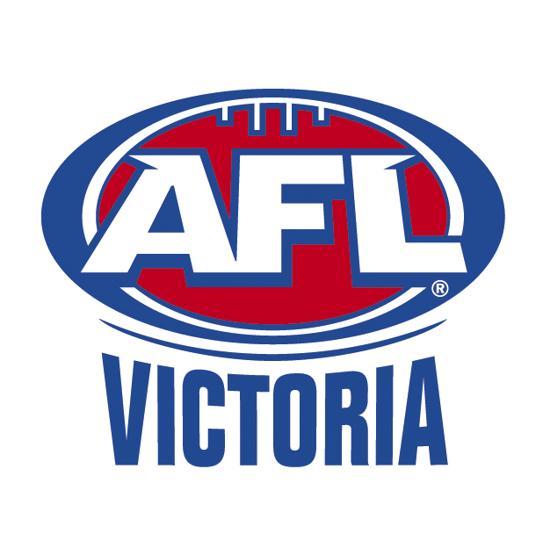
TAC Cup
Football Victoria Ltd. ABN 87 052 795 399
NORTH BALLARAT REBELS FOOTBALL CLUB
Eureka Stadium, Creswick Rd, Ballarat, 3350
PO Box 151N, Ballarat North, 3350
Telephone: 5339 0915 Fax: 5332 9538 Email: phil.rebels@theroosters.com.au
Website: www.nthballaratrebels.aflvic.com.au

Rebels Playing Squad & Staff Weekly Memo
Monday 12th- Sunday 18th April 2010
With a Development Round this week we have a break from training this Thursday night. An opportunity for those players not involved in State Trials this weekend to go back to their local club and display their talent and knowledge gained thus far.
Players that do go back and play at local club are reminded to get their Player Report done by local coach and return to us on the next Monday by fax or email. We have so far had a poor response this week with returns. If you have lost or need any copies of the Player Report please go to our website and follow link to Player Documents.

Hopefully all players have invited all Parents and Sponsors to next weekend’s ANZAC DAY Clash if not please do so ASAP. Day will begin at noon inside the Social Rooms. Any questions please call Phil Partington.

Please ensure you check the club’s new website each week to get your updated memo. http://nthballaratrebels.aflvic.com.au
This week:
Tues 13th April: Training at Eureka Stadium @ 4.30pm (Ballarat Based)
Wed 14th : Top aged Ballarat Based players to train with Roosters @ 5.30pm
Thursday 15th April NO TRAINING DUE TO DEVELOPMENT WEEKEND

Next Week Training
Tuesday 20th April: Training at Eureka Stadium @ 4.30pm (Ballarat Based)
Thurs 22nd April: Training at Eureka Stadium @ 4.30pm
Dinner/Team Meeting to be held at conclusion of training. We will be having a guest Speaker on the night. Parents/Supporters are most welcomed to attend.

REMINDERS
25th April- ANZAC DAY SPONSORS & PARENTS DAY.
Please ensure all Player Sponsors and Parents are aware and invited to attend this day.
Day will start at 12noon with finger food and drinks supplied.

Player Levies are now overdue please ensure prompt payment


Major Sponsor of the North Ballarat Rebels Talented Player Pathway Programs

