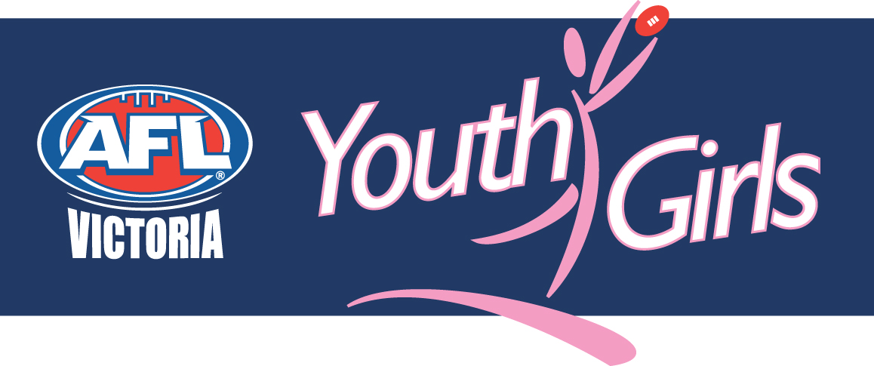
YOUTH GIRLS VICTORIAN COUNTRY CHAMPIONSHIPS POSITION DESCRIPTION

Position:
Team Manager - Bendigo/Geelong Youth Girls Representative Team

Summary:
AFL Victoria’s Youth Girls’ Representative Team Managers will be responsible for the administration of the players through the selection process and throughout the competition phase.

The Youth Girls’ Country Championships will be held on Tuesday June 29 and will be held as part of the VCFL’s VLine Cup. A training and selection schedule is still being developed.

The Youth Girls’ Victorian Championships extends the talented player pathway to Youth Girls participants, providing them with opportunities to develop their abilities and demonstrate them in front of family, friends and selectors for the 2010 Victorian team and the 2011 Youth Girls Academy. The Youth Girls principle of providing girls with an all female football environment that is fun and friendly will be emphasised throughout the training, selection and competition phases. Teams will be selected to maximise the development of successful and unsuccessful participants, providing them with knowledge and skills that can be distributed to their club team mates throughout the remainder of the year. The Championships will involve all teams from participating metropolitan Youth Girls’ competitions.

Experience and Qualifications
Required
- Availability on the above dates and times

Preferred
- Experience in managing a sporting team
- Understanding of Youth Girls competition and representative programs

Key Competencies
The successful applicant must be able to demonstrate:
- an ability to compile players’ details and official paperwork;
- an ability to coordinate training attendances for selection eligibility purposes;
- excellent communication skills.

Please note: Team Managers will have no role in player selection.

Attributes
- Passionate about girls’ football
- Focused on development of players rather than ‘winning at all costs’
- Professional
- Punctual
- Responsible
- Leadership

Please note: These positions are unpaid voluntary positions. You may need to obtain Working With Children Check accreditation.

Submission
Please submit an expression of interest in the form of a written letter of application and your curriculum vitae.

Forward applications to:
Chyloe Kurdas
Female Football Development Manager
AFL Victoria

By mail:
GPO Box 4337
Melbourne
VIC 3001

By fax:
03 9654 8684

By email:
chyloe.kurdas@aflvic.com.au

