
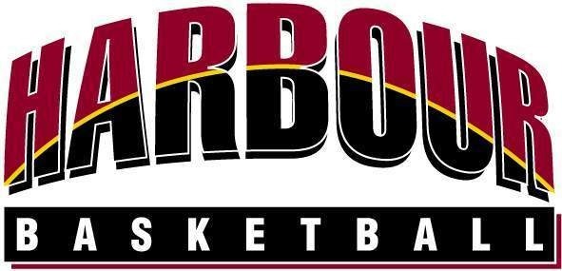
Social Basketball

Entry Form

Harbour Basketball is now accepting entries for the next Social Mixed
Basketball League Starting Monday 29th March 2010

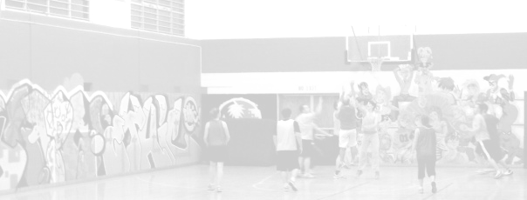
Entries close - Friday 12th March 2010

12 weeks (Monday Nights) – 2 x 16 half’s

Mixed - 2 of each gender on the court at all times

Cost - $695 please pay by direct credit to:
ASB, Northcote Branch 12-3053-0401960-00
(Please Reference your team name)

Plus 2 x $50 Bar tabs up for Grabs each week

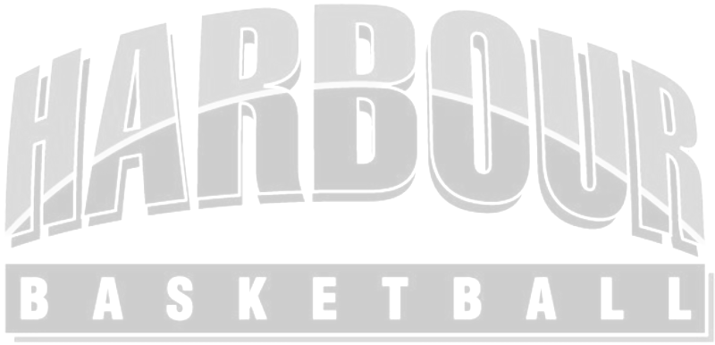
Team Name: ................................................................................... Grade A (Social) / B (Very Social)

Team Contact: ................................................................................ Cell Phone: ................................................

Email: ..................................................................................(2nd Email) .......................................................................
Team contact (2nd): ............................................................................ Cell Phone: ...............................................
Billing Address:

Player’s Name | Date of Birth | Email

Please contact Harbour Basketball
Email: admin@harbourbasketball.co.nz Phone: (09)4433854 Fax : 4433298



