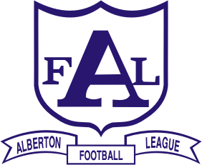
ALBERTON FOOTBALL LEAGUE Inc.
• DALYSTON • DEVON/WELSHPOOL WON WRON WOODSIDE • FISH CREEK
• FOSTER • INVERLOCH-KONGWAK • KILCUNDA-BASS • KORUMBURRA-BENA
• MEENIYAN DUMBALK UNITED • PHILLIP ISLAND • STONY CREEK
• TARWIN • TOORA & DISTRICT • WONTHAGGI POWER • YARRAM

2009 BEST & FAIREST WINNERS:
SENIORS:
Aaron WARE, Wonthaggi Power - 20 votes
RESERVES:
Vaughan VAN DILLEN, Tarwin - 20 votes
Luke BORNE, Yarram - 20 votes
THIRDS:
Troy HARLEY, Wonthaggi Power - 24 votes
2009 TOP GOALKICKERS:
SENIORS:
Corbin STEVIC, Phillip Island - 71 goals
RESERVES:
Robert BIRNIE, Dalyston - 63 goals
THIRDS:
Joshua SCHELLING, Stony Creek - 65 goals
FOURTHS:
Josh HUGHES, Wonthaggi Power - 74 goals
RISING STARS:
April: Zac VERNON, Phillip Island
May: Zeke LAMB, Yarram - 2009 WINNER
June: Lachlan PARK, Fish Creek
July: Jamie ROBINSON, Phillip Island
August: Lachie PRATT, Fish Creek

