PRESIDENT’S REPORT TO CONGRESS

CENTRAL PARK HOTEL, ROME, 23RD JULY 2009.

My report covers the period from our Mandatory Congress held in Christchurch, New Zealand in June 2008.

I would like to begin by informing members of messages of support for our Association has received from the Union Americas de Natacion and the Asian Swimming Federation. I have been in regular contact with these two continental federations since my election to foster closer relations and to explore where our federations can mutually benefit from exchanges of information and knowledge.

On membership, we have maintained our level as in 2008. However I note that FINA have provisionally approved the membership of Vanuatu in the FINA family, and I have been in regular contact with administrators there to formalise programs and membership of OSA. There have been recent moves to revive the Solomon Islands Federation, and again I have been in touch with colleagues in Honiara to see how best to get the sport going again there.

I would like to thank member federations for keeping our Hon. Secretary up to date with happenings in their countries as this enables him to regularly update our website on aquatic activities in our region. I would encourage this to continue and improve.

I am pleased to see the level of representation by Oceania Federations here in Rome for the World Championships, and I wish to thank FINA and the Roma 2009 Organising Committee for their assistance in facilitating this representation. Congratulations to Australia and New Zealand for their results so far in the Championships and best wishes to the athletes from our other members as they prepare for the swimming events later this week.

I would like to mention that the teams from Palau and Fiji were recently based in Liverpool, UK for a pre-Championships training camp. This camp was facilitated by the NW England Development Agency, a group with which the Oceania National Olympic Committees has signed a Memorandum of Understanding to assist island member countries of ONOC to prepare for the London 2012 Olympic Games. I would encourage our island members to proactively discuss this program with their respective National Olympic Committees, as we are only 3 years away from London. I also note that the Australian Team was based in Manchester around the same time and I trust these pre-Championships training camps will bear fruit in the pool here at the Foro Italico.

Since our Congress in Christchurch, the ramifications of the election processes carried out there have continued to exercise the minds of your Executive Committee. I am pleased to note that today agreement has been reached on our FINA Bureau representation for 2009 – 2013 and this will be placed before you for endorsement at this Congress. There are bridges to be rebuilt between the largest member of our Association and the region and your Executive will concentrate its efforts in this area in the months ahead.

The new FINA Bureau, which will be elected tomorrow, has many challenges facing it and I expect a number of new development initiatives to be announced in the forthcoming months. This, as you know, is an issue close to my heart and I will be working hard in this area for the benefit of the region.

In closing, many thanks for your support over the past year. Best wishes for a successful World Championships.

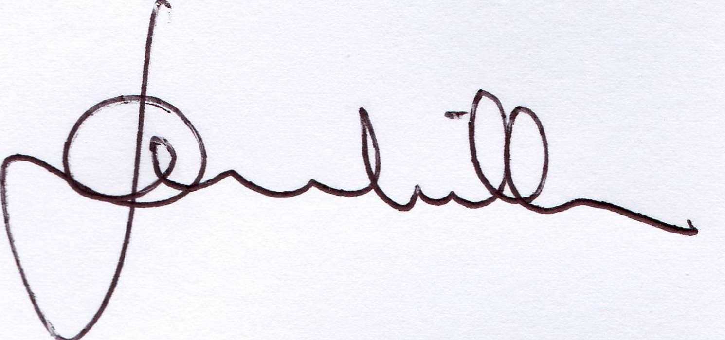

DENNIS MILLER
PRESIDENT

