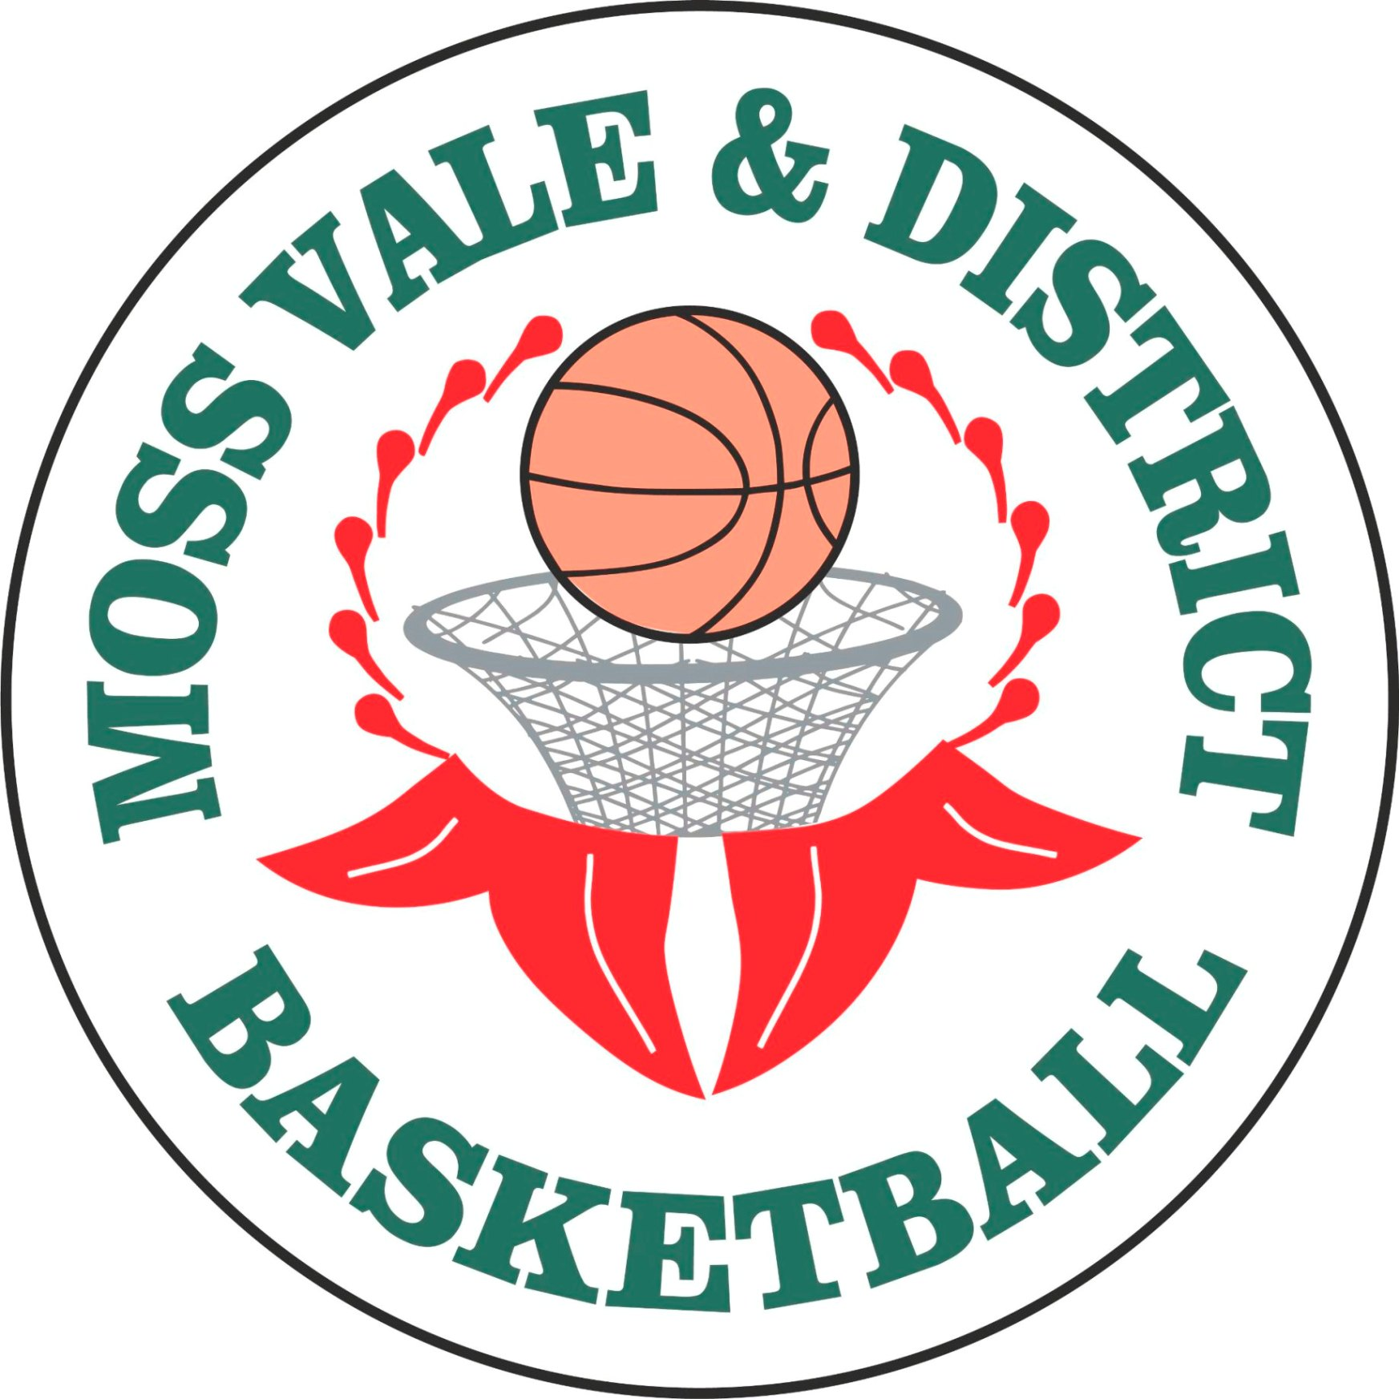
Summer Basketball Competition 2015 - 2016

Basketball is a great indoor team sport that is played all year round.
The new junior competition starts Term 4 2015


AUSSIE HOOPS (Wednesday afternoons 4pm – 5pm)
8 weeks of fun basketball skills for
5 – 10 years of age.
Includes ball, backpack and singlet.
All new players are encouraged to participate in Aussie Hoops
(Register for this online at www.aussiehoops.com.au)

Junior Competition

Boys and Girls teams
Played Wednesday and Friday afternoons
(that’s right…No Saturday’s!)
Under 10’s – for children born 2007/2008
Under 12’s – for children born 2005/2006
Under 14’s – for children born 2003/2004
Under 16’s – for children born 2001/2002
Under 18’s – for children born 1999/2000

Come along and bring your friends and yourself
and we will place you in a team.
Nomination forms available from the office
For more details go to our website www.mvbasketball.sportingpulse.net
P: 02 4868 1569 E: mvbball@bigpond.com.au



