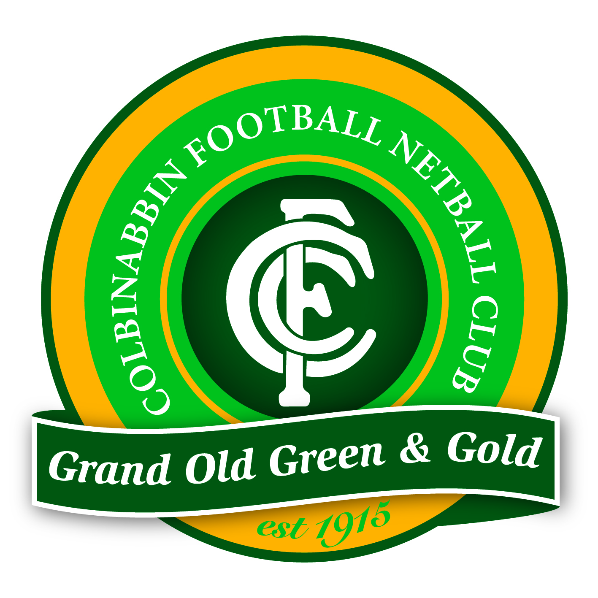

Colbinabbin Football Netball Club

Alcohol Management Policy

This policy provides the basis for the responsible use of alcohol by the Colbinabbin Football Netball club and is seen as fundamental to the aims of the club.

The club recognises the importance of holding a liquor licence, enabling it to generate income and hold social functions. In doing so however, we accept the responsibilities and expectations of the community in adhering to liquor licensing laws and the criteria of the Good Sports program.

To ensure the aims of the club are upheld and that alcohol is managed responsibly by the club and its members, the following requirements will apply when alcohol is served at the club or during a club function.

Serving Alcohol
Alcohol will be served according to the legal and moral requirements of the club’s Liquor Licence with the safety and well being of patrons the priority.
- The Club maintains a current appropriate Liquor Licence
- Where Possible only RSA trained servers will serve alcohol
- Bar servers do not consume alcohol when on duty
- People under 18 will not serve alcohol
- The club does not encourage excessive or rapid consumption of alcohol
- When serving non pre-packaged alcohol, standard drink measures will be served at all times
- Information posters about Standard Drink measures will be displayed at the bar
- The Liquor Licence and all legal signage will be displayed at the bar
- Names of RSA trained bar staff will be displayed
- An incident register shall be maintained and any incident recorded.

Intoxicated Patrons
- Drunk patrons will not be permitted to enter the premises
- Alcohol will not be served to any person who is intoxicated or drunk
- Servers will follow RSA training procedures when refusing service
- Drunk patrons will be asked to leave the premises (after appropriate safe transport options are offered).

Underage Drinking
- Alcohol will not be served to persons aged under 18
- Servers and committee members will ask for proof of age whenever necessary or whenever in doubt
- Only photo ID’s will be accepted as ‘proof of age’.

Alcohol Alternatives
The Club recognises that alcohol is not the only revenue stream available and actively encourages the sales of alternative products to that of alcohol.
- Tap water is provided free of charge (where available)
- At least four non-alcoholic drinks and one low-alcoholic drink options are always available and are at least 10% cheaper than full strength drinks
- Substantial food is available when the bar is open for more than 90 minutes or more than 15 people are present
- The club will avoid using alcohol for player awards and fundraising prizes.

Safe Transport
The Club has a (separate) Safe Transport Policy that is reviewed regularly in conjunction with this Alcohol Management Policy.

Smoke-Free
The Club has a (separate) Smoke-Free Policy that is reviewed regularly in conjunction with this Alcohol Management Policy.

Club Trips
The Club will monitor and ensure any club trips, particularly end of season player trips, strictly adhere to responsible behaviour and alcohol consumption in accordance with the principles of this policy and the aims of the club.

Non Compliance
All club committee members will enforce the alcohol management policy and any non-compliance, particularly in regard to Licencing Laws will be handled according to the following process:
- Explanation of the club policy to the person/people concerned, including identification of the section of policy not being complied with
- Continued non-compliance with the policy should be handled by at least two committee members who will use their discretion as to the action taken, which may include asking the person/ people to leave the club facilities or function.

Committee Policy Management
The presence of committee members is essential to ensure the operation of the bar and compliance with this policy. At least two committee members who are RSA trained are required to be present at all club functions when the bar is open. Key responsibilities of the duty committee members are to:
- Meet visiting police, cooperate and assist with any inquiries
- Compliance in respect of persons under 18 years of age on premises
- Recording any incidents in the incident register
- Ensuring strict compliance with all sections of this policy in accordance with legal requirements and the Good Sports program.

Policy Promotion
The Club will promote the alcohol management policy regularly by:
- Putting a copy of the policy in club communications, eg. newsletters, website and printed member/ player information
- Displaying a copy of the policy in the club social rooms
- Periodic announcements to members at functions.

The Club recognises the importance of educating club members, particularly players, about the benefits of an alcohol management policy and will endeavour to provide information to assist this process.

The Club will actively participate in the Australian Drug Foundation’s Good Sports program with an ongoing priority to maintain Level 3 accreditation.

Policy Review
This policy will be reviewed annually to ensure it remains relevant to club operations and reflects both community expectations and legal requirements.

Updates.
Revised Date | Changes | Author.
10/4/19 | Nil | Mark Turner
26/1/2020 | Nil | Mark Turner
8/3/2021 | Nil | Mark Turner
22/10/2023 | Nil | Mark Turner
29/12/2024 | Nil | Mark Turner

