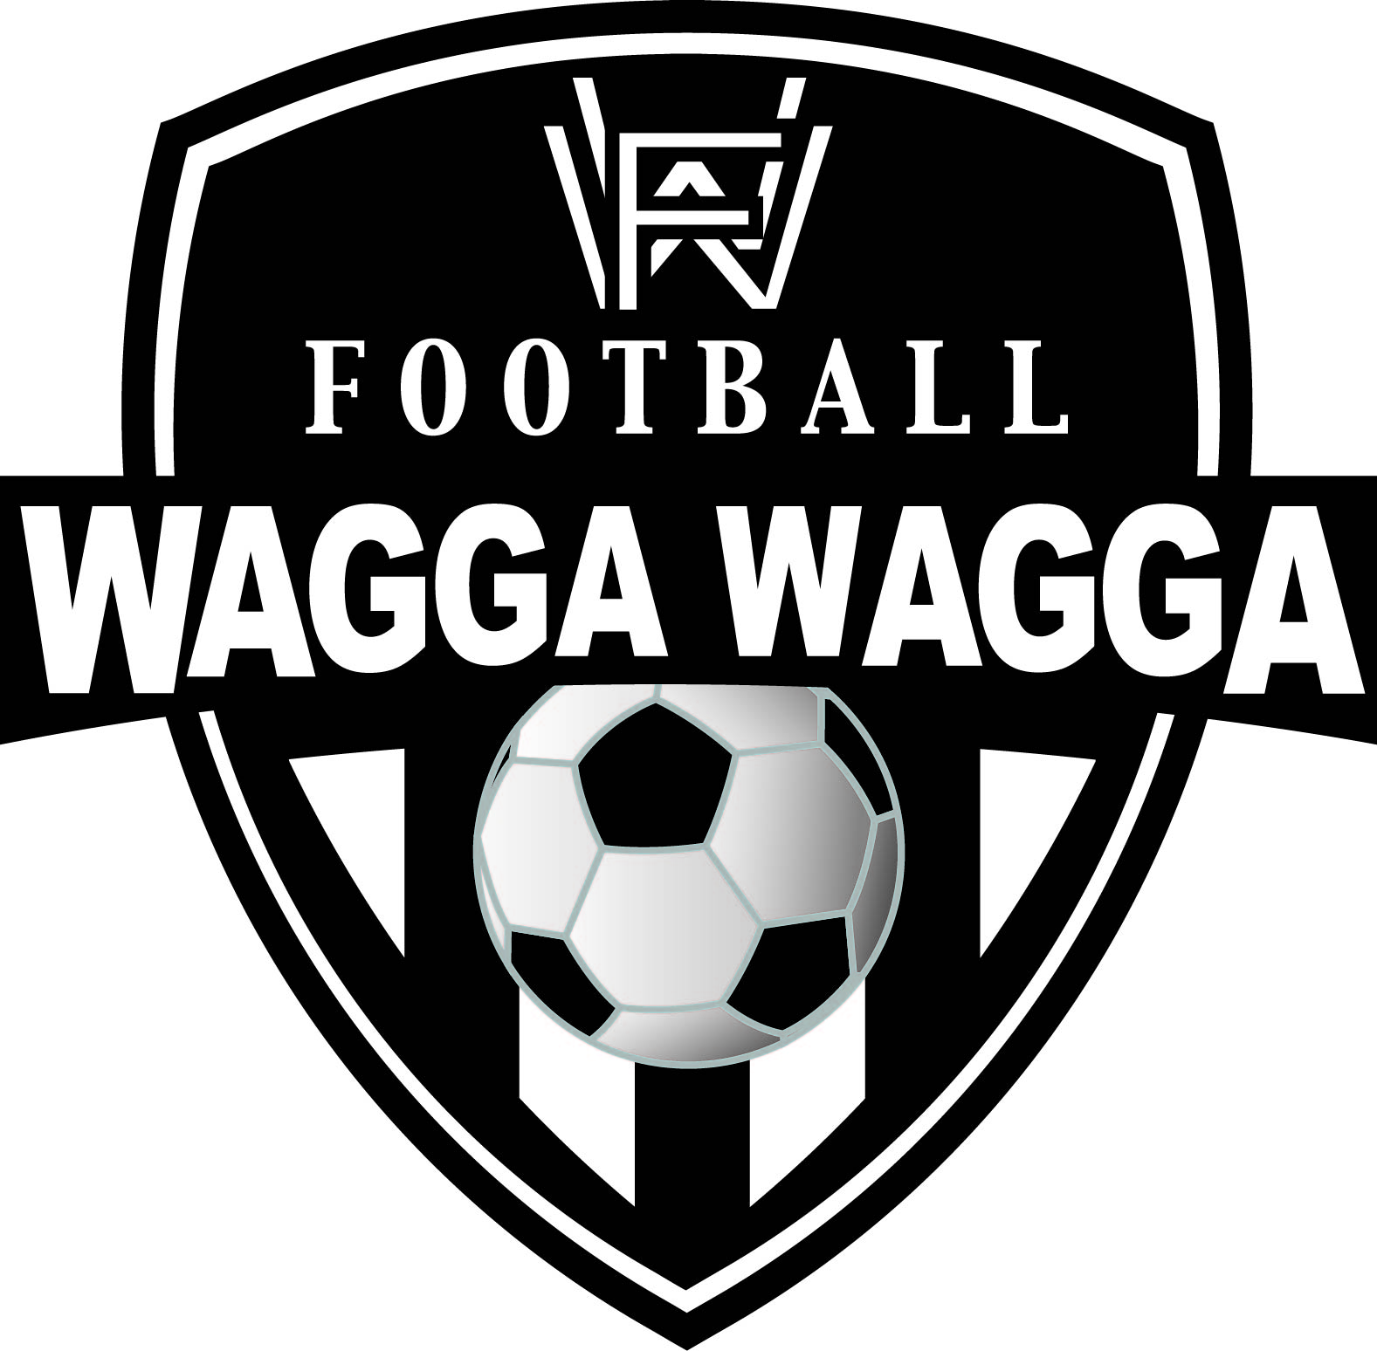
WAGGA WAGGA & DISTRICT AMATEUR FOOTBALL ASSOCIATION Inc.
FOOTBALL WAGGA WAGGA
ABN: 35 393 790 501
PO Box 2264, Wagga Wagga NSW 2650 Email: secretary@footballwagga.com.au
Fax: 02 6931 0921

NOTICE OF PLAYER SUSPENSION

[NAME]
[TITLE]
[CLUB]

[DATE]

Name of Player |  | Shirt Number
Competition |  | Team
Opponent |  | Date of Game
Send off Code |  | Summary of the Offence
Time of Game Incident Occurred

The Referee has reported that
[insert referees report details here]

Suspension Issued (Fixtures or Time)
Is this the minimum suspension for this send off code? | Yes / No

If the suspension imposed equals the minimum suspension for this send off, it can not be appealed except on the basis of mistaken identity. Mistaken Identity claims must be submitted within 4 days of the offence occurring.

This player is suspended from the following football activities for the duration of their suspension, within the winter football season:

Activity | Tick if Yes | Comments
Participating as a player |  | All R Codes and accumulated Y suspensions
Participating as a coach or manager of their team |  | R2, R3, R6 Codes
Participating as a coach or manager of another team |  | R2, R3, R6 Codes
Club or Ground Official |  | R2, R3, R6 Codes

Should the suspension not be served in full in the 2014 winter competition, the suspension will continue to apply at the start of the 2015 winter competition.

Note: A player suspended for a set number of Fixtures is suspended from playing any grade until their sentence is served in the Age Grade it was received it.

Once the suspension is served and prior to the player’s involvement in any of the activities for which they are suspended for, you must complete and submit the form FWW010 Notification of Suspension Served (downloadable from the Football Wagga Wagga website www.footballwagga.com.au).

Football Wagga Wagga
Per The Disciplinary Committee

