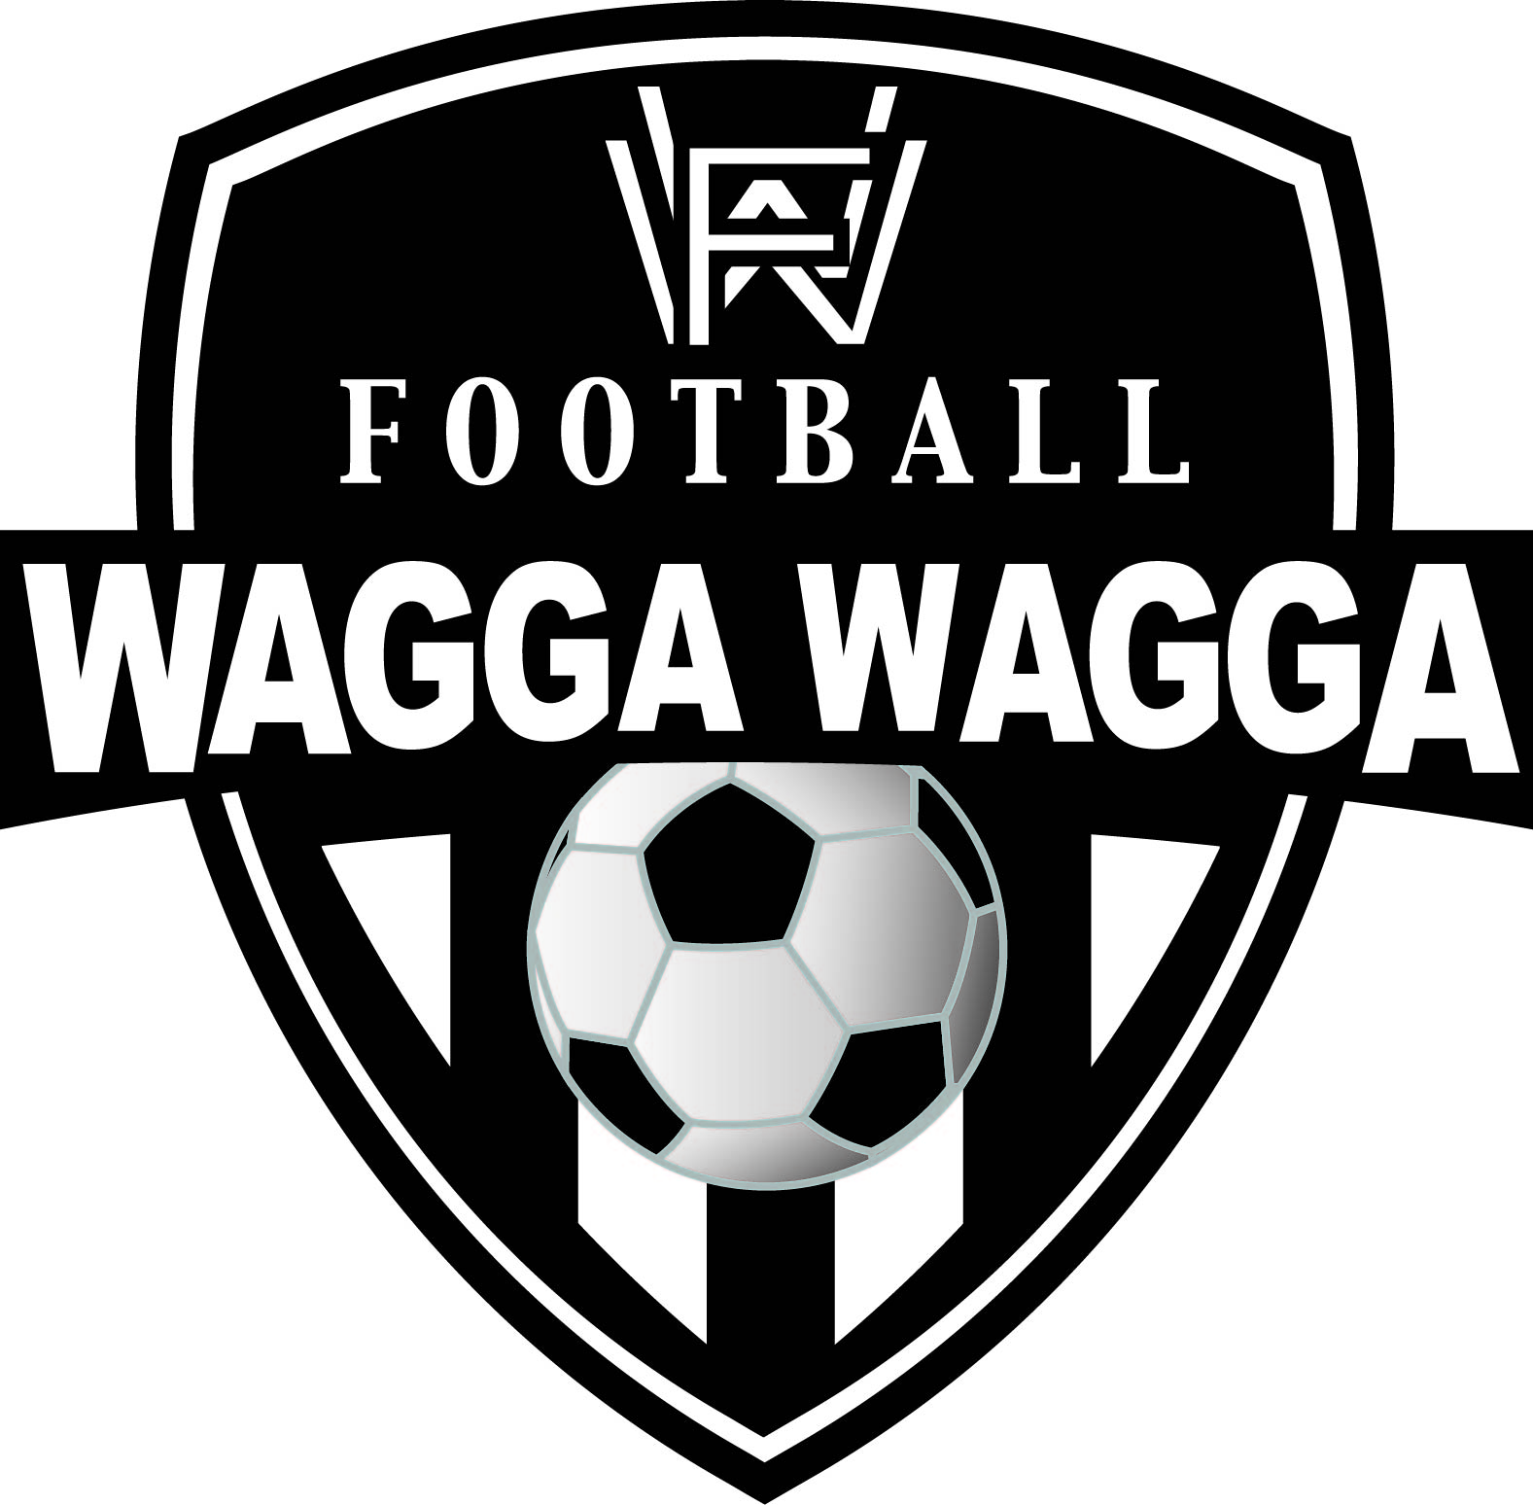
Notification Form for Mistaken Identity

Prescribed Form 03

To: Football Wagga Wagga Secretary
Email secretary@footballwagga.com.au

Full Name of Participant:

FFA Number of Participant:

Club:

Team/Grade:

Date of Match:

Opposition in Match:

Submission

- I declare that the following Participant of my Club was responsible for the Offence and the Suspension issued against the player noted above should be transferred across to the Participant mentioned below:

Offender's Name:

- I declare that the information in this statement is accurate and to the best of my knowledge.
- I acknowledge that I may be charged with Misconduct if it is established that the contents of this statement are incorrect and amount to an abuse of process.

Please submit this form within 48 hours of the completion of the match. If FWW does not receive a properly completed forms by the time specified above, you are deemed to have committed the Offence and will be issued with a Notice of Suspension.

Insert your full name:

Position in the Club (if signed by someone other than the Player)

I certify that the information entered above is true and correct and was entered by myself

Date:

