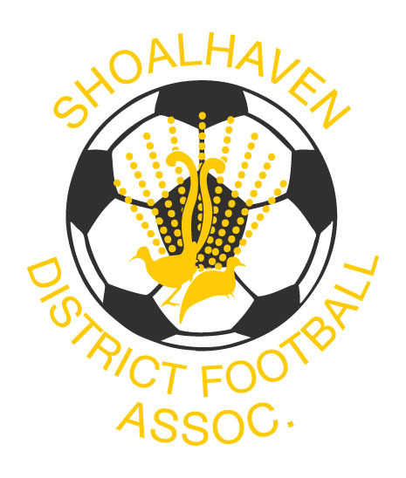
SHOALHAVEN FOOTBALL 2021
Term 2 Talent Identification Programs
Players Born 2010 – 2013
The Shoalhaven Football Talent identification program is the official player pathway for Male & Female Players.
Our qualified and experienced coaches will create a positive learning environment in which players can development the necessary skills for footballing success. Our coaches work through a yearly-periodised plan based on the National Curriculum, Building Blocks and Skill Acquisition with specific focus on the Skill Acquisition & Small Sided Games content. Focus is on developing the 4 Core Skills, 1st Touch, Striking the ball, Running the ball and 1v1’s. As they progress players will also focus on Positioning Games & Game awareness.
The program consists of 1 session per week.
To register email coaching@shoalhavenfootball.com.au 0488034500
7 Week Talent Identification Program
Cost = $85
Ulladulla Mondays
Commencing 26th April 4.15pm – 5.15pm

Shoalhaven Heads Tuesdays 4.15pm – 5.15pm
Commencing 27th April

South Nowra Wednesdays
Commencing 28th April 4.15pm-5.15pm

EXPRESSION OF INTEREST
Player’s Name: ______________________________________________________________________________
(Please print neatly)
Address: ____________________________________________________________________________________
Post Code: ___________________ Date of Birth: _________________ Phone: _________________________

Health Issues

Mobile: _____________________ * Email

