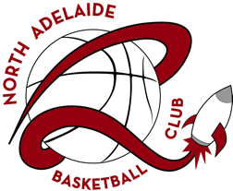
NORTH ADELAIDE
BASKETBALL CLUB

JUNIOR TRIALS
Under 12, 16 & 18 Girls

Wednesday 16th December 2020
The Lights Community & Sports Centre,
corner Hampstead Road & East Parkway, Lightsview

Junior Trials for the U12, U16 & U18 girls age groups will be held for the 2021 seasons.

All current players are required to attend. Any new players wishing to try out are invited and welcome to come along.

Trial details are as follows:

Age Group | Year of Birth | Time
Under 12 Girls | 2010 & 2011 | 5.00pm – 6.30pm
Under 16 Girls | 2006 & 2007 | 6.30pm – 8pm
Under 18 Girls | 2004 & 2005 | 8pm – 9.30pm

Due to Covid-19 we are asking that you arrive NO MORE than
10 minutes prior to your trial time for registration and that players leave promptly once their trials are completed.

Spectators should remain outside of the court area and observe any social distancing guidelines in place at that time.

Any current player who is unable to attend must advise
admin@nabc-rockets.club

Information regarding trials in other age groups will be shared as soon as the details are confirmed.

For further information and contact numbers please visit the
North Adelaide Basketball Club website: http://www.northadelaide.basketball.net.au

