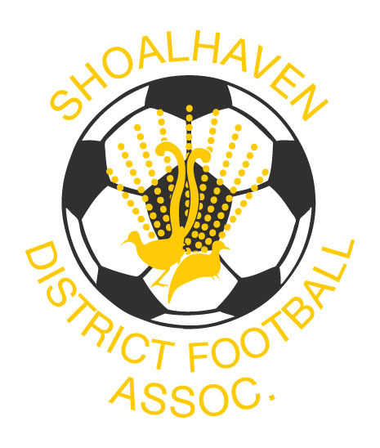
SHOALHAVEN FOOTBALL
Term 3 Talent Identification Programs

The Shoalhaven Football Talent identification program is the official player pathway for Male & Female Players.
Our qualified and experienced coaches will create a positive learning environment in which players can development the necessary skills for footballing success. Our coaches work through a yearly-periodised plan based on the National Curriculum, Building Blocks and Skill Acquisition with specific focus on the Skill Acquisition & Small Sided Games content. Focus is on developing the 4 Core Skills, 1st Touch, Striking the ball, Running the ball and 1v1’s. As they progress players will also focus on Positioning Games & Game Training.
The program consists of 1 session per week.

PLAYERS BORN 2008 - 2011
7 Week Talent Identification Programs Cost = $85
Shoalhaven Heads Tuesdays 4.30 pm – 5.30 pm
Commencing 6th August

South Nowra Wednesdays 5pm – 6 pm
Commencing 7th August

For all enquiries and/or to register email
Shoalhaven Football Director of Coaching Mark Johnston
sdfa.coaching@shoalhavenfootball.com.au 0488034500
Direct Debit Details SDFA BS 082 762 ACC 64050 0038

EXPRESSION OF INTEREST

Player’s Name:
______________________________________________________________________________
(Please print neatly)
Address

Post Code:

Date of Birth: Phone:

Location Shoalhaven Heads / South Nowra

Mobile

E-Mail: _

