Mansfield Junior Football Club
Uniform Orders

 |  | Qty | Size
Warm Up Top.
( Compulsory for all players to have)
Please provide name to be put on back of top.
$40
Training Singlet
$30
Hoodie
$60
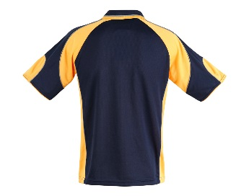 | Club Shirt  $25

Order Name __________________________ Contact Number ______________________________
Please return order form to your coach or email to admin@alpinecivil.com.au and please make payment to bank account. Orders must be in before Friday March 22nd or will miss out on the first run (especially training singlets and warm up tops)
Mansfield Junior Football League – BSB – 633 000 Account – 155284144
Please use reference – Uniforms and Players Surname
Uniforms won’t be given out till paid in full
Available in SIzes Adults S,M,L,XL,XXL Youth 12,14,16
Name for Back of Warm Up Top ________________________________________

