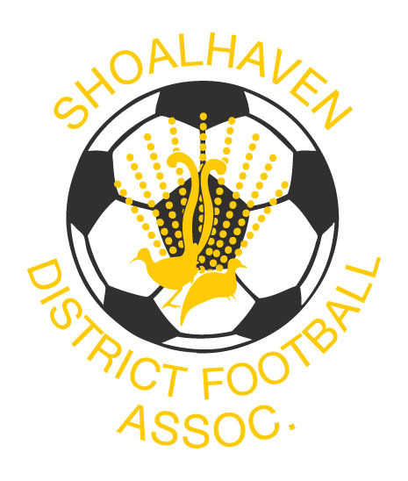
SHOALHAVEN FOOTBALL 2019

Term 1 Talent Identification Program

The shoalhaven Football Talent identification program is the official player pathway for Male & Female Players.
Our qualified and experienced coaches will create a positive learning environment in which players can development the necessary skills for footballing success. Our coaches work through a yearly-periodised plan based on the National Curriculum, Building Blocks and Skill Acquisition with specific focus on the Skill Acquisition & Small Sided Games content. Focus is on developing the 4 Core Skills, 1st Touch, Striking the ball, Running the ball and 1v1’s. As they progress players will also focus on Positioning Games & Game Training.
The program consists of 1 session per week.

7 Week Talent Identification Program Cost = $85
Mondays Commencing 11th February
5.00 pm – 6.00 pm
Venue South Nowra
This Program is for Players Born 2010 – 2011

For all enquiries and/or to register email
Shoalhaven Football Director of Coaching Mark Johnston
mjonno1@sdfa.org.au 0488034500

EXPRESSION OF INTEREST

Player’s Name:
______________________________________________________________________________
(Please print neatly)
Address

Post Code:

Date of Birth: Phone:

Mobile

E-Mail: _

