

ALBERTON FOOTBALL
NETBALL LEAGUE

NETBALL YEARBOOK

2018 SEASON

BOARD OF MANAGEMENT
President – Barry Stride
Vice President & Director of Netball – Leonnie McCluskey
Director of Football – Neil Park
Director of Special Events – Dean Cashin
Director of Finance & Sponsorship – Ralph Hubbert
League Coordinator/Treasurer – Lynn Whelan

SPECIAL ASSISTANTS
Amanda Calder
Natasha McRae

ASSOCATION CHAMPIONSHIPS

The 2018 Association Championships were held in Sale on the 20th May 2018. Alberton FNL entered Under 15s & 17s teams. Thank you to coaches, team managers, umpires, parents & players for their huge efforts towards these championships which produced great results and showcased the many talented players within our league.

FINAL CHAMPIONSHIP LADDERS

Netball Victoria – Eastern 15&U Championship

RANK | TEAM | P | W | L | D | F | A | Pts | %
1 | Sale NA | 7 | 7 | 0 | 0 | 77 | 33 | 28 | 233.33
2 | Gippsland League | 7 | 6 | 1 | 0 | 83 | 34 | 24 | 244.12
3 | Bairnsdale NA | 7 | 5 | 2 | 0 | 54 | 44 | 20 | 122.73
4 | North Gippsland FNL | 7 | 4 | 3 | 0 | 55 | 62 | 16 | 88.71
5 | Mid Gippsland NA | 7 | 3 | 4 | 0 | 44 | 59 | 12 | 74.58
6 | Ellinbank & District NA | 7 | 2 | 5 | 0 | 37 | 48 | 8 | 77.08
7 | Alberton FNL | 7 | 1 | 6 | 0 | 41 | 74 | 4 | 55.41
8 | West Gippsland FN | 7 | 0 | 7 | 0 | 35 | 72 | 0 | 48.61

Netball Victoria – Eastern 17&U Championship
RANK | TEAM | P | W | L | D | B | F | A | Pts | %
1 | West Gippsland FN | 8 | 8 | 0 | 0 | 1 | 124 | 39 | 36 | 317.95
2 | Mid Gippsland NA | 8 | 7 | 1 | 0 | 1 | 81 | 46 | 32 | 176.09
3 | Gippsland League BLUE | 8 | 6 | 2 | 0 | 1 | 76 | 49 | 28 | 155.10
4 | North Gippsland FNL | 8 | 5 | 3 | 0 | 1 | 100 | 70 | 24 | 142.86
5 | Bairnsdale NA | 8 | 4 | 4 | 0 | 1 | 63 | 54 | 20 | 116.67
6 | Alberton FNL | 8 | 2 | 6 | 0 | 1 | 67 | 76 | 12 | 88.16
7 | Gippsland League RED | 8 | 2 | 6 | 0 | 1 | 66 | 82 | 12 | 80.49
8 | Ellinbank & District NA | 8 | 2 | 6 | 0 | 1 | 60 | 90 | 12 | 66.67
9 | Orbost NA | 8 | 0 | 8 | 0 | 1 | 18 | 149 | 4 | 12.08

ALBERTON FNL CHAMPIONSHIP RESULTS

15&UNDER
Round 1 – North Gippsland 13 d 5
Round 2 – Alberton 8 d West Gippsland 5
Round 3 – Sale 11 d Alberton 6
Round 4 – Ellinbank 8 d Alberton 5
Round 5 – Bairnsdale 9 d Alberton 3
Round 6 – Mid Gippsland 11 d Alberton 7
Round 7 – Gippsland 17 d Alberton 7
Round 8 – Sale White 7 d Alberton 5

17&UNDER
Round 1 – Gippsland Blue 11 d Alberton 3
Round 2 – Bairnsdale 12 d Alberton 5
Round 3 – Mid Gippsland 10 d Alberton 7
Round 4 – West Gippsland 15 d Alberton 5
Round 5 – Bye
Round 6 – Gippsland Red 5 d Alberton 3
Round 7 – Alberton 22 d Orbost 1
Round 8 – Alberton 11 d Ellinbank 7
Round 9 – North Gippsland 15 d Alberton 11

15&UNDER AFNL CHAMPIONSHIP TEAM
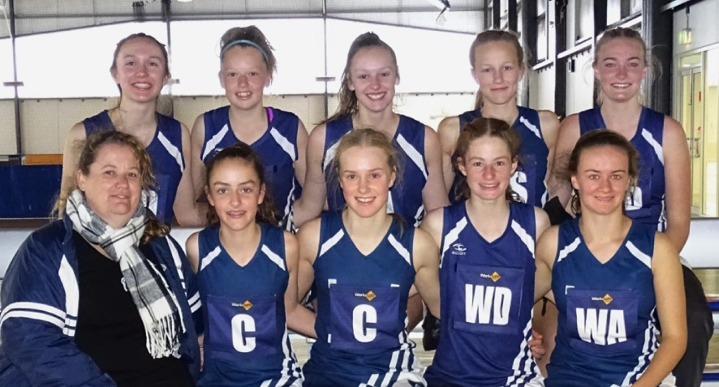

17&UNDER AFNL CHAMPIONSHIP TEAM
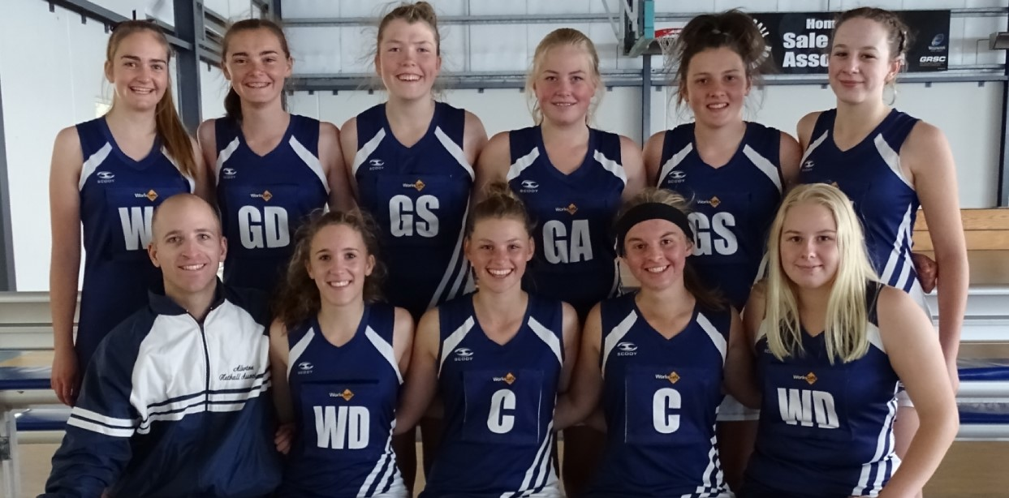

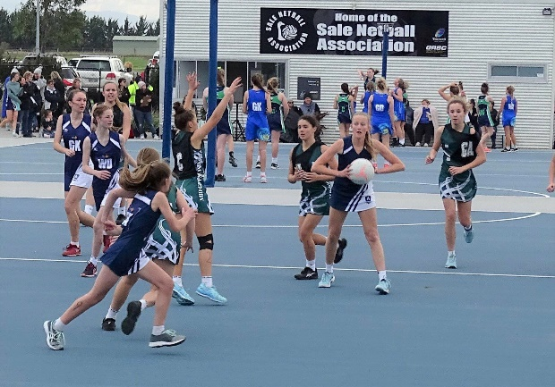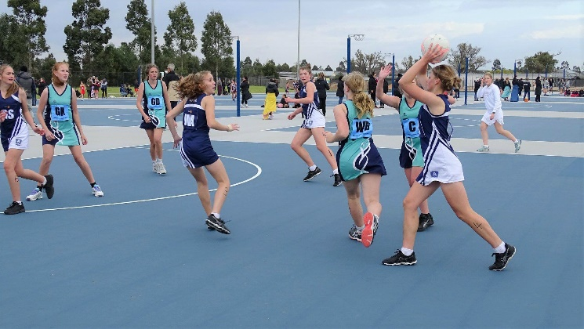

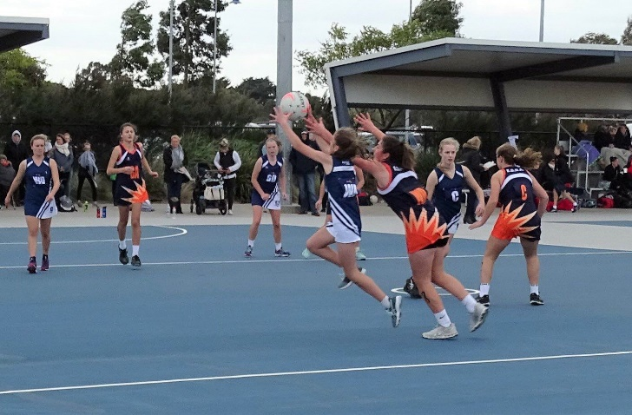

2018 RISING STARS
APRIL
IRENE THORSON – 2018 WINNER
M.D.U.
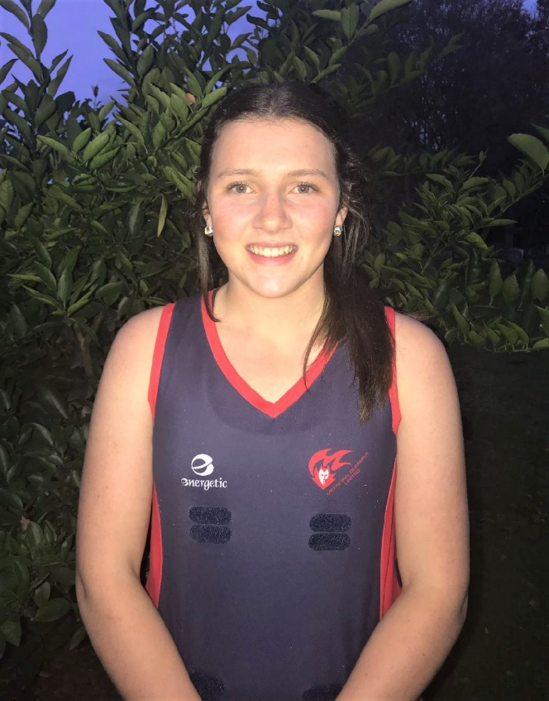
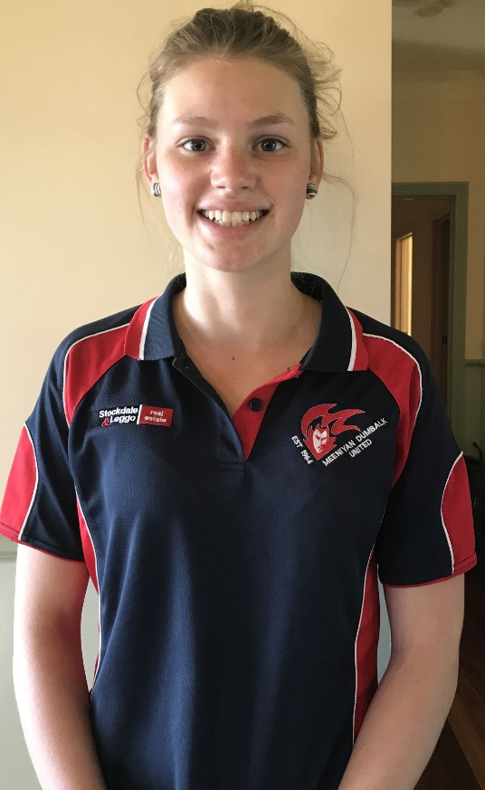
Irene started playing netball for Meeniyan & District (LDNA Comp) and has played for MDU since she was 11 years old, coming along with her older sisters. She was Alberton Football Netball League Best and Fairest in 15&U and 17&U and has represented Alberton in the Association Champs and Gippsland at State Titles for the last two years. She co-coached the MDU 15&U team last year. She plays for Southern Fusion at Waverley Netball Centre each week.

As well as netball, Irene enjoys hiking, camping, cooking, spending time with friends and at home on the farm. She works part-time at Meeniyan IGA. She participated in the Captains Camp program last year which she loved.

Kasey's netball career started as an 8 year old doing 2 years of NetSetGo at Meeniyan. As Kasey's family were already involved with MDU, she started playing as an 11 year old in the Under 13s. Having played in finals in the previous years it wasn't until top age 15s that the MDU girls were successful in winning her first Alberton Premiership in 2016. This was followed up by Alberton U17s Premiership in 2017. Kasey played alongside her mother in the B Grade Premiership & was a member of the A grade Premiership team in 2017. She was also assistant coach for the U13s. Kasey is currently Captain of MDU U17s and a member of the A grade team for 2018.

Kasey played with Southern Fusion netball from Under 13s to Under 17s, winning a Premiership at Waverley night netball and 2 Best & Fairest awards in Under 17s. She has represented Alberton at Association Championships and Gippsland Region Netball at State Titles and also participated in the captains camp program 2017-18.

MAY
KASEY THORSON
M.D.U.
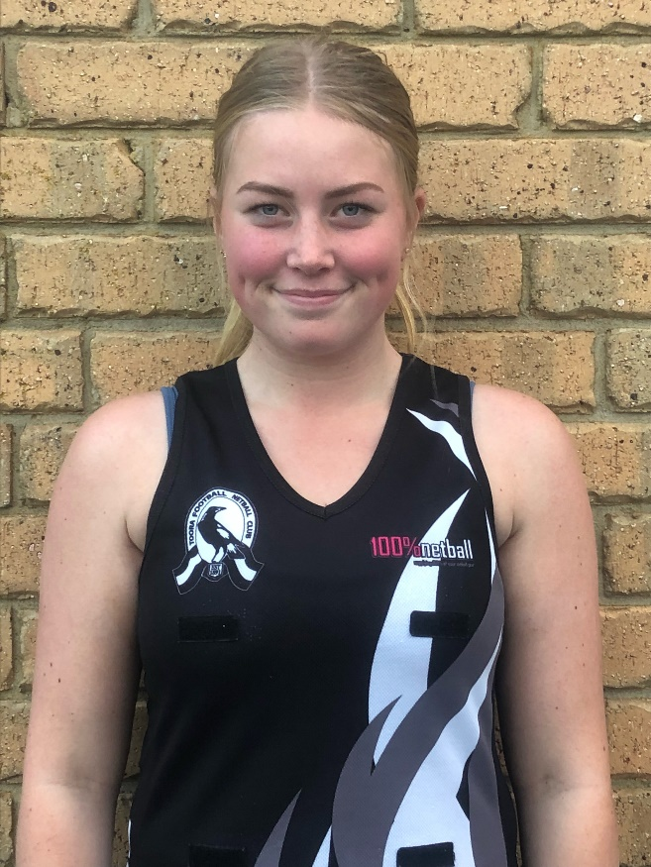
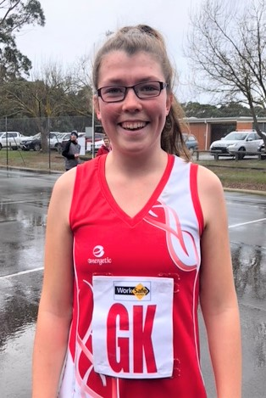
Stephanie is a talented young Toora netball player and has gone from strength to strength in her playing career.

Accolades so far are:
2017 – 15&Under club Best & Fairest
2017 – 15&Under league Best & Fairest
runner-up
2017 – 15&Under Alberton FNL
representative team

JULY
STEPHANIE CRAWFORD
Toora
Lauren is a Fish Creek up and coming star, making the nomination very fair and well deserved. Lauren has played all her junior netball at Fish Creek Football Netball Club and is now a crucial member of the Fish Creek Football Netball Club A grade side.

She began playing senior netball at the ripe old age of 14 and this is clearly evident when watching her skill in the junior ranks, as it’s well beyond her years. Lauren dominates either end of the court in U17’s and A grade. She has been known to slip into the mid court making it look like she has played there for years. Her versatility, carefree attitude and willingness to learn has enabled her to achieve so many fantastic accomplishments thus far in her netball career – League B&F, Premiership player/Captain, Diamonds pathway member, Eastern Zone Academy Squad Member just to name a few.

Lauren remains a very valued member of the Fish Creek Football Netball Club where we endeavour to further develop her netball career and watch her rise into the star that she is.

JUNE
LAUREN GALE
Fish Creek
TEAM OF THE YEAR
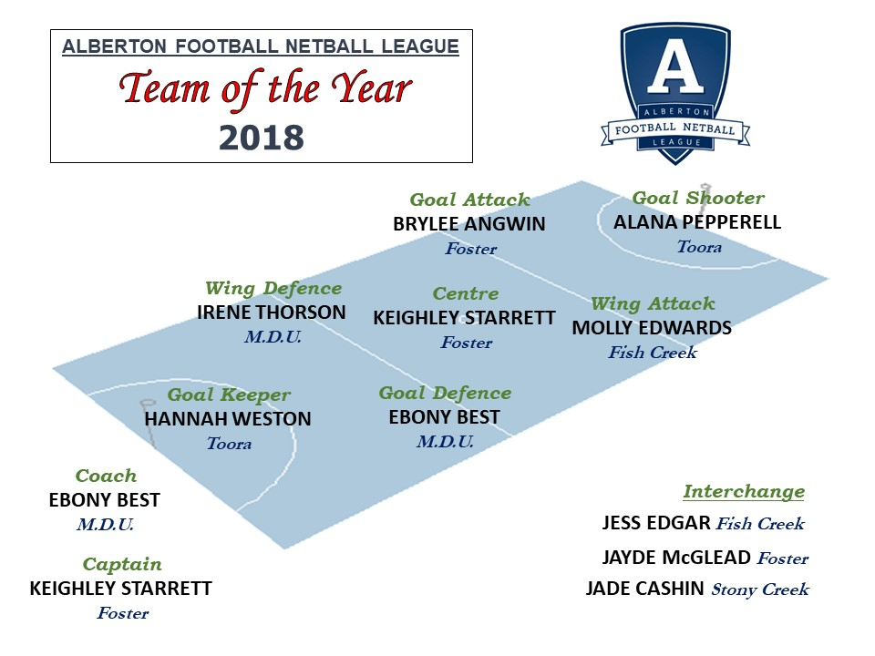
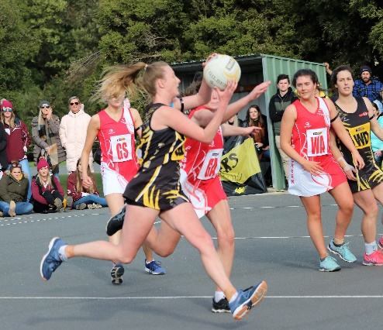
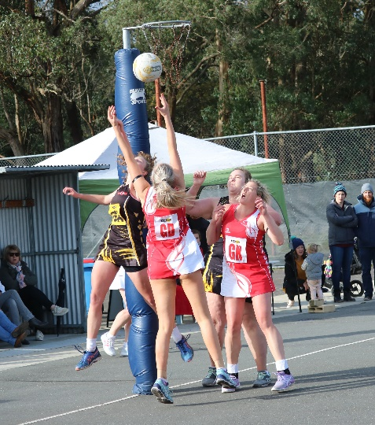
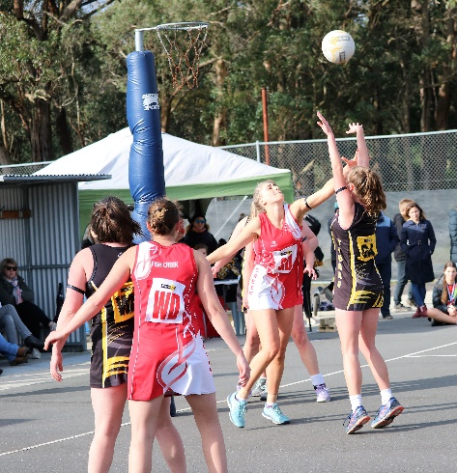
2018 FINAL LADDERS
Alberton Football Netball League - A Grade
RANK | TEAM | P | W | L | D | B | F | A | Pts | %
1 | M.D.U. | 16 | 13 | 2 | 1 | 1 | 928 | 499 | 54 | 185.97
2 | Fish Creek | 16 | 10 | 4 | 2 | 0 | 871 | 581 | 44 | 149.91
3 | Foster | 16 | 9 | 4 | 3 | 0 | 733 | 513 | 42 | 142.88
4 | Toora | 16 | 9 | 7 | 0 | 0 | 697 | 548 | 36 | 127.19
5 | Stony Creek | 16 | 4 | 12 | 0 | 0 | 559 | 844 | 16 | 66.23
6 | Tarwin | 16 | 0 | 16 | 0 | 1 | 357 | 1160 | 0 | 30.78

Alberton Football Netball League - B Grade
RANK | TEAM | P | W | L | D | F | A | Pts | %
1 | Toora | 16 | 16 | 0 | 0 | 853 | 353 | 64 | 241.64
2 | M.D.U. | 16 | 13 | 3 | 0 | 874 | 456 | 52 | 191.67
3 | Fish Creek | 16 | 10 | 6 | 0 | 717 | 547 | 40 | 131.08
4 | Foster | 16 | 6 | 10 | 0 | 599 | 657 | 24 | 91.17
5 | Stony Creek | 16 | 2 | 14 | 0 | 448 | 886 | 8 | 50.56
6 | Tarwin | 16 | 1 | 15 | 0 | 390 | 982 | 4 | 39.71

Alberton Football Netball League - C Grade
RANK | TEAM | P | W | L | D | F | A | Pts | %
1 | Fish Creek | 16 | 15 | 1 | 0 | 583 | 334 | 60 | 174.55
2 | M.D.U. | 16 | 14 | 2 | 0 | 660 | 405 | 56 | 162.96
3 | Toora | 16 | 9 | 7 | 0 | 485 | 467 | 36 | 103.85
4 | Tarwin | 16 | 5 | 11 | 0 | 399 | 559 | 20 | 71.38
5 | Stony Creek | 16 | 4 | 12 | 0 | 393 | 502 | 16 | 78.29
6 | Foster | 16 | 1 | 15 | 0 | 293 | 546 | 4 | 53.66

FINAL LADDERS (Cont’d)

Alberton Football Netball League - 17&Under
RANK | TEAM | P | W | L | D | F | A | Pts | %
1 | M.D.U. | 16 | 15 | 1 | 0 | 710 | 307 | 60 | 231.27
2 | Fish Creek | 16 | 12 | 4 | 0 | 562 | 346 | 48 | 162.43
3 | Foster | 16 | 11 | 5 | 0 | 619 | 402 | 44 | 153.98
4 | Stony Creek | 16 | 5 | 11 | 0 | 279 | 523 | 20 | 53.35
5 | Toora | 16 | 3 | 13 | 0 | 260 | 543 | 12 | 47.88
6 | Tarwin | 16 | 2 | 14 | 0 | 299 | 608 | 8 | 49.18

Alberton Football Netball League - 15&Under
RANK | TEAM | P | W | L | D | F | A | Pts | %
1 | Foster | 16 | 14 | 1 | 1 | 527 | 182 | 58 | 289.56
2 | Fish Creek | 16 | 11 | 5 | 0 | 412 | 284 | 44 | 145.07
3 | M.D.U. | 16 | 9 | 7 | 0 | 363 | 291 | 36 | 124.74
4 | Tarwin | 16 | 8 | 7 | 1 | 427 | 333 | 34 | 128.23
5 | Toora | 16 | 5 | 11 | 0 | 295 | 335 | 20 | 88.06
6 | Stony Creek | 16 | 0 | 16 | 0 | 92 | 691 | 0 | 13.31

Alberton Football Netball League - 13&Under
RANK | TEAM | P | W | L | D | F | A | Pts | %
1 | M.D.U. | 16 | 13 | 1 | 2 | 504 | 110 | 56 | 458.18
2 | Foster | 16 | 12 | 2 | 2 | 429 | 126 | 52 | 340.48
3 | Toora | 16 | 11 | 5 | 0 | 309 | 233 | 44 | 132.62
4 | Fish Creek | 16 | 6 | 9 | 1 | 262 | 386 | 26 | 67.88
5 | Stony Creek | 16 | 2 | 14 | 0 | 125 | 435 | 8 | 28.74
6 | Tarwin | 16 | 1 | 14 | 1 | 120 | 459 | 6 | 26.14

FINALS SERIES

SEMI FINAL @ Meeniyan
A GRADE: Fish Creek 45 d M.D.U. 28
B GRADE: Toora 40 d by M.D.U. 27
C GRADE: Fish Creek 46 d M.D.U. 38
17&UNDER: M.D.U. 33 d Fish Creek 13
15&UNDER: Foster 23 d Fish Creek 18
13&UNDER: Foster 19 d M.D.U. 18

ELIMINATION FINAL @ Stony Creek
A GRADE: Foster 48 d Toora 27
B GRADE: Fish Creek 40 d Foster 26
C GRADE: Toora 28 d Tarwin 16
17&UNDER: Foster 39 d Stony Creek 11
15&UNDER: M.D.U. 18 d Tarwin 13
13&UNDER: Fish Creek 17 d Toora 13

PRELIMINARY FINAL @ Tarwin
A GRADE: Foster 43 d M.D.U. 31
B GRADE: Fish Creek 43 d M.D.U. 35
C GRADE: M.D.U. 41 d Toora 24
17&UNDER: Foster 30 d Fish Creek 26
15&UNDER: M.D.U. 30 d Fish Creek 22
13&UNDER: M.D.U. 41 d Fish Creek 17

GRAND FINAL @ Meeniyan
A GRADE: Foster 35 d Fish Creek 29
B GRADE: Toora 36 d Fish Creek 32
C GRADE: M.D.U. 34 d Fish Creek 29
17&UNDER: M.D.U. 35 d Foster 23
15&UNDER: Foster 26 d M.D.U. 16
13&UNDER: Foster 15 d M.D.U. 13


PREMIERS PHOTOS

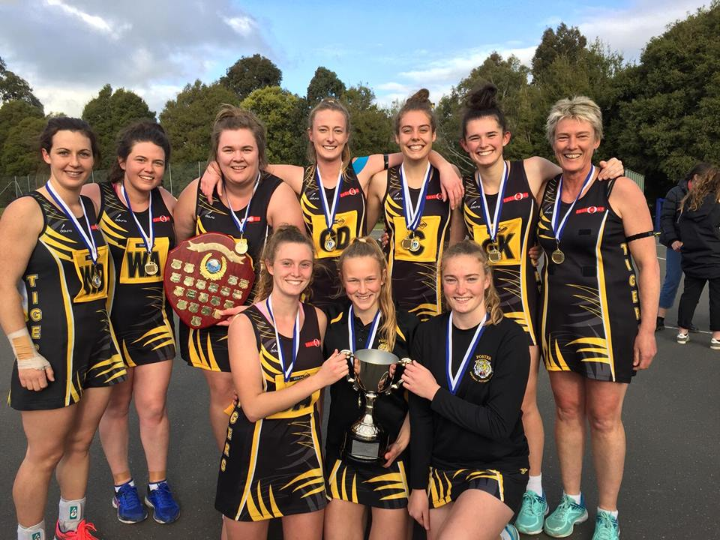
A GRADE PREMIERS – FOSTER
Best on Court – KEIGHLEY STARRETT (Foster)

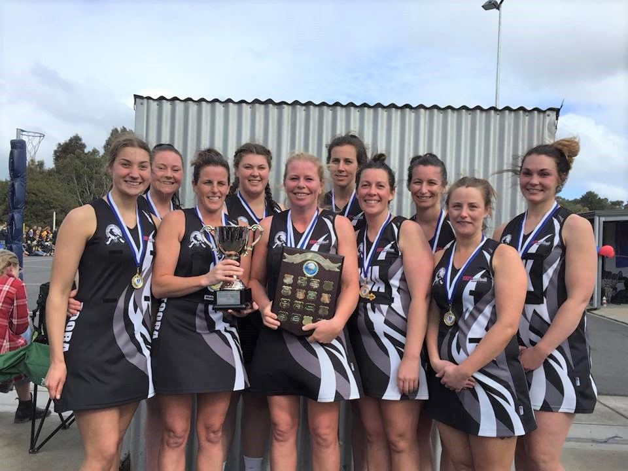
B GRADE PREMIERS – TOORA
Best on Court – BELINDA CRAWFORD (Toora)
PREMIERS PHOTOS (Cont’d)

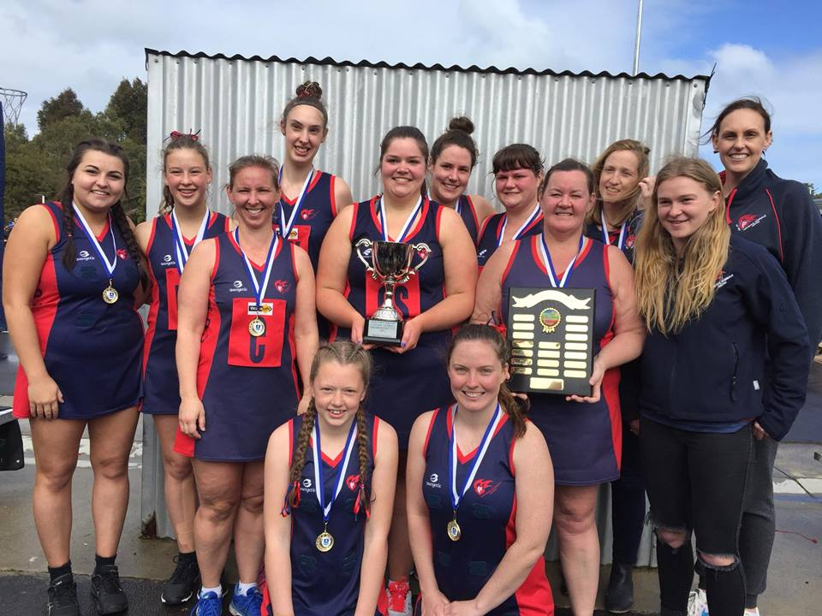
C GRADE PREMIERS – M.D.U.
Best on Court – LAUREN WIGHTMAN (M.D.U.)

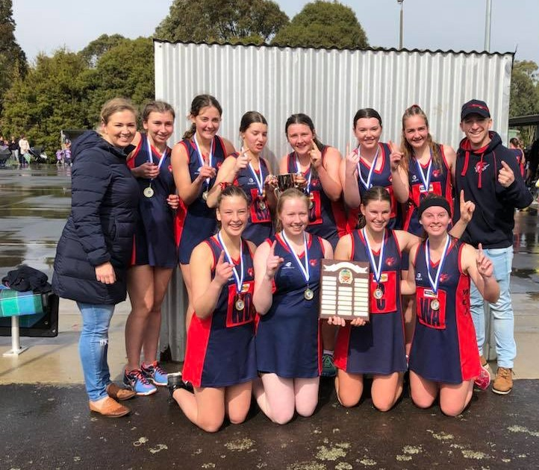
17&UNDER PREMIERS – M.D.U.
Best on Court – KASEY THORSON (M.D.U.)

PREMIERS PHOTOS (Cont’d)

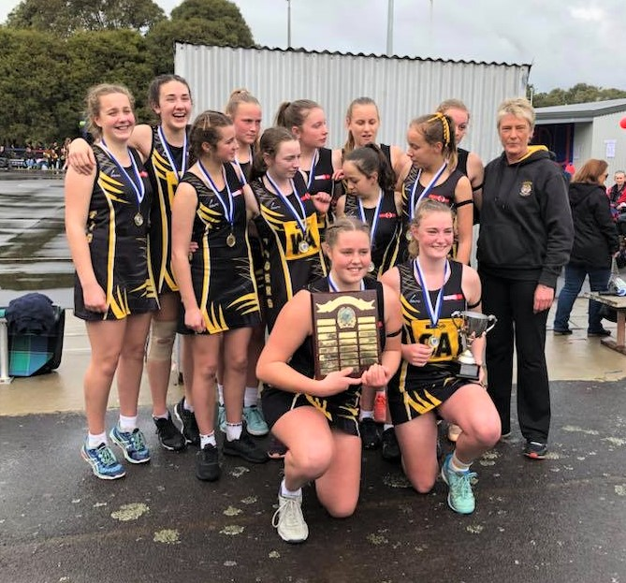
15&UNDER PREMIERS – FOSTER
Best on Court – BELLE GRABHAM ANDREWS (M.D.U.)

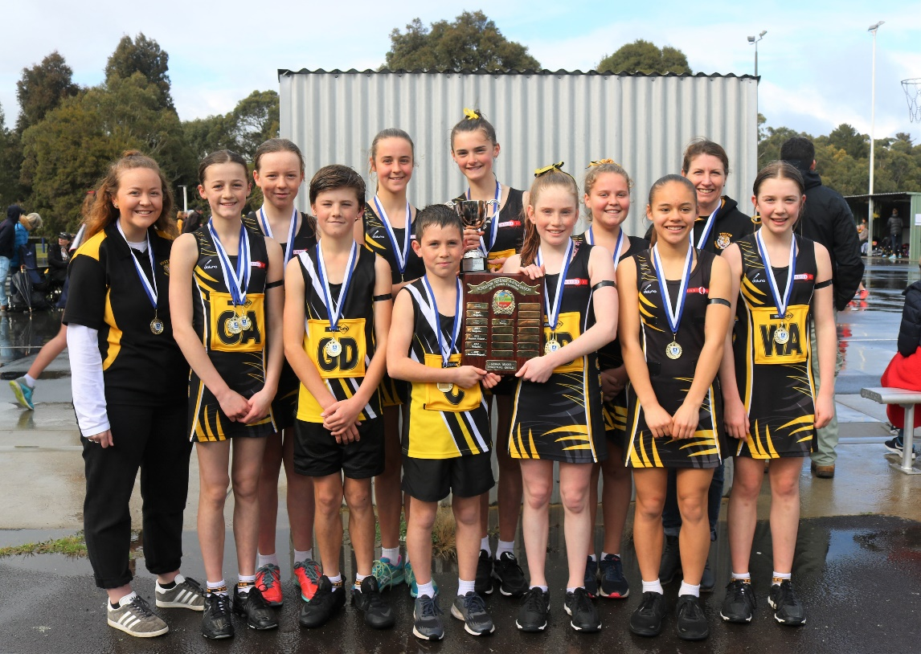
13&UNDER PREMIERS – FOSTER
Best on Court – MEG RATHJEN (Foster)

VOTE COUNT

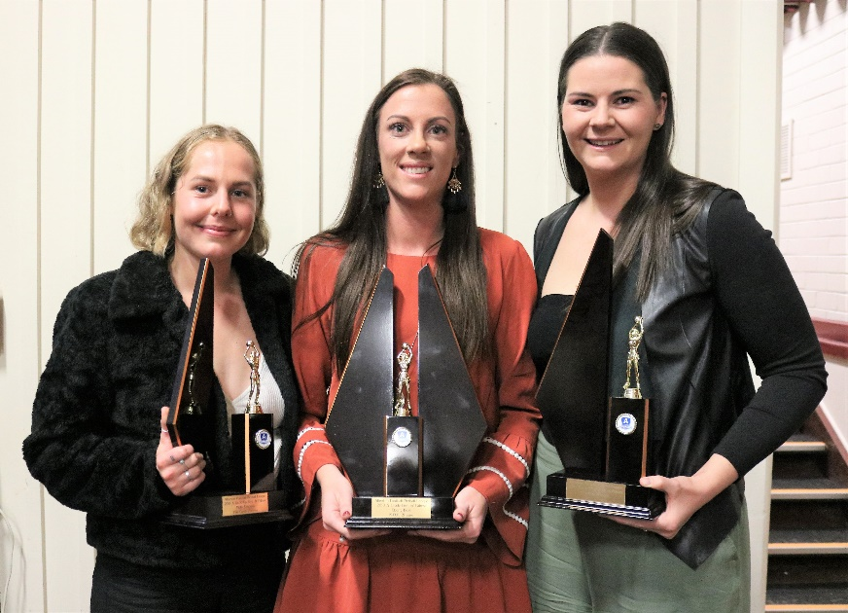
A GRADE Best & Fairest Equal Runner Up – MOLLY EDWARDS (Fish Creek),
B&F Winner EBONY BEST (M.D.U.) & Equal Runner Up – HANNAH WESTON (Toora)

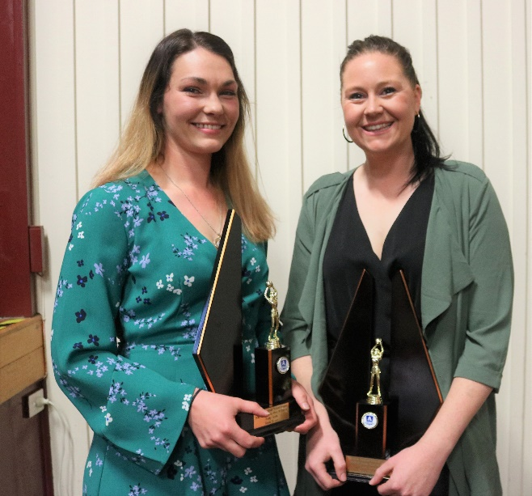
B GRADE Best & Fairest Runner Up – EMILY GRYLLS (Toora)
& Best & Fairest Winner – CARLA JENKINS (Toora)

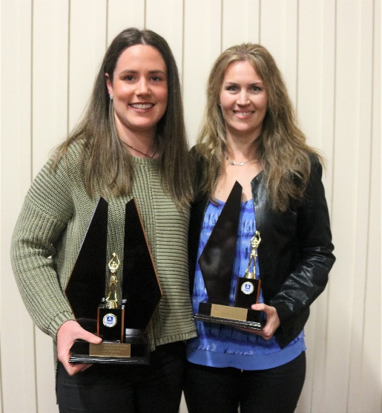
C GRADE Best & Fairest Winner – LAUREN WIGHTMAN (M.D.U.)
& Runner Up – MARIANNE BLOYE (Tarwin)
VOTE COUNT (Cont’d)

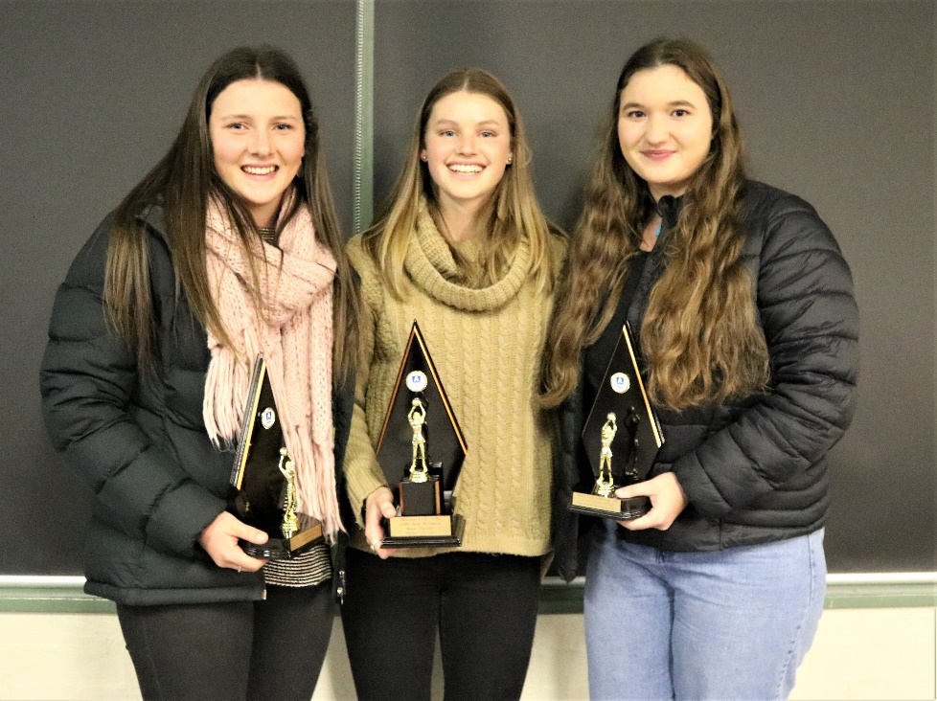
17&UNDER Best & Fairest Equal Runner Up – KASEY THORSON (M.D.U.),
Winner – IRENE THORSON (M.D.U.) & Equal Runner Up – ELLA SCHAUBLE (Fish Creek)

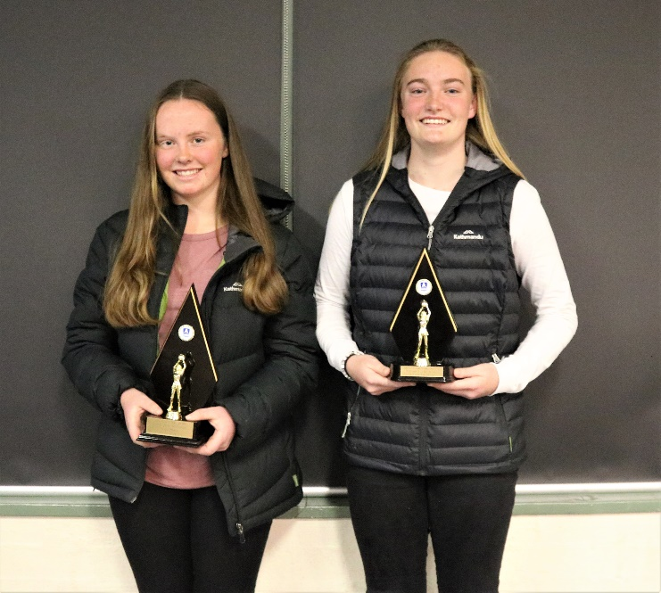
15&UNDER Best & Fairest Winner – SHARLI HAMS (Fish Creek)
& Runner Up – TYLA ANGWIN (Foster)

