 |  | 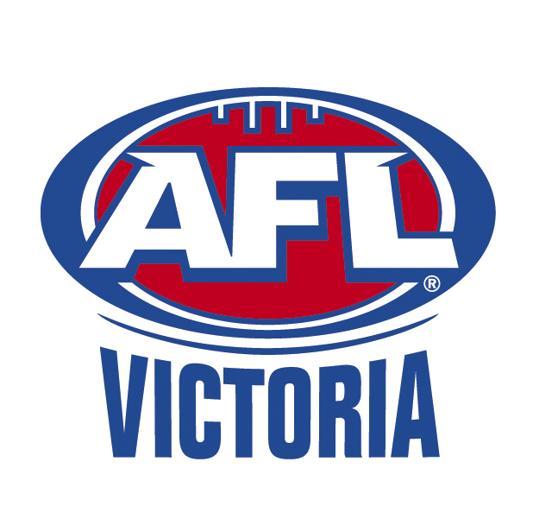
To: | 2018 U16 Patton Squad Players, Parents & Officials
From: | Marc D’Cruze (Football Admin)
Date: | Monday, 12 February 2018
Subject: | Memo (4) 2018 U16 Patton Squad Training Arrangements

Training Dates:
4 | 12 | February | Monday |  | Kilsyth Recreation Reserve | 5.00pm
5 | 14 | February | Wednesday |  | Kilsyth Recreation Reserve | 5.00pm
 | 17 | February | Saturday |  | Practice Match 1 Vs Calder RAMS | 10am
 | 19 | February | Monday |  | U16 Phase 2 List Announced | 10am
6 | 19 | February | Monday |  | Kilsyth Recreation Reserve | 5.00pm
7 | 21 | February | Wednesday |  | Kilsyth Recreation Reserve | 5.00pm
8 | 26 | February | Monday |  | Kilsyth Recreation Reserve | 5.00pm
9 | 28 | February | Wednesday |  | Kilsyth Recreation Reserve | 5.00pm
 | 4 | March | Sunday |  | Practice Match 2 Vs Gippsland @ Garfield | 10am

Practice Match v Calder Cannons

Date: Saturday 17th February 2018
Venue: RAMS Arena (Highgate Recreation Reserve) - Grand Blvd, Craigieburn VIC 3064
Time: 10:00AM
Players & staff to arrive at 8.30AM
Uniform: Jumper to be provided on the day
WHITE Shorts and any dark coloured football socks.
Notes: Anyone who is injured and unable to play in these games is still expected to attend to assist with running water & goal umpiring for the game.

U16 Patton Squad Phase 2 Announcement
Players invited back to U16 Patton Squad Phase 2 will be displayed on the Eastern Ranges website at 10am Monday 19 February: www.easternranges.aflvic.com.au. Only players that are selected will be required to continue attending training on Monday and Wednesday nights beginning the same day Monday 19 Feb.

U16 Metropolitan Carnival
Players selected in the final U16 Patton Squad will be required for 2 U16 Metro Carnival games:
- Wednesday 4 April, 12pm at Avalon Airport Oval Werribee
- Tuesday 10 April, 2pm at RAMS Arena Craigieburn
If you cannot attend either of these games, please notify Marc D’Cruze ASAP.

Talent Manager Position
Sean Toohey has been appointed to the role of Talent Manager. He will begin in this role from 26 February. Until this time please communicate with Marc D’Cruze. Phone 0434501998. Email marc.dcruze@afl.com.au.
Please continue to send information such as players missing training by text or email etc.

U16 Patton Squad Training Levies:
A reminder that the Under 16 Patton Squad Training Levies are now OVERDUE. If there are any problems please contact Alf Pennington on 9724 9499 or see Marc about Sponsorship.

Training Requirements:
All players are responsible for bringing their drink bottle along that is adequate for the session, mouthguard, boots, runners and swimming gear to ensure they are organised for any type of session. ONLY Eastern Ranges issued apparel is to be worn for training sessions.

Rehab:
This time of the year often reveals a number of minor injury complaints that need to be treated quickly and effectively. All players should ensure they take responsibility for their bodies by seeking the advice and attention of the medical team for ANY injuries or complaints, no matter how small! Players are then responsible for completing their rehabilitation in conjunction and under the guidance of the Ranges medical team. This includes being prepared for a pool session or whatever else is required ie- money, towel, clean shorts, and being diligent with the program set for them. You are expected to train harder than the main group if you are in the rehab group.

Security:
Please ensure that nothing of value is left in bags during training, especially with training at different venues and sometimes sharing with other community groups.

Yours sincerely,

Marc D’Cruze
AFL Victoria
Football Administration – Eastern Ranges FC

