

ALBERTON FOOTBALL
NETBALL LEAGUE

NETBALL YEARBOOK

2017 SEASON

BOARD OF MANAGEMENT
President – Barry Stride
Vice President & Director of Netball – Leonnie McCluskey
Director of Football – Neil Park
Director of Special Events – Dean Cashin
Director of Finance & Sponsorship – Ralph Hubbert
League Coordinator/Treasurer – Lynn Whelan

SPECIAL ASSISTANTS
Amanda Calder
Natasha McRae

ASSOCATION CHAMPIONSHIPS

The 2017 Association Championships were held in Traralgon on the 28th May 2017. Selection for teams took place at M.D.U. with Alberton FNL entering Under 13s, 15s & 17s teams. Thank you to coaches, team managers, umpires, parents & players for their huge efforts towards these championships which produced great results and showcased the many talented players within our league.

FINAL CHAMPIONSHIP LADDERS

Netball Victoria – Eastern 13&U Championship
RAN | TEAM | P | W | L | D | F | A | Pts | %
1 | Sale NA | 7 | 7 | 0 | 0 | 97 | 28 | 28 | 346.43
2 | Gippsland FNL | 7 | 5 | 1 | 1 | 86 | 43 | 22 | 200.00
3 | Bairnsdale NA | 7 | 4 | 2 | 1 | 63 | 49 | 18 | 128.57
4 | Alberton NA | 7 | 4 | 2 | 1 | 58 | 57 | 18 | 101.75
5 | Ellinbank & District NA | 7 | 2 | 4 | 1 | 51 | 74 | 10 | 68.92
6 | West Gippsland FNL | 7 | 2 | 5 | 0 | 52 | 79 | 8 | 65.82
7 | Phillip Island NA | 7 | 1 | 6 | 0 | 38 | 73 | 4 | 52.05
8 | Traralgon NA | 7 | 1 | 6 | 0 | 23 | 65 | 4 | 35.38

Netball Victoria – Eastern 15&U Championship
RANK | TEAM | P | W | L | D | F | A | Pts | %
1 | Gippsland FNL | 9 | 9 | 0 | 0 | 141 | 41 | 36 | 343.90
2 | West Gippsland FNL | 9 | 8 | 1 | 0 | 103 | 57 | 32 | 180.70
3 | Bairnsdale NA | 9 | 7 | 2 | 0 | 106 | 52 | 28 | 203.85
4 | Mid Gippsland NA | 9 | 5 | 3 | 1 | 81 | 57 | 22 | 142.11
5 | Sale NA White | 9 | 5 | 4 | 0 | 72 | 78 | 20 | 92.31
6 | Ellinbank & District NA | 9 | 4 | 5 | 0 | 60 | 87 | 16 | 68.97
7 | North Gippsland FNL | 9 | 3 | 6 | 0 | 62 | 80 | 12 | 77.50
8 | Sale NA Black | 9 | 1 | 6 | 2 | 48 | 82 | 8 | 58.54
9 | Traralgon NA | 9 | 1 | 8 | 0 | 35 | 113 | 4 | 30.97
10 | Alberton NA | 9 | 0 | 8 | 1 | 40 | 101 | 2 | 39.60

Netball Victoria – Eastern 17&U Championship
RANK | TEAM | P | W | L | D | F | A | B | Pts | %
1 | Gippsland FNL Blue | 8 | 8 | 0 | 0 | 104 | 37 | 1 | 32 | 281.08
2 | Alberton NA | 8 | 7 | 1 | 0 | 108 | 55 | 1 | 28 | 196.36
3 | Sale NA | 8 | 6 | 2 | 0 | 83 | 75 | 1 | 24 | 110.67
4 | West Gippsland FNL | 8 | 5 | 3 | 0 | 87 | 52 | 1 | 20 | 167.31
5 | North Gippsland FNL | 8 | 3 | 5 | 0 | 59 | 71 | 1 | 12 | 83.10
6 | Mid Gippsland NA | 8 | 2 | 5 | 1 | 63 | 89 | 1 | 10 | 70.79
7 | Gippsland FNL Red | 8 | 2 | 5 | 1 | 50 | 88 | 1 | 10 | 56.82
8 | Ellinbank & District NA | 8 | 1 | 6 | 1 | 56 | 103 | 1 | 6 | 54.37
9 | Bairnsdale NA | 8 | 0 | 7 | 1 | 48 | 88 | 1 | 2 | 54.55

ALBERTON FNL CHAMPIONSHIP RESULTS

13&UNDER
Round 1 – Alberton 9 d Traralgon 4
Round 2 – Alberton 12 d West Gippsland 10
Round 3 – Alberton 11 d Phillip Island 8
Round 4 – Sale 15 d Alberton 4
Round 5 – Alberton 10 d Bairnsdale 8
Round 6 – Alberton 6 drew Ellinbank 6
Round 7 – Gippsland 8 d Alberton 6
SEMI FINAL – Sale 18 d Alberton 6

15&UNDER
Round 1 – Ellinbank 11 d Alberton 5
Round 2 – West Gippsland 14 d Alberton 1
Round 3 – Bairnsdale 20 d Alberton 8
Round 4 – Traralgon 11 d Alberton 7
Round 5 – Mid Gippsland 15 d Alberton 4
Round 6 – North Gippsland 4 d Alberton 3
Round 7 – Gippsland 12 d Alberton 4
Round 8 – Sale White 7 d Alberton 5
Round 9 – Alberton 3 drew Sale Black 3
SEMI FINAL – Sale 18 d Alberton 6

17&UNDER
Round 1 – Alberton 15 d Mid Gippsland 8
Round 2 – Alberton 10 d West Gippsland 5
Round 3 – Bye
Round 4 – Gippsland Blue 14 d Alberton 10
Round 5 – Alberton 19 d Gippsland Red 3
Round 6 – Alberton 20 d Ellinbank 7
Round 7 – Alberton 11 d Sale 7
Round 8 – Alberton 11 d North Gippsland 2
Round 9 – Alberton 12 d Bairnsdale 9
SEMI FINAL – Alberton 16 d Sale 8
GRAND FINAL – Gippsland Blue 18 d Alberton 9

13&UNDER AFNL CHAMPIONSHIP TEAM
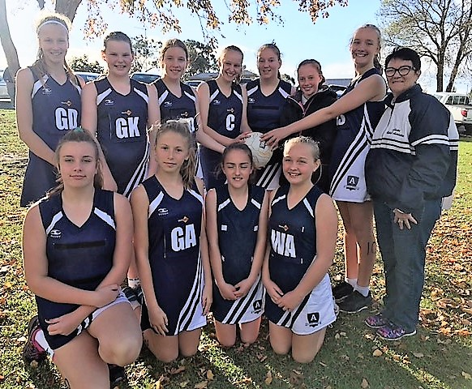

15&UNDER AFNL CHAMPIONSHIP TEAM
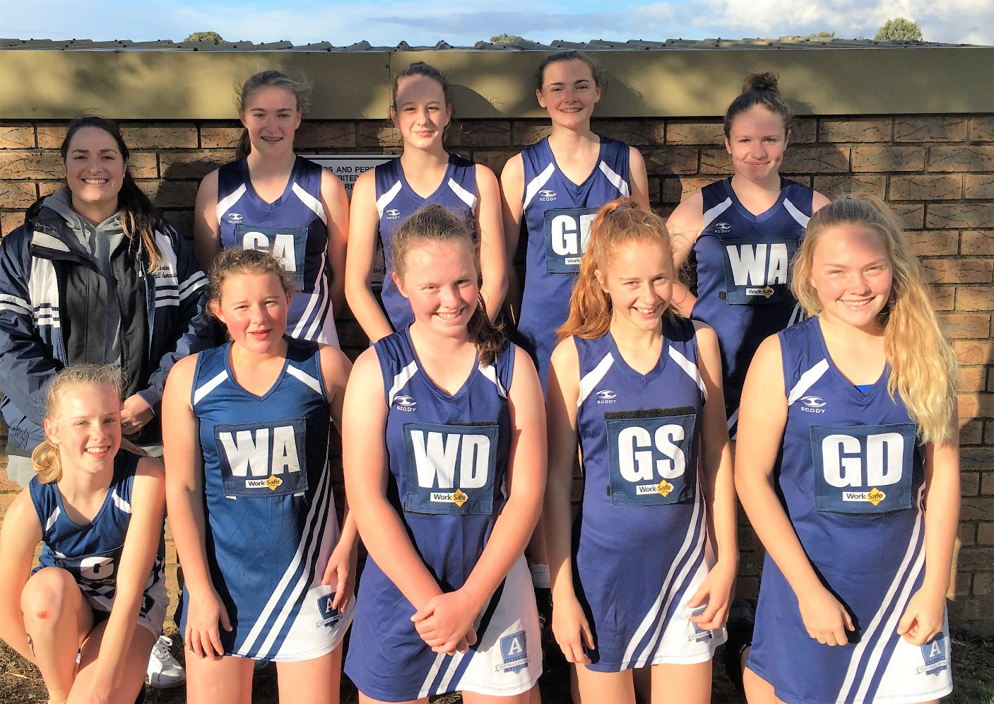

17&UNDER AFNL CHAMPIONSHIP TEAM
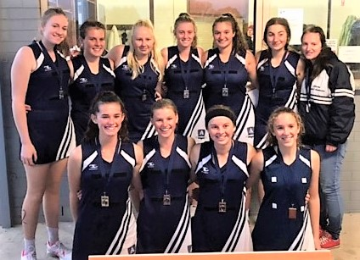

2017 RISING STARS
APRIL
TANEKA ROFFEY
Toora
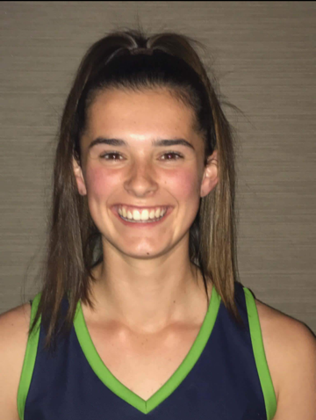
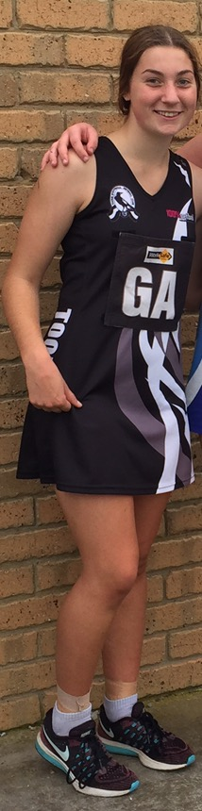
MAY
JAYDE McGLEAD
Foster
Jayde McGlead is an outstanding netballer. Her work ethic, determination and commitment to becoming the best netballer she can be shows in her achievements at such a young age. Jayde started netball when she was 10 and started playing with Foster because she enjoyed playing team sports and still loves it.

Her achievements include 3 club B&Fs, 2015 15/U Alberton FNL B&F, 2015 15/U Waverley Premiers (best on in grand final), 2016 Waverley Runners Up, 2014/15/16/17 Alberton FNL Association/Interleague, 2014/15/16 Gippsland regionals, 2016 Eastern Zone Academy, 2016 Foster NC junior club person. She has represented Southern Fusion, Foster, Gippsland Eastern Zone Academy and Alberton FNL. Her Fusion records include 2016 17/U NSW state titles side (undefeated) and 2017 captain of 17/U.

Jayde sets an excellent example for younger players with her attitude towards training and playing and demonstrates outstanding sportsmanship.
Taneka has been around netball all her childhood and always seen with a ball in her hand. She started her netball career with NetSetGo, then played circle defence for Foster in 13s.

Taneka was diagnosed at 14½ with Type 1 diabetes but this hasn’t deterred her love for the game.

Realising when she started playing for Southern Fusion Netball Club, she had a good technique goaling, Taneka then went to goaler and hasn’t looked back. She has now started playing netball for Toora to play with her friends.
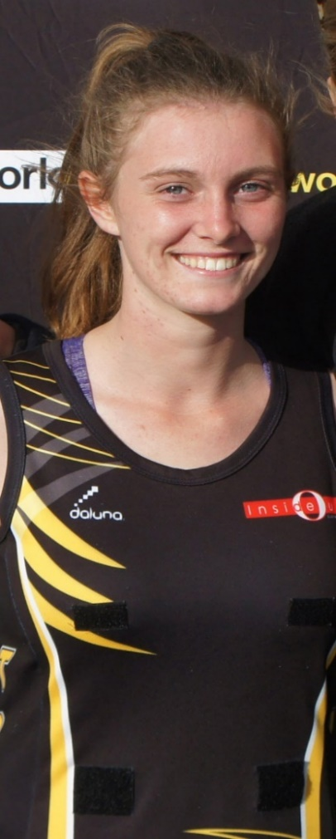
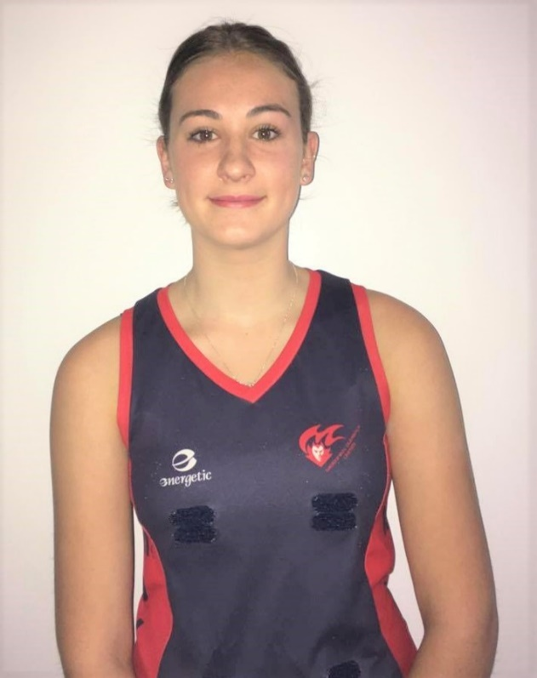
Kayla is currently playing netball for MDU Football Netball Club and doing Year 11 at Leongatha Secondary College. Kayla has played all her junior years at MDU and is currently playing U17s and A Grade. In U17s she mainly plays GD and in A grade in WD. She has also played netball for Gippsland Storm in 2014 and 2015 at Waverly Netball Centre. She played in a Premiership side in Autumn 2015 and a Runner Up side in Spring season 2015. She also played as a fill-in for Southern Fusion in 2016 for a few games throughout the year.

In 2012 Kayla won Runner Up Best & Fairest for U13s. In 2014, 2015 and 2016 she won Best & Fairest and in 2015 she also won Best in Finals in 2015 for MDU Netball Club. In 2014 and 2015 she was Runner Up Best & Fairest for U15s for the Alberton League.

Kayla has represented the Alberton League at Association Championships for U13s, U15s, U15s & U17s and also represented the Gippsland Region at State Titles for 15s & 17s.
JULY
BRYLEE ANGWIN
Foster
Kayla is currently playing netball for MDU Football Netball Club and doing Year 11 at Leongatha Secondary College. Kayla has played all her junior years at MDU and is currently playing U17s and A Grade. In U17s she mainly plays GD and in A grade in WD. She has also played netball for Gippsland Storm in 2014 and 2015 at Waverly Netball Centre. She played in a Premiership side in Autumn 2015 and a Runner Up side in Spring season 2015. She also played as a fill-in for Southern Fusion in 2016 for a few games throughout the year.

In 2012 Kayla won Runner Up Best & Fairest for U13s. In 2014, 2015 and 2016 she won Best & Fairest and in 2015 she also won Best in Finals in 2015 for MDU Netball Club. In 2014 and 2015 she was Runner Up Best & Fairest for U15s for the Alberton League.

Kayla has represented the Alberton League at Association Championships for U13s, U15s, U15s & U17s and also represented the Gippsland Region at State Titles for 15s & 17s.

JUNE
KAYLA REDPATH
M.D.U.
2017 RISING STAR WINNER

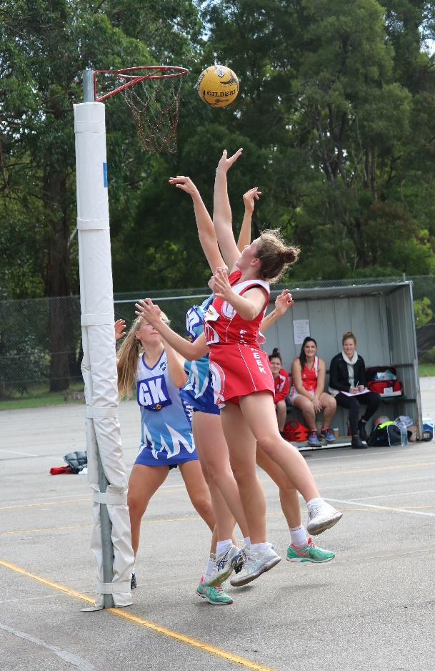
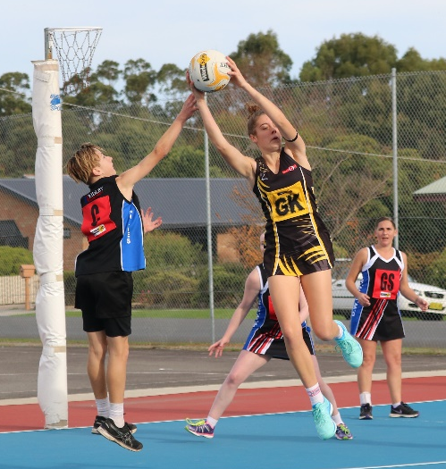
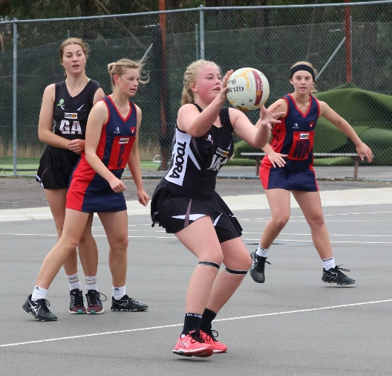
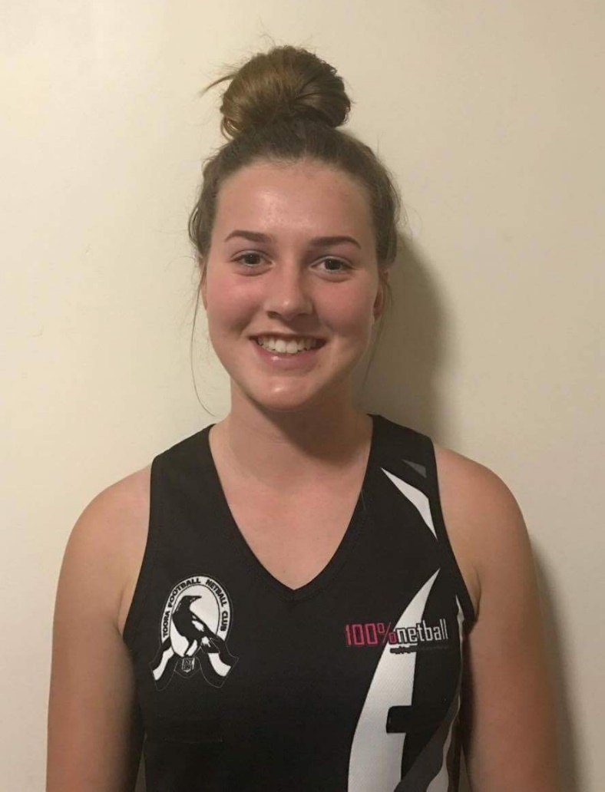
AUGUST
MADISON ROBERTS
Toora
Madison started playing netball when she was 9 years old and has played at three different clubs, having now been at Toora for three years. She has been Club B&F in U13, R-up in U15 twice and league R-up in U15 in 2016.

She played GD in younger years, then went through a stage and played C, she has returned to goals in the past few years, now plays a mix of GD and GA/GS, wherever she gets put. Maddie's netball goal would be just to win a premiership in the next year or so; she just enjoys playing netball to socialise and keep fit.
TEAM OF THE YEAR

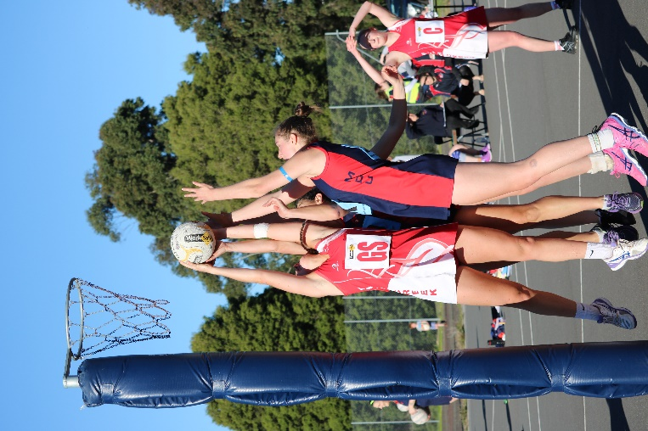
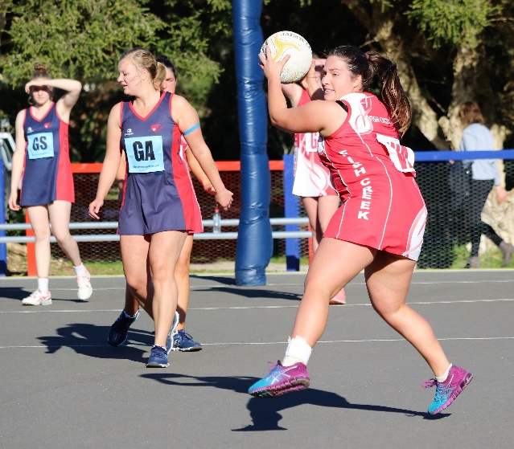
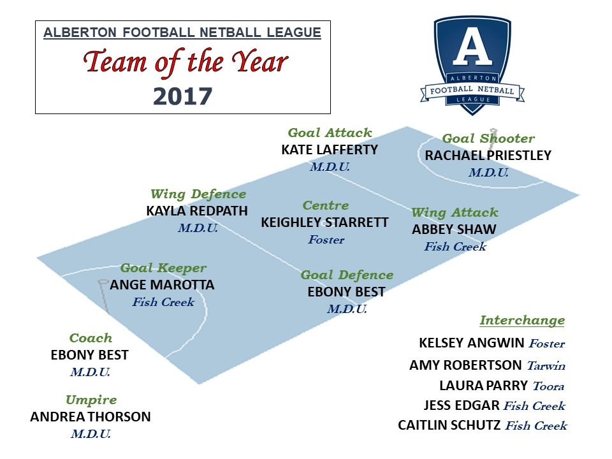
2017 FINAL LADDERS
Alberton Football Netball League - A Grade
RANK | TEAM | P | W | L | D | B | F | A | Pts | %
1 | M.D.U. | 18 | 16 | 1 | 1 | 3 | 1253 | 452 | 66 | 277.21
2 | Fish Creek | 18 | 15 | 2 | 1 | 3 | 1011 | 572 | 62 | 176.75
3 | Foster | 18 | 13 | 5 | 0 | 3 | 903 | 561 | 52 | 160.96
4 | Tarwin | 18 | 6 | 12 | 0 | 3 | 802 | 713 | 24 | 112.48
5 | Stony Creek | 18 | 6 | 12 | 0 | 3 | 797 | 793 | 24 | 100.50
6 | Toora | 18 | 6 | 12 | 0 | 3 | 685 | 734 | 24 | 93.32
7 | DWWWW | 18 | 0 | 18 | 0 | 3 | 158 | 1784 | 0 | 8.86

Alberton Football Netball League - B Grade
RANK | TEAM | P | W | L | D | B | F | A | Pts | %
1 | Toora | 18 | 17 | 0 | 1 | 3 | 1116 | 515 | 70 | 216.70
2 | M.D.U. | 18 | 13 | 3 | 2 | 3 | 1026 | 587 | 56 | 174.79
3 | Fish Creek | 18 | 12 | 6 | 0 | 3 | 955 | 589 | 48 | 162.14
4 | Foster | 18 | 10 | 7 | 1 | 3 | 982 | 745 | 42 | 131.81
5 | Stony Creek | 18 | 4 | 13 | 1 | 3 | 665 | 1028 | 18 | 64.69
6 | Tarwin | 18 | 3 | 14 | 1 | 3 | 749 | 983 | 14 | 76.20
7 | DWWWW | 18 | 1 | 17 | 0 | 3 | 276 | 1322 | 4 | 20.88

Alberton Football Netball League - C Grade
RANK | TEAM | P | W | L | D | B | F | A | Pts | %
1 | M.D.U. | 18 | 18 | 0 | 0 | 3 | 1043 | 429 | 72 | 243.12
2 | Fish Creek | 18 | 14 | 4 | 0 | 3 | 779 | 424 | 56 | 183.73
3 | Toora | 18 | 10 | 8 | 0 | 3 | 646 | 524 | 40 | 123.28
4 | Foster | 18 | 9 | 8 | 1 | 3 | 607 | 619 | 38 | 98.06
5 | Stony Creek | 18 | 6 | 11 | 1 | 3 | 520 | 627 | 26 | 82.93
6 | Tarwin | 18 | 5 | 13 | 0 | 3 | 565 | 644 | 20 | 87.73
7 | DWWWW | 18 | 0 | 18 | 0 | 3 | 188 | 1081 | 0 | 17.39

FINAL LADDERS (Cont’d)

Alberton Football Netball League - 17&Under
RANK | TEAM | P | W | L | D | B | F | A | Pts | %
1 | M.D.U. | 18 | 18 | 0 | 0 | 3 | 1174 | 336 | 72 | 349.40
2 | Foster | 18 | 14 | 4 | 0 | 3 | 693 | 474 | 56 | 146.20
3 | Toora | 18 | 11 | 7 | 0 | 3 | 686 | 564 | 44 | 121.63
4 | Fish Creek | 18 | 10 | 8 | 0 | 3 | 553 | 543 | 40 | 101.84
5 | Tarwin | 18 | 7 | 11 | 0 | 3 | 478 | 637 | 28 | 75.04
6 | Stony Creek | 18 | 3 | 15 | 0 | 3 | 384 | 707 | 12 | 54.31
7 | DWWWW | 18 | 0 | 18 | 0 | 3 | 207 | 914 | 0 | 22.65

Alberton Football Netball League - 15&Under
RANK | TEAM | P | W | L | D | B | F | A | Pts | %
1 | Fish Creek | 12 | 12 | 0 | 0 | 9 | 375 | 124 | 48 | 302.42
2 | Foster | 12 | 9 | 3 | 0 | 9 | 303 | 231 | 36 | 131.17
3 | Tarwin | 12 | 4 | 7 | 1 | 9 | 190 | 293 | 18 | 64.85
4 | Toora | 12 | 3 | 9 | 0 | 9 | 193 | 258 | 12 | 74.81
5 | M.D.U. | 12 | 1 | 10 | 1 | 9 | 157 | 312 | 6 | 50.32

Alberton Football Netball League - 13&Under
RANK | TEAM | P | W | L | D | B | F | A | Pts | %
1 | Foster | 18 | 16 | 1 | 1 | 3 | 580 | 188 | 66 | 308.51
2 | Tarwin | 18 | 15 | 1 | 2 | 3 | 598 | 179 | 64 | 334.08
3 | Fish Creek | 18 | 12 | 5 | 1 | 3 | 592 | 237 | 50 | 249.79
4 | Toora | 18 | 8 | 10 | 0 | 3 | 237 | 353 | 32 | 67.14
5 | M.D.U. | 18 | 5 | 13 | 0 | 3 | 207 | 465 | 20 | 44.52
6 | DWWWW | 18 | 5 | 13 | 0 | 3 | 205 | 511 | 20 | 40.12
7 | Stony Creek | 18 | 0 | 18 | 0 | 3 | 77 | 563 | 0 | 13.68

FINALS SERIES

SEMI FINAL @ Toora
A GRADE: M.D.U. 36 d Fish Creek 28
B GRADE: Toora 26 d by M.D.U. 28
C GRADE: M.D.U. 33 d Fish Creek 30
17&UNDER: M.D.U. 40 d Foster 27
15&UNDER: Fish Creek 29 d Foster 8
13&UNDER: Foster 23 d Tarwin 22

ELIMINATION FINAL @ Fish Creek
A GRADE: Foster 39 d Tarwin 33
B GRADE: Fish Creek 54 d Foster 52
C GRADE: Toora 37 d Foster 27
17&UNDER: Toora 34 d Fish Creek 27
15&UNDER: Tarwin 27 d Toora 23
13&UNDER: Fish Creek 40 d Toora 7

PRELIMINARY FINAL @ Foster
A GRADE: Fish Creek 27 d by Foster 41
B GRADE: Toora 42 d Fish Creek 27
C GRADE: Fish Creek 43 d Toora 28
17&UNDER: Foster 32 d Toora 24
15&UNDER: Foster 44 d Tarwin 22
13&UNDER: Tarwin 35 d Fish Creek 30

GRAND FINAL @ Meeniyan
A GRADE: M.D.U. 50 d Foster 34
B GRADE: M.D.U. 41 d Toora 40
C GRADE: M.D.U. 45 d Fish Creek 38
17&UNDER: M.D.U. 38 d Foster 27
15&UNDER: Fish Creek 33 d Foster 24
13&UNDER: Foster 23 d Tarwin 16


PREMIERS PHOTOS

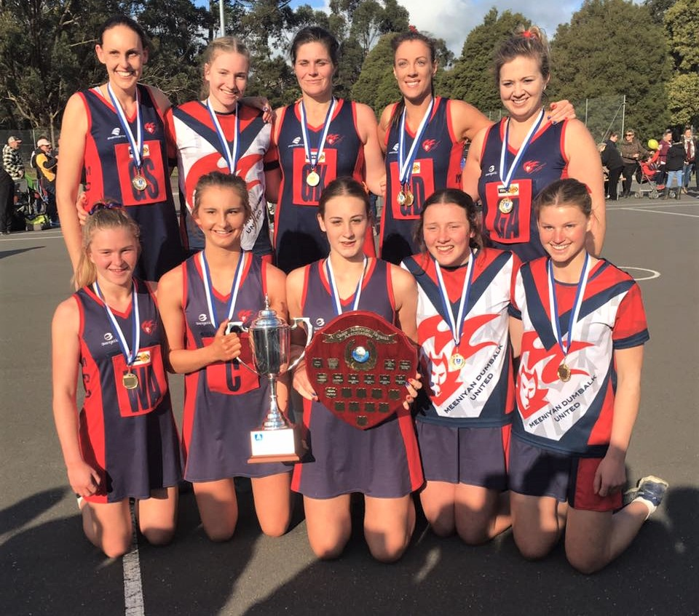
A GRADE PREMIERS – M.D.U.
Best on Court – EBONY BEST (M.D.U.)

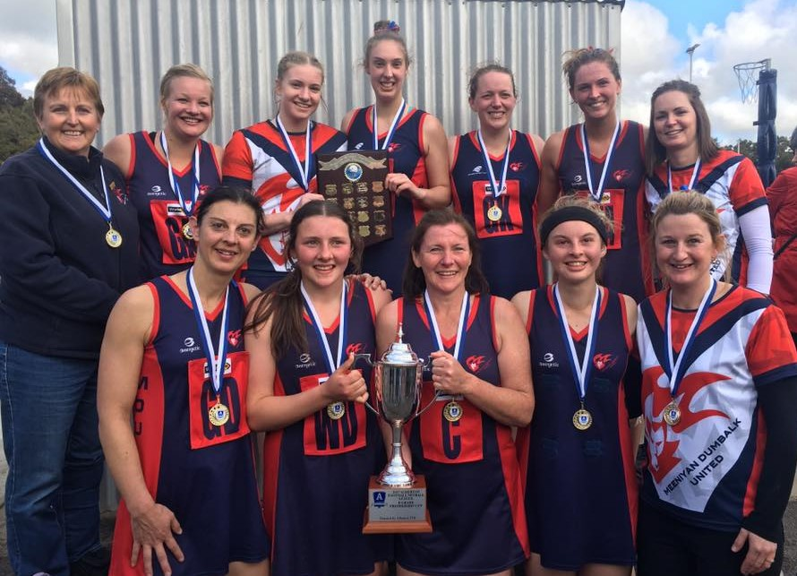
B GRADE PREMIERS – M.D.U.
Best on Court – SOPHIE TARATUTA (M.D.U.)

PREMIERS PHOTOS (Cont’d)

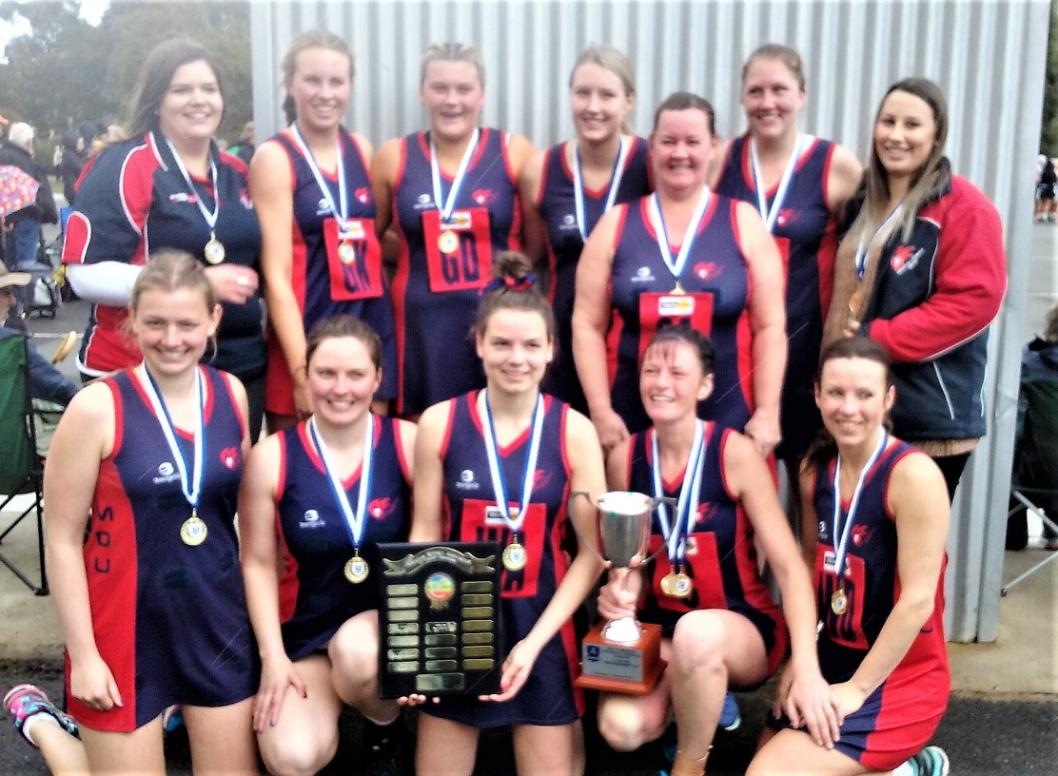
C GRADE PREMIERS – M.D.U.
Best on Court – JANE HARRISON (M.D.U.)

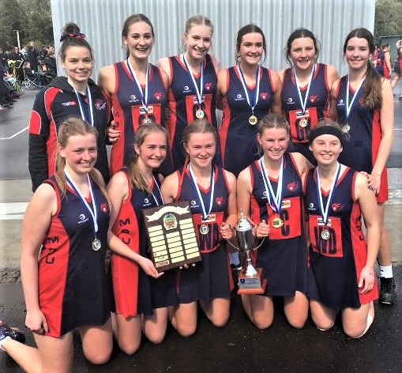
17&UNDER PREMIERS – M.D.U.
Best on Court – IRENE THORSON (M.D.U.

PREMIERS PHOTOS (Cont’d)

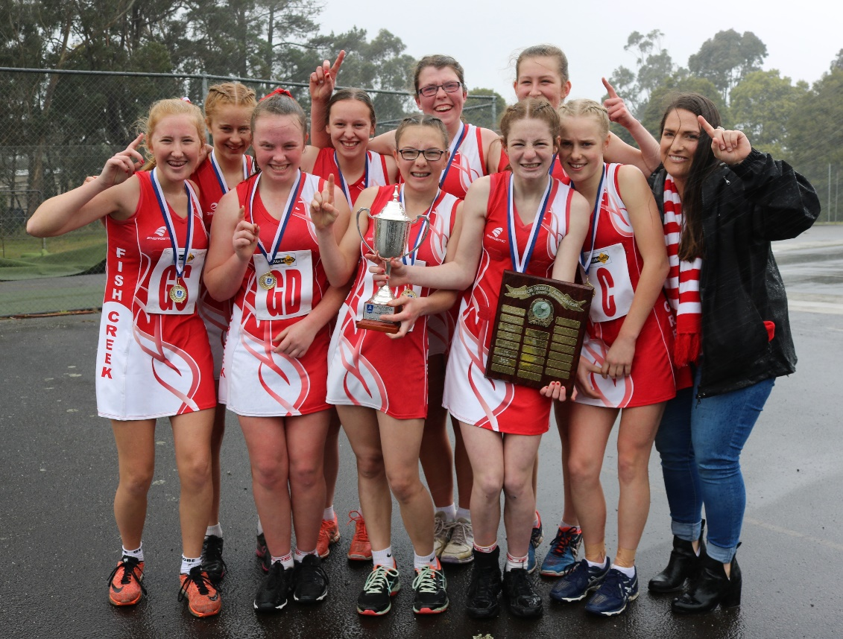
15&UNDER PREMIERS – FISH CREEK
Best on Court – LAUREN GALE (Fish Creek)

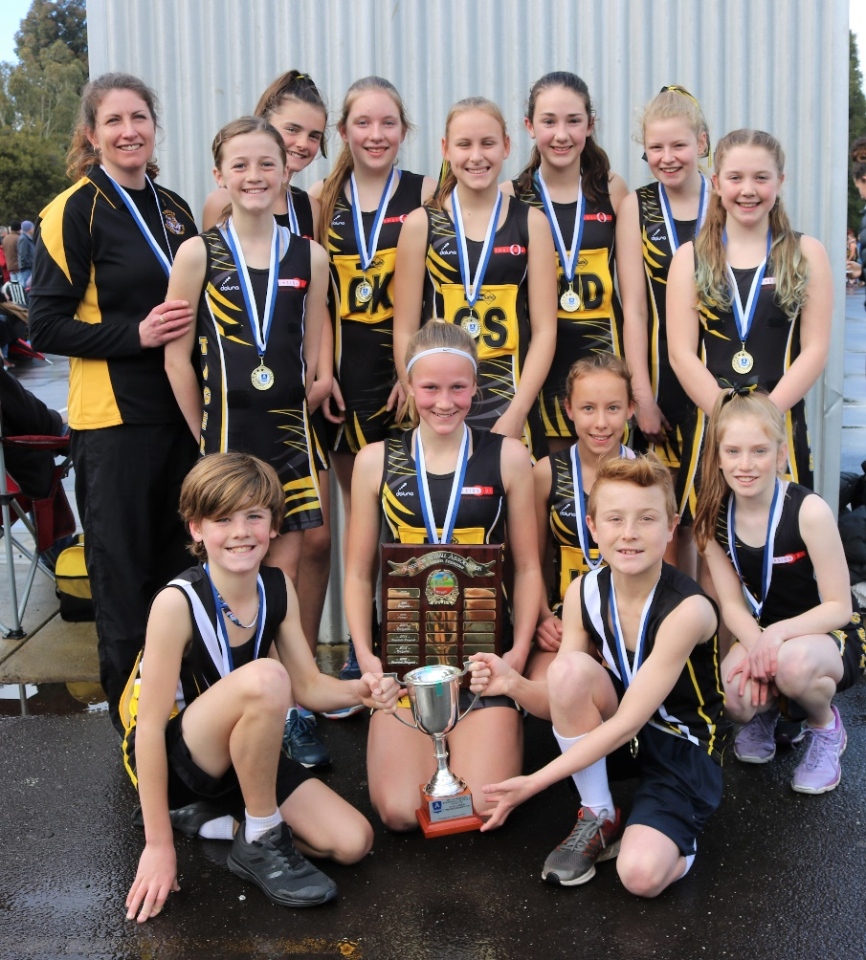
13&UNDER PREMIERS – FOSTER
Best on Court – MACEY McGLEAD (Foster)
VOTE COUNT


A GRADE Best & Fairest Runner Up – EBONY BEST (M.D.U.)
and Best & Fairest Winner – ABBEY SHAW (Fish Creek)

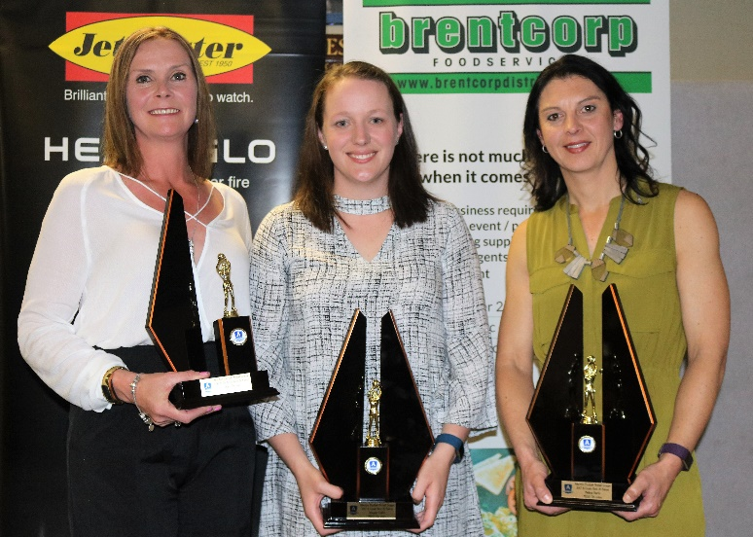
B GRADE Best & Fairest Runner Up – HELEN NICHOLLS (Toora)
& Equal Best & Fairest Winners – AMANDA CALDER (M.D.U.) & MELISSA HARRIS (M.D.U.)

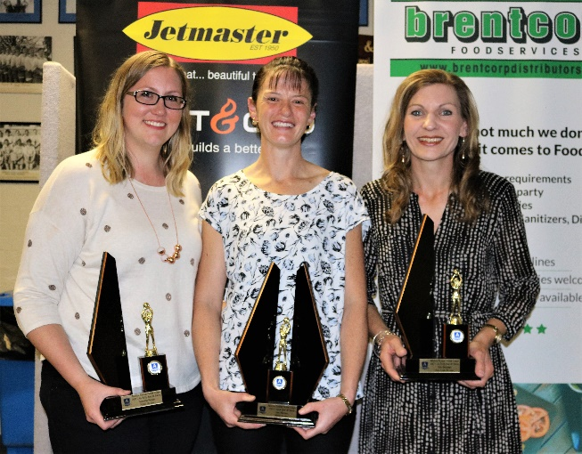
C GRADE Best & Fairest Equal Runner Up – SAMANTHA RAYSON (M.D.U.),
Best & Fairest Winner – JANE HARRISON (M.D.U.)
& Equal Runner Up – KYM BERRYMAN (Fish Creek)

VOTE COUNT (Cont’d)

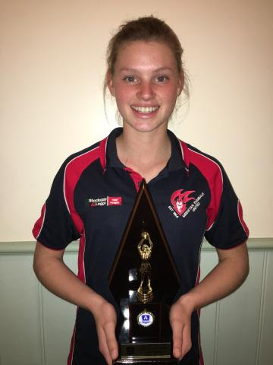
17&UNDER Best & Fairest Winner – IRENE THORSON (M.D.U.)

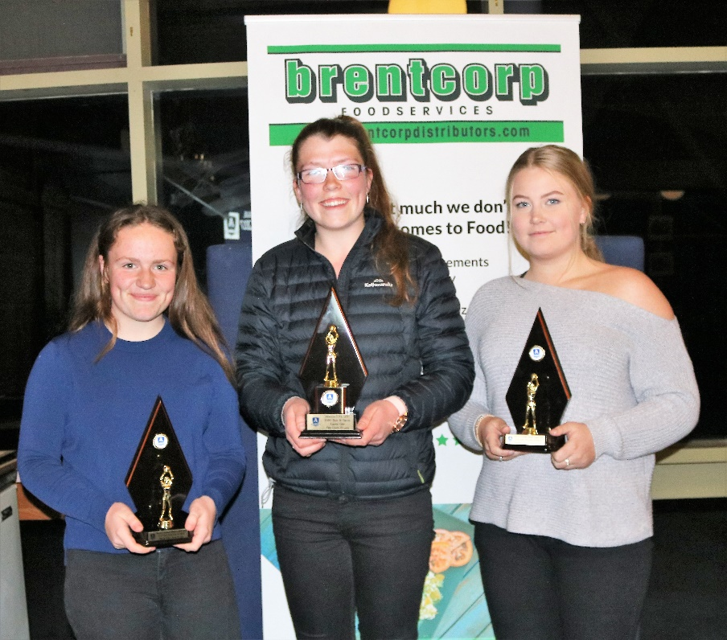
15&UNDER Best & Fairest Equal Runner Up – MIKAYLA PEDLEY (Tarwin),
Best & Fairest Winner – LAUREN GALE (Fish Creek)
& Equal Runner Up – STEPHANIE CRAWFORD (Toora)

