
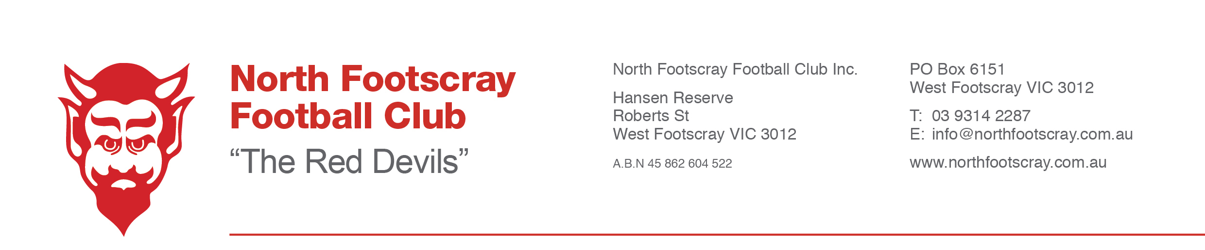

2018 Coaching Applications
The North Footscray Football Club are seeking expressions of interest in coaching Senior and Junior roles at the club for the 2018 Season.
For our Senior Coach we will be seeking experienced coach with a focus on player development and an ability to collaborate with the senior coaching team and the club’s leadership team. The successful candidate will be responsible for the program for Seniors, Reserves and Under 19’s.
For our Junior sides we are looking for coaches with a focus on team work, player development, knowledge of the game and the ability to provide skills based coaching.
We will be fielding sides in the following Divisions/Age groups:
Senior Men
Senior Reserves
Under 19’s
Under 17’s
Under 15’s
Under 14’s
Under 12’s
Under 9’s
Youth Girls 15’s
Applicants are required to contact the club president Shaun Brown on 0418 355 013 or email s.brown@bendigobank.com.au
Confidential Applications Close 11th of September

