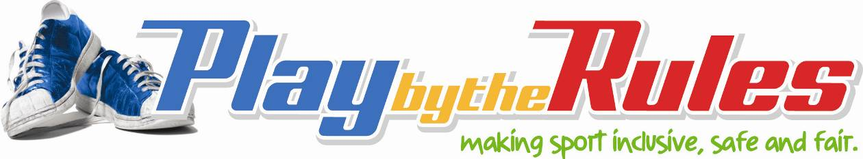

Risk management strategy

Coaches

Maintain control
Coaches should be a good role model for their players. Your behaviour is influential in setting the team culture. Encourage good sportsmanship in your team.
Try not to lose your temper, particularly with children, and have strategies to deal with these situations (e.g., get support if you have trouble managing children’s behaviour or complete accredited training courses to improve your skills and knowledge as a coach).
You should not make sexist, racist, homophobic or other comments or jokes that may offend, humiliate or intimidate others. This behaviour is not only inappropriate it could be unlawful.

Balance competition with participation
Coaches that have a win at all costs mentality can reduce the enjoyment of participation in sport. Coaches should balance participation with competition.

Follow fair and consistent team selection processes
Selection is often contentious because of perceived bias and/or favouritism towards particular players; and selection criteria processes are unclear or unknown. If coaching junior teams emphasise participation and ensure equal playing times and rotation of positions. Senior teams should be given clear criteria and processes for team selection that are communicated to all players. Selection decisions should be fair and not based on irrelevant characteristics such as a person’s sexuality, race or religion.

Consider flexible coaching practices
Flexible coaching practices should help to encourage participation from all members of the community (e.g. people with a disability, people from multicultural background, older people and families). Flexible practices may require you to change how you view participation and the way you coach (e.g., to modify equipment or rules).

Make sure you use appropriate coaching techniques

Do not use punishment to improve performance
Punishment rarely improves performance and it is not an appropriate strategy to deal with poor behaviour by players. Coaches need to understand the difference between discipline and abuse and use appropriate actions to manage children’s behaviour.

Make sure training regimes are appropriate
It is important that training regimes are appropriate to the skills and development of child. Adults players also should not be expected to training beyond their abilities (e.g weight circuits beyond their strength) or in inappropriate conditions (e.g. playing sport in extreme heat). Make sure that players are not overtrained and be committed to injury prevention and that training levels and intensity for children are appropriate.

Use appropriate techniques when demonstrating skills
Coaches need to take care when demonstrating a skill. If possible avoid contact with a player to demonstrate a skill. If it is necessary ask their permission or ask for a volunteer. Ensure any physical contact is appropriate to the development and skills required for the sport or activity.

Maintain appropriate boundaries
Because you are in a position of power you need to maintain appropriate boundaries with players at all times. You should:
- avoid physical contact with athletes and players. Physical contact should be appropriate to the situation and with the athlete or players understanding and permission (except in personal emergencies).
- avoid sexual relationships with athletes or players.
- never engage in an intimate or sexual relationship with a minor or athlete under the age of consent.

Avoid being alone with a child or young person
To protect both yourself and a child from risk:
- Do not isolate yourself and a child and avoid being alone with any particular child.
- If a child approaches you and wants to talk to you privately about a matter, do so in an open area and in the sight of other adults (e.g. other coaches, officials or parents/guardians).
- Before going into change rooms knock or announce that you will be coming in. Try to have at least one adult with you in a change room with children.
- Only take photos of children if you have parents permission. Do not copy or distribute photos for personal use.
- Make sure parents know they are expected to pick their child up on time from training.
- Avoid transporting children and only with the permission of their parents.

Take action over any inappropriate behaviours
Coaches must not only model good behaviour they should be prepared to take action if they become unaware of inappropriate behaviour in their team. You should:
- report suspicions of harm to your club President and child protection authority. This is a moral and in some state legal obligation.
- take action if you observe harassment and bullying between athletes and players.

