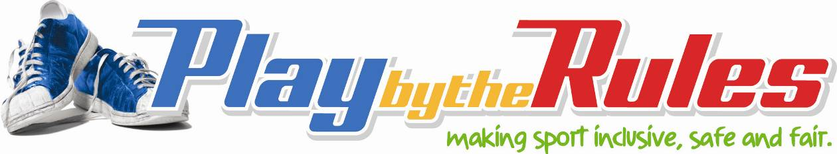

Fair and safe behaviour in
sport and recreation

New South Wales
Everyone needs to feel safe and to act fairly and respectfully towards each other.

Be a good sport
- Treat all participants in your sport as you like to be treated yourself.
- Co-operate with your team-mates, coach and opponents.
- Control your temper. Verbal abuse and sledging are not acceptable behaviours.
- Respect the rights, dignity and worth of all participants regardless of their ability, gender or cultural background.

You must feel safe
- playing, at training and practice
- travelling to and from games and training
- with other players, your coach or team personnel.

No-one should
- make you feel unsafe
- ask you to do anything that you are not comfortable with
- verbally abuse you or anyone else
- make racist or sexist jokes or comments
- allow offensive pictures or graffiti to be visible
- look at or touch anyone in ways that make them feel uncomfortable
- make uninvited sexual comments that offend, intimidate or humiliate
- discriminate against or harass anyone else.

Bad sporting behaviour is unacceptable and it can be unlawful

www.playbytherules.net.au
Provides information and online training on equal opportunity and child protection laws to address inappropriate behaviour in sport. It complements the Australian Sports Commission’s Harassment-free Sport Strategy.
If a person is not following your sport’s guidelines and is behaving inappropriately or if you think that you have been abused, discriminated against or harassed, then tell someone about it:
- a friend, colleague or parent
- a club official or contact officer
- your state or national association
- your department of sport and recreation
- your equal opportunity or anti-discrimination body
- the Australian Sports Commission
- your child welfare agency or the police.

Contacts

NSW Department of Communities (Sport and Recreation)
Tel: (02) 9006 3700
Fax: (02) 9006 3800
www.dsr.nsw.gov.au

Anti-Discrimination Board of NSW
Telephone: (02) 9268 5555
Fax: (02) 9268 5500
Toll Free: 1800 670 812
www.lawlink.nsw.gov.au\adb

Australian Sports Commission
www.ausport.gov.au

