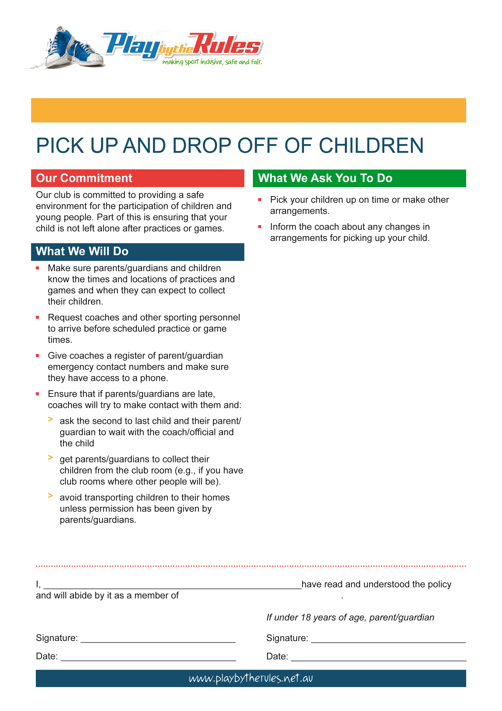
INSERT CLUB NAME
INSERT
CLUB
LOGO
HERE
[ INSERT YOUR NAME ]

[ YOUR ORGANISATION’S NAME ]
DD/MM/YYYY
DD/MM/YYYY

