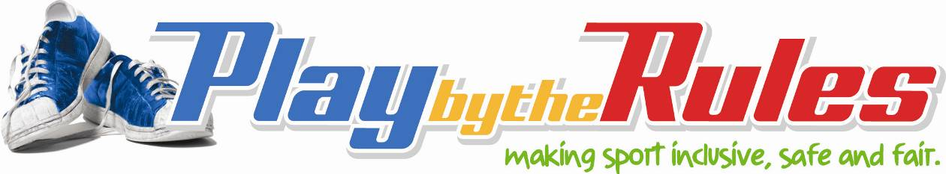

Legal rights and responsibilities

Officials
As an official you have the right to:
- a safe environment while officiating or umpiring
- be treated with dignity and respect (e.g. you shouldn’t be harassed or bullied because of your decisions)
- be treated fairly (e.g. in selection for officiating and umpiring positions)
- complain about inappropriate and unlawful behaviours and have those complaints taken seriously and addressed promptly
- a fair process – you should not be harassed or bullied if you make a complaint or penalise a player because of their behaviour.
You also have a number of responsibilities.
As a coach you’re responsible for ensuring that the rules of your sport are followed consistently and fairly, and that players/athletes participate in an environment free from discrimination, harassment or abuse.
You can meet your legal responsibilities by:
- meeting all Working With Children Checks and other child protection legislation requirements
- following your sports Member Protection or other welfare policies, code of behaviour
- applying guidelines to ensure athlete safety (e.g., heat guidelines)
- making fair and consistent decisions about the rules of the game
- following your sport’s rules and policies when dealing with inappropriate and unlawful on‐field behaviour (e.g. provide a warning, time out, removal from the game, report a breach of rules)
- ensuring any decisions you make to prevent players/athletes participating are based on your sport’s policies not your personal views (e.g. Do you know your sport’s rules on the participation of pregnant women or players wearing the hijab? These can be complex issues, so it’s important that you act according to your sport’s guidelines)

Related links
- Tools and tips for officials
- Umpires and officials – Online learning in discrimination and harassment
- Coaches and officials – Online learning in child protection
- Introductory officiating general principles – Online course

