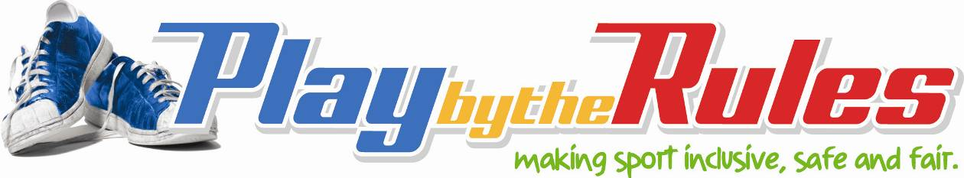

Legal rights and responsibilities

Coaches

Information

Your rights
As a coach you have the right to:
- be treated with dignity and respect (e.g. you shouldn’t be harassed or bullied at practice or during games)
- be treated fairly (e.g. you should be assessed on your merits whenever you apply for a club position)
- complain about inappropriate and unlawful behaviours (e.g. offensive behaviour by other coaches or players)
- a fair process – if you make a complaint or someone complains about you, you should not be harassed or bullied.

Your responsibilities
As a coach the way you act, the things you say and the behaviours you accept will all influence how players treat you and each other. Players, parents, club and community members look to you to set the standard.
You are responsible for:
- ensuring a safe and fair environment for players/athletes, particularly children
- treating players/athletes and officials with respect
- addressing inappropriate behaviours from members of your team.
Actions you can take to meet your legal responsibilities include:
- meeting all Working With Children Checks and other child protection legislation requirements
- following your sports Member Protection or other welfare policies, code of behaviour and other guidelines
- taking prompt action to address concerns about inappropriate or unlawful behaviour
- not victimising a player/athlete or others if they complain about you.

Resources

Interactive scenarios – Play by the Rules
The following interactive scenarios may assist you in problem solving similar issues you face at your club.
- Disability inclusion
- Girls playing in boys teams
- Homophobia and sexuality discrimination
- Over training or suspicion of harm
- Pregnancy and participation
- Religious inclusion
- Team selection (junior sport)
- Verbally abusive coach

Online training
- Play by the Rules online training
- Introductory coaches general principles – Online course (ASC website)

Guidelines
- Hot weather guidelines (SMA website)
- Transgender (ASC website)
- Pregnancy in sport (ASC website)
- Getting it Right – Guidelines for Selection

Information sheets
- Harassment Free Sport information sheets (ASC website)
- Images of children (ASC website)
- Play by the Rules Guidelines and Information Sheets

