 |  | 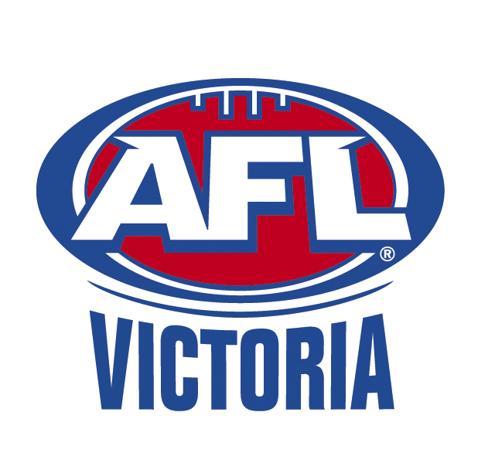
To: | 2016 U15 Summer Training Squad Players, Parents & Officials
From: | Len Villani (Talent Manager) & Marc D’Cruze (Football Admin Asst.)
Date: | Thursday, 18 February 2016
Subject: | Memo (4) 2016 U15 Summer Training Squad Training Arrangements
Training Dates:
No. | Date | Month | Day | Venue | Time
8 | 23 | February | Tuesday | Official Intra Club Trial @ Kilsyth | 6.30pm

Intra Club Practice Match Details
Date: Tuesday, 23rd February 2016
Venue: Kilsyth Recreation Reserve
Time: 6.30pm Start
Players to arrive by 5.45pm
Uniform: Jumper to be provided on the night
Any colour football shorts and socks.
Notes: Team will be announced on the night with 4 x 10 mins qtrs. Match to be complete no later than 7.30pm.

U15 Summer Training Squad Training Levies:
A final reminder that the Under 15 Summer Training Squad Levies are now overdue. There are still a number players that have outstanding fees. There are still several players yet to have paid these fees. If there are any problems please contact Alf Pennington on 9724 9499 or see Marc about Sponsorship.

Training Requirements:
All players are responsible for bringing their along a drink bottle that is adequate for the session, mouthguard, boots, runners and swimming gear to ensure they are organised for any type of session. ONLY Eastern Ranges issued apparel is to be worn for training sessions.

Yours sincerely,
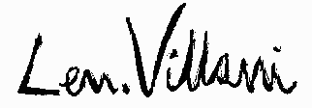

Len Villani
AFL Victoria
Talent Manager
Eastern Ranges FC

