Press Release
29 April 2009

PNOC-In a recent trip to New Zealand, Palau National Olympic Committee executive board members attended the 2009 Oceania National Olympic Committee Executive Meeting. The meeting which was held from 31 March – 3 April gathered executive members from all the national Olympic committees in the Oceania region. From Palau, President Frank Kyota; Vice President Bill Keldermans and Secretary General Baklai Temengil represented our country. The main highlight of the meeting was the election of new officers to the ONOC Executive Board. PNOC Secretary General, Baklai Temengil, was once again elected to the Executive Board; while Dr. Caleb Otto, PNOC Board Director, who was unable to attend due to prior commitments, was elected to the ONOC Medical Commission.

Another highlight of the Meeting was the presence of International Olympic Committee President, Jacques Rogge. Palau had the opportunity to talk with President Rogge for a short period of time to update him on the progress of Palau NOC as well as proposed activities/programs for the upcoming Olympiad.

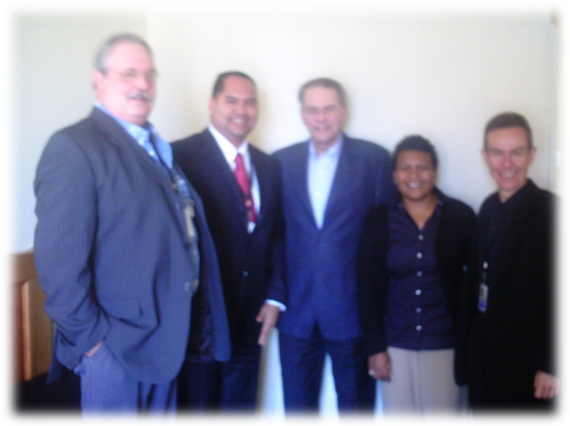

From L-R: Bill Keldermans, PNOC Vice President; Frank Kyota, PNOC President; Jacques Rogge, IOC President; Baklai Temengil, PNOC Secretary General and Pere Miro, IOC NOC Relations Direcor

Celebrating 10 Years of Olympism
“Excellence Through Sport”

