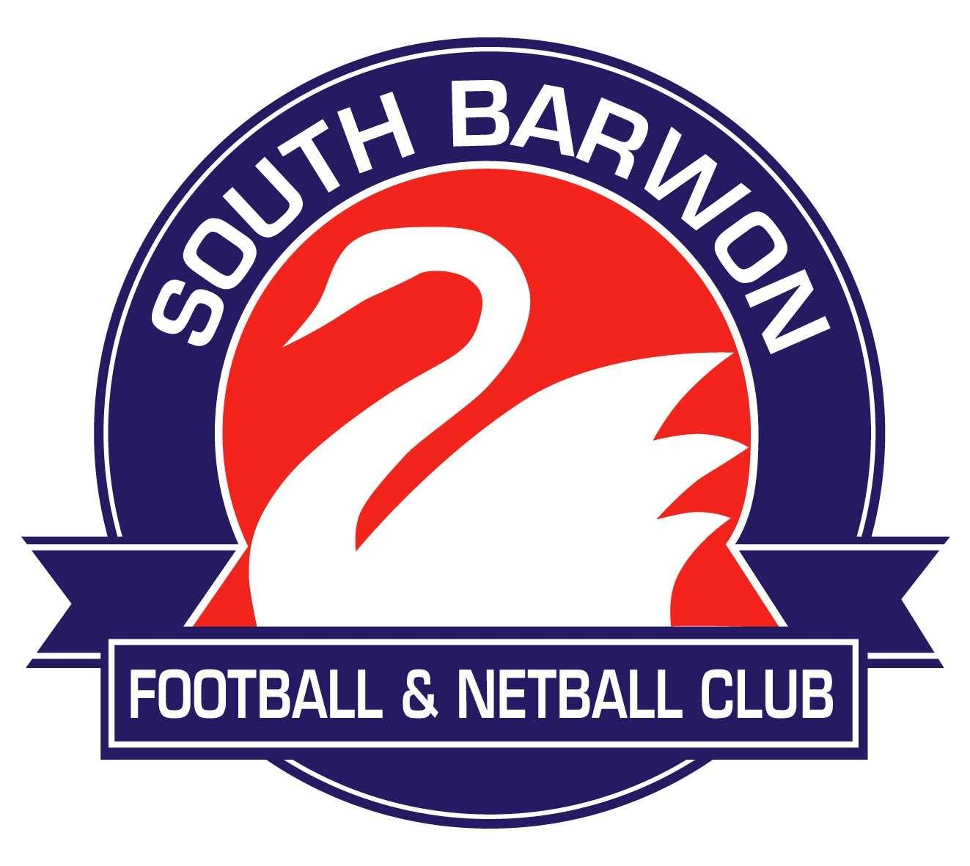

South Barwon Football and Netball Club
2015 – Year in Focus

2015 has been a team building phase for the football section. After losing a lot of players through retirements and transfers after the 2014 season the opportunity arose for young players from the reserves and colts to establish themselves as senior players. Over the season eight players from the 2014 colts teams played senior football and most displayed an ability to play regular senior football with the club.

The Netball Section were once again prominent in all grades, both senior and junior, bring home five premierships and, for the thirteenth year in a row, won the league netball section's club championship.

Our U/16A team flew the flag for the Junior Football Section with a premiership in the GJFL U/16 Div. 2 competition and it's star player Jonty Broughton winning the B&F Medal for that division.

During the year we noted the passing of four life members - Gary Plumridge, Joe Hassan, John Nankervis and Geoff Walker.
Gary Plumridge was a former junior team coach, committee person, club secretary, president and life member. Gary passed away in January after a long battle with cancer. Gary's wife, Sybil, also a staunch supporter and volunteer for the club died a few weeks after Gary's death, also following a long illness.
Joe Hassan was a hard working volunteer and committee person in the Belmont days.
John Nankervis played for many years with the Barwon FC and then later with Grovedale. The South Barwon and Grovedale clubs have, for the past 10 years, played for the John Nankervis Shield on each occasion that they meet.
Geoff Walker was coach of Barwon FC's 1960 premiership team and a volunteer and supporter of the club for many years.

The club extends its sympathy to their families.

Senior Football Section
Following back to back Reserves Grade premierships in 2013/14 we saw so many players "cherry picked" by minor league clubs with enticements of money and senior football games. A lot of hard work then had to be done at the commencement of the season to ensure that we had sufficient numbers to field two senior teams. This task became harder as the season rolled on due to a rather expanded injury list.

We welcomed several new players to the club including Meryck Buchanan - Colac, Nick Dixon - Geelong Amateur and Ryley Stuhldreier - Bacchus Marsh.
These guys slotted comfortably into the senior team and all performed extremely well. Once again we had a number of players listed on the Geelong, Footscray, Werribee and North Ballarat VFL lists. These players included: Mitch Herbison, Meryck Buchanan, Ben Raidme Tom Maas, Darcy Fort, Fraser Fort, Jay Lever and Andrew Boseley. Their irregular call-ups to VFL was certainly a constant dilemma for our coaches and team selectors.

Because of an extended injury list and other factors, over 40 players played senior football for the Swans. Although not ideal for stability within the side, it was fantastic to see a number of players get their opportunity following, in many cases, years of hard work and commitment.

Our congratulations to Mitch Herbison on winning the club's senior Best and Fairest award. Although playing quite a few games at Geelong VFL he polled votes in almost every game he played with the Swans. The Reserves B&F award was won by Ritchie McCann.

Our last game for the season at St Marys saw Clinton Wells retire as a player. Clinton played his junior football at South Barwon and was promoted to the senior team in 1998 whilst still playing in the u/18 team. He has played 329 games and kicked 650 goals for the Swans over 17 years. He has never played a game of reserves footy. Clinton has played in all eight premierships and has played more that a "season" of finals games at Simonds Stadium.

We thank our senior coaches Matt Scarlett and Warwick Knuckey for their service over the past two years. These guys are now stepping down and we are pleased to announce that Clinton Wells and James Maas have now been appointed co-coaches of the senior side with Mitch Herbison as assistant coach. Toby Prendergast has been appointed coach of the reserves. Wellsey has jumped in at the deep end by taking up a coaching role at the club. His enthusiasm for the game and for our club is just amazing. Welcome to our new coaching panel and we wish them well for next season.

Pre-season training for 2016 kicked off on Monday 16 November. There was a great roll up of players, old and new, and quite an enthusiastic vibe amongst coaching staff, players and supporters. We look forward with great anticipation to the commencement of the 2016 season.

Netball Section
The netball section again enjoyed a very successful season and, for the 13th year in a row, won the GFNL Club Championship. Twenty one teams played off in their respective finals series and five premierships were won.
As a club we are duly proud of this effort as collectively it rewards everyone from players, coaches, executive, team managers and supporters of South Barwon Netball.

Congratulations to Ruby Horton and Danielle Gaylard for being named in the GFNL Team of the Year. Ruby also was successful for third year running in the A Grade Hot Shots Award with 729 goals. Olivia Cameron was our top vote getter in A grade finishing 4th overall after an awesome season again. Kailah-Mae Keepen was also a nominee for the Rookie of the year after a tremendous season. In B grade, Elly Hoiles finished 4th and was our top vote getter. In C grade Caitlyn Wood and Abbey Morgan finished equal 6th and in D grade Ellen Doyle in her seniors debut finished 4th. Congratulations to Meg Newman for finishing runners up in the U15 Div 2 League Best and Fairest and to Maggie Johannes on winning the U13 Div 2 League Best and Fairest.
It is

Junior Football Section
The junior section has once again made a huge contribution to the development of our great game. This season we fielded 3 x u/10 teams, 3 x u/12 teams, 3 x u/14 teams and 2 x u/16 teams. There are just over 250 players registered and most teams were very competitive in their respective competitions. To field so many teams requires a massive amount of planning and support. Each weekend there are approximately 100 volunteers involved in making our junior section tick. We congratulate and thank Sandy Wasik and Scott Edwards and their band of helpers for ensuring that South Barwon is recognized as one of the best junior section programs in Geelong.

As mentioned previously, the highlight for the Junior Section was a premiership to the U/16A team in the GJFL U/16 Div. 2 competition and it's star player Jonty Broughton winning the B&F Medal for that division.

Auskick
Our local Auskick section once again enjoyed a bumper season with footy activities conducted at the club each Sunday morning during the winter months. Matches at half time during senior home games are a highlight for the kids and great photo opportunities for proud parents. This year there were approximately 200 boys and girls registered in the program which is a fantastic launching pad for those wishing to take the next step into club football.

The Auskick program was managed by Theo Nicopolous and we thank him for his efforts. It's a tough gig running such a large program so well done to Theo and all his helpers.
Ryan Mackay will be the co-ordinator for season 2016. This man has heaps of energy and we look forward to an exciting 2016 program.

Social Awareness
The club, under the Swans Community leadership program, is committed to programs that will help in the development of our 14-18 youth age groups (male and female).

Our club has identified, and continues to identify, major life issues away from football and netball. Areas of social awareness and education that were featured in dedicated sessions included:

- Mental health with the successful Read The Play program
- Anzac Day address by Geelong Vietnam Veterans to U/14 boys.
- Social media issues and appropriate use.

Resources & Facilities Development
The club is committed to a policy of continuous improvement to the facilities at McDonald's Reserve and we were fortunate to secure funding at the last state election for a lighting upgrade on the top oval and also for terracing along the bottom oval to enable better spectator comfort.

It is anticipated that the lighting project will commence earlier in the new year followed by the terracing.

Volunteer Management
The volunteers range from all the people who act as team mangers, coaches, scoreboard attendants, ground preparation, line marking facility maintenance, preparing meals to a host of tasks that can be onerous, difficult, time consuming and when done well are rarely noticed. The club recognises its volunteers by providing a volunteers’ evening at the commencement of each season and we could not operate without them. Our heartfelt thanks to all of you.

We can never have too many volunteers to tackle the dozens of tasks required for football and netball operations, facilities management, canteen assistance etc and any additional help is always greatly appreciated.

New Life Members
At our presentation night held in October, life membership was awarded to Sascha Veldhuis and Scott Edwards. Sascha has been a premiership player and coach of 8 premierships over 11 years for the Swans. She has won best and fairest awards at both club and league levels. Scott has been junior football section co-ordinator at the club for 14 years and, from meagre beginnings, our junior program is now recognised as one of the best in the district.

All at South Barwon congratulate Sascha and Scott on achieving this magnificent milestone.

