
December 1995 was a month in my life that I
will never forget. First I receive the news early in December that I will be in the Gold Coast Rollers National Basketball League Squad for the upcoming year. And then three days before Christmas, Anthony "Choc" Mundine rocks up at my door in Sydney and says "lets drive to Darwin, I wouldn't mind seeing that part of the country and doing a bit of relaxing."

My first thought was "Does he really know how far Darwin is?" Is he serious?
His response: "No worries brother, I'll just go home now and get my mum to make us some sandwiches and cordial and we'll go tonight!'

Later that night, "Choc", Shane Kennedy and I embarked on the three day journey from Sydney. Well that's how long I thought it would take. We ended up at my house in Millner in Darwin on Christmas Eve! Less than two days after we left Sydney.

What does this story have to do with the history
of Hoops 4 Health? Well let's begin with Christmas morning, and for all young people reading this, believe me, hard work and self belief while living a healthy lifestyle can get you a long way. I awoke that morning to huffing and puffing outside my bedroom window. No he wasn't smoking cigarettes, Choc was in the middle of a set of push ups. I said to him. I thought you came here to relax, he replied: "I did but no one else will be training on Christmas morning, so I am going to get that extra workout in". n the following years he would go on to win rugby league titles and become world super middleweight champion. After watching him run length of the field tries and become champion of the world I
hink about him doing those extra push-ups and
sit ups between ads on TV and most importantly being a person who lives life clean and with a positive attitude. He would wake up my family on that holiday ten years ago with the saying: "Rise and shine, it's a brand new day." We would then play one on one basketball all day long in my backyard and even had a scrimmage in the exact stadium where the Hoops 4 Health Challenge will take place
with some other well-known Darwin basketballers and other people including Michael MacLean, Coofy Cole, David Cole, the late John - Boy Ahmat, Matty Bonson, Koorda Roe, Kane Ellis, Clint Kononen, Shawn Lewfatt, Aaron Talbot, Moses Wigness and Jason Ahsam. The score in the Millner backyard challenge of December 1995. Eight games to nil. Mundine 8, Duggan 0. A number of "Health" stories came out of that trip to Darwin. The main one that stood out was Choc Mundine doesn't drink alcohol, doesn't smoke cigarettes and doesn't smoke marijuana. Never has and never will.

Another reason for creating the Hoops 4 Health Program was the witnessing of family and friends passing on before their time and seeing many people having numerous chronic diseases that could have well been prevented if healthy decisions were made. My thoughts to create the Hoops 4 Health program were along the lines of prevention Is better than cure so start with our youth and give them the education to make smart decisions for the betterment of their personal and communities health and well-being.
Hoops 4 Health began and was launched in 2002 as a program of Wuchopperen Health Service by Trendy Trev in Cairns, Queensland.
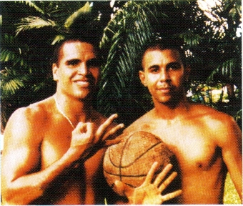
Mundine 8, Duggan 0, Millner Dec '95
