Guide to Player Self-Registration via MyFootballClub

Welcome to MyFootballClub Registration for Riversdale Soccer Club

Start Here: Go to the MyFootballClub website - www.myfootballclub.com.au
Click on “Register Now” → Select “Player Registration”
Options are:
➢ Click here to proceed to the login pages (if you have a FFA number & know your password)
See section on Registering for Our Club
➢Click here to find your FFA Number (if you have registered in previous years with FFA)
You will need to provide your name date of birth and email. Your FFA number and password will be emailed the email address recorded on MyFootballClub.
See Section on Retrieving a password
➢ Click here to create an FFV account (if you are new to football and do not have an FFA number)
Complete the registration pages with player details

Retrieving a Password

- Click on “Register Now” and then “Register” on the top menu.
- Click on “Find your FFA Number” to find your FFA number. Enter your name and DOB to find your FFA number
- Click on your name to take you to the login screen
- Click on “Need a Password?” to reset and retrieve a password by entering a matching e-mail address that is currently on the MyFootballClub system
- If your email address does not match with data in MyFootballClub, contact FFA in order to update your current email address and log into the system.

Note: Do not create an account if you have been registered within the last 5 years – Contact FFA or FFV for assistance to find your FFA number

Registering for Our Club

Start Here: Go to the MyFootballClub website - www.myfootballclub.com.au

Logging into your own MyFootballClub Account
- Click on “Register Now” and then “Register” on the top menu.
- Click on “Player Registration”
- Select the option that reflects your previous registration history and follow the prompts to login to your MyFootballClub account

Registering to Riversdale Soccer Club
- To begin registration, click on “Register”
- Click “Add new Image”, click “Browse” and select a photo from your computer. (Please note that all players registering for U12-U18’s must have a current photo uploaded onto the system to allow the Club to produce ID cards for Match day)
- Under “Subject” type your name and then click “Save and Exit”
- Update your Personal and Contact Details, click on “Proceed with Registration”
- Type in our Club name which is Riversdale Soccer Club
  - Note: You must select our Clubs name from the drop down menu that appears for packages to be made available.
ERROR ALERT!
If you see this error, select “OK” and ensure that the correct Club Name is typed in and selected from the drop down box
Riversdale Soccer Club
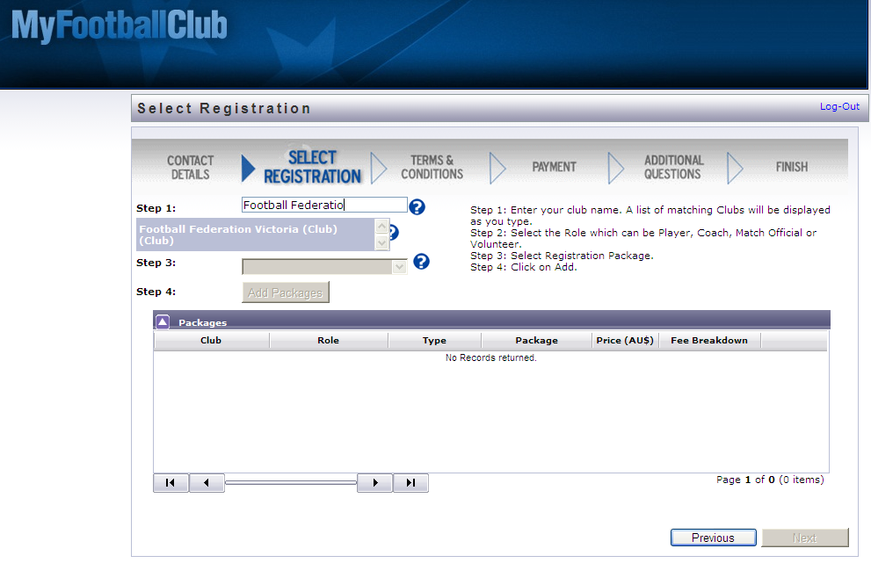

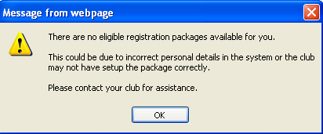

- Choose the option “Player” and confirm your playing details in the subsequent pop-up
- Select the appropriate Registration Fee that applies to you
- Click on “Add Packages” and then click on “Next”

Acknowledging Terms and Conditions
- Read and acknowledge all Terms and Conditions by checking all boxes and then click on “Next”.

Payment Options Screen
- You will be given the option to “Invoice Me” or “Pay Now”.
- To “Pay Now” - Continue to Pay your registration fee on-line via Credit Card (MasterCard or Visa) (You will also receive an invoice via email)
IF you have chosen the “Invoice Me” option, payment will need to be made via EFT or cheque

EFT:
Bank: Bendigo Bank
BSB: 633-000
Account No: 140251513
Account Name: Riversdale Soccer Club
Use your Surname as Reference

Cheque - send to Riversdale Soccer Club PO Box 1094, Camberwell VIC 3123

Answer Additional Questions
- Answer the questions, click on “Save All Answers” or click on “Next”.

Your Online Registration is now complete! What happens next?

If you have made payment via Credit Card - Your Registration Status is now “Pending Awaiting Approval”. The Club Registrar will complete the final step of accepting your registration to make you Active and finalise your registration with FFV to make you eligible to play.

If you have chosen to make payment at another time via EFT or cheque - Your Registration Status is now “Pending Awaiting Payment”. When the payment has been received and allocated to your registration on MyFootballClub, the Club Registrar will complete the final step of accepting your registration to make you Active and finalise your registration with FFV to make you eligible to play.

For more information, please contact Alison Dean via e-mail registrations@riversdalesc.com.au

Updating your Details

If you wish to update any of your personal details
- Click on “My Details” then “Edit My Details” to update your Personal and Contact Details. Finalise by clicking “Save My Details”
- You may also Change your Password in this section by clicking “Change Password” and clicking “Save”
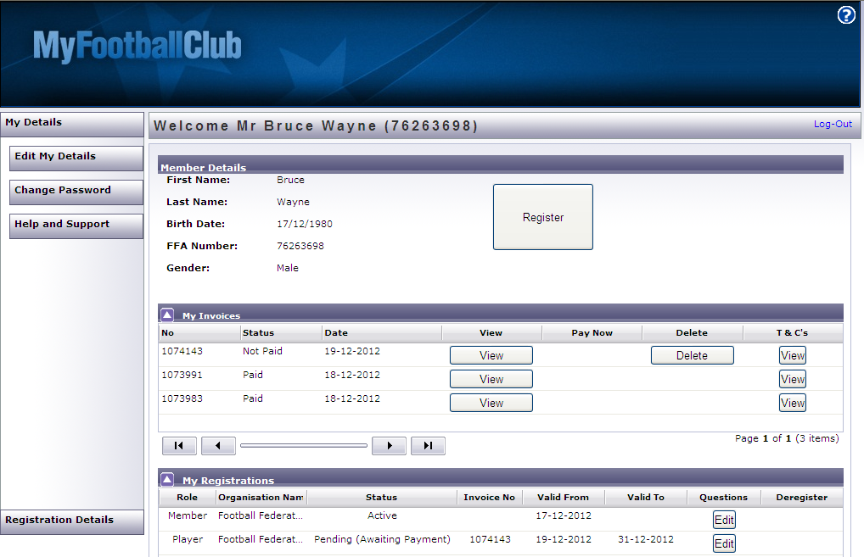

Where do I go for help?

- FFA Support Centre Ph: (02) 8020 4199 or e-mail myfootballclub@footballaustralia.com.au
- FFV MyFootballClub Support Ph: (03) 9474 1800 (Press 2) or e-mail myfootballclub@footballfedvic.com.au
- Player resources (Videos/Manuals) which is available via www.myfootballclub.com.au under MyFootballClub/Register Now/Guides
- FAQ’s on the MyFootballClub website or FFV Website via www.footballfedvic.com.au (under Registrations > MyFootballClub)

