MEMORANDUM

To: Association Referee Advisors
From: Bruce Keirs – Manager, Education & Officials Development
Subject: Australian Schools Championship, Referee Development Camp
Date: Friday 20th June 2014

Basketball Australia and Basketball ACT are preparing for a major Referee Development Camp for December 2014.
The camp is to be held in conjunction with the Australian Schools Championships in ACT from 1st to 5th December 2014.
This camp will be known as the “2014 Zebra Tour”, from the 30th November-5th December 2014.
The tournament will involve refereeing the non championships divisions of the Australian Schools Championships, with experienced referee coaches providing feedback and coaching as required, along with formalised educational sessions.
This is a fantastic opportunity for referees to develop their skills and meet other referees in a friendly, fun and exciting camp style environment.
The objective of the Development Camp is to provide unique education and training for developing referees and combining this with hands on experiences and coaching while officiating quality standard games in the Australian Schools Championships.
The program will involve formal theoretical education sessions on Sunday and then follow up with practical expert coaching during games conducted at the tournament from Monday to Friday.
The camp commences 12.00pm Sunday 30th November and the event concludes Friday 5th December. Travel will need to be arranged to fit these time frames.
Fortunately the cost to the participants has been kept close to the previous years and it is hoped this prior information may help assist the various bodies plan for the December Program.

A game fee will be paid to individual referees of $10 per game.
Accommodation is at the UC Village on the University of Canberra, all meals and a tournament shirt will be provided and includes the ground transport to the various venues from the accommodation.
All officials will have to organize their own transport to and from the championship and officials who reside outside the state of ACT will have to organise their own flights to Canberra.
Basketball Australia and Basketball ACT are looking at options of group bookings with a bus company to travel from Melbourne and Sydney to assist with the travel costs. We will look at these options when we have an indication of the number of interstate referees and referee coaches submitting an expression of interest.
Could you please forward on this initial information along with the attached “Expressions of Interest Forms” to appropriate referees and to all those concerned in the development of referees?
An expression of interest form will soon follow for the referee coaches wishing to attend.
More detailed information will be provided in August, to those officials completing an expression of interest form.
Regards
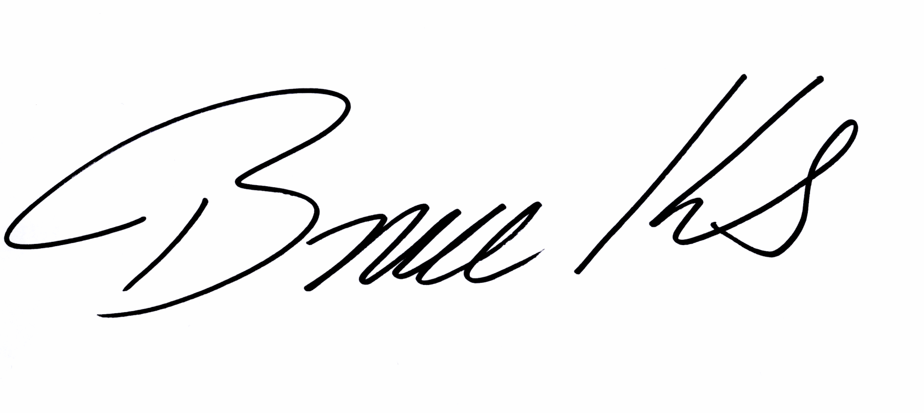
Bruce Keirs
Manager, Education & Officials Development

Australian Schools Championships
30th November -5th December 2014, ACT
Expression of Interest – REFEREE

Minimum requirements:
- Intermediate Referee (Old Level 1B)
- 16 years of age
- You must be a registered member of relevant State body
- Cost $400 (plus air fare to ACT for interstate referees / coaches)

Name: _________________________ DOB:_________________________
Phone #1: _________________________ Phone #2: _________________________
Street: _______________________________________________________________
Suburb: _________________________ Post Code: _________________________
Email: _______________________________________________________________

Association: _________________________ Referee Level / Grade: ______________
Referee Advisor: ____________________ Contact Phone: ___________________
Referee Advisor Signature: _____________________________ Date: ______________
What level do you currently Referee at? (Example Junior League, State League Div 1, Youth League) _________________________________________________________
Information regarding Refereeing at Australian Schools Championships will be sent to those officials who complete an expression of interest by November 2014. For all queries please contact Bruce Keirs at Basketball Australia on (02) 8396 5533 or 0412 331 051.

Complete and return form by Tuesday 4th November 2014

Fax: (02) 8396 5501

OR POST:

Basketball Australia
PO Box 7141
Alexandria, NSW, 2015

Email: bruce.keirs@basketball.net.au

