  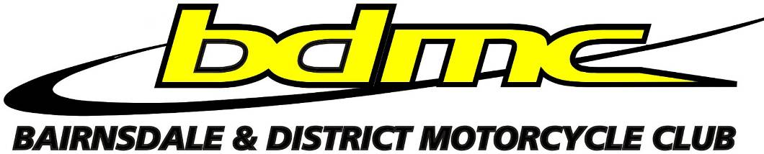
  
    - 9th November
  SWAP MEET
  Bairnsdale and District Motorcycle Club
  The Bairnsdale and District Motorcycle club are holding the first of what is hoped to be an annual swap meet event at the clubs facility on Aerodrome rd. off Humphries rd. (Follow the RED signs). NOTE: Road is now SEALED so no more dust, mud and pot holes. Stalls will cost $10. Gold coin entry donation for everyone else.
  Plenty of onsite parking.
  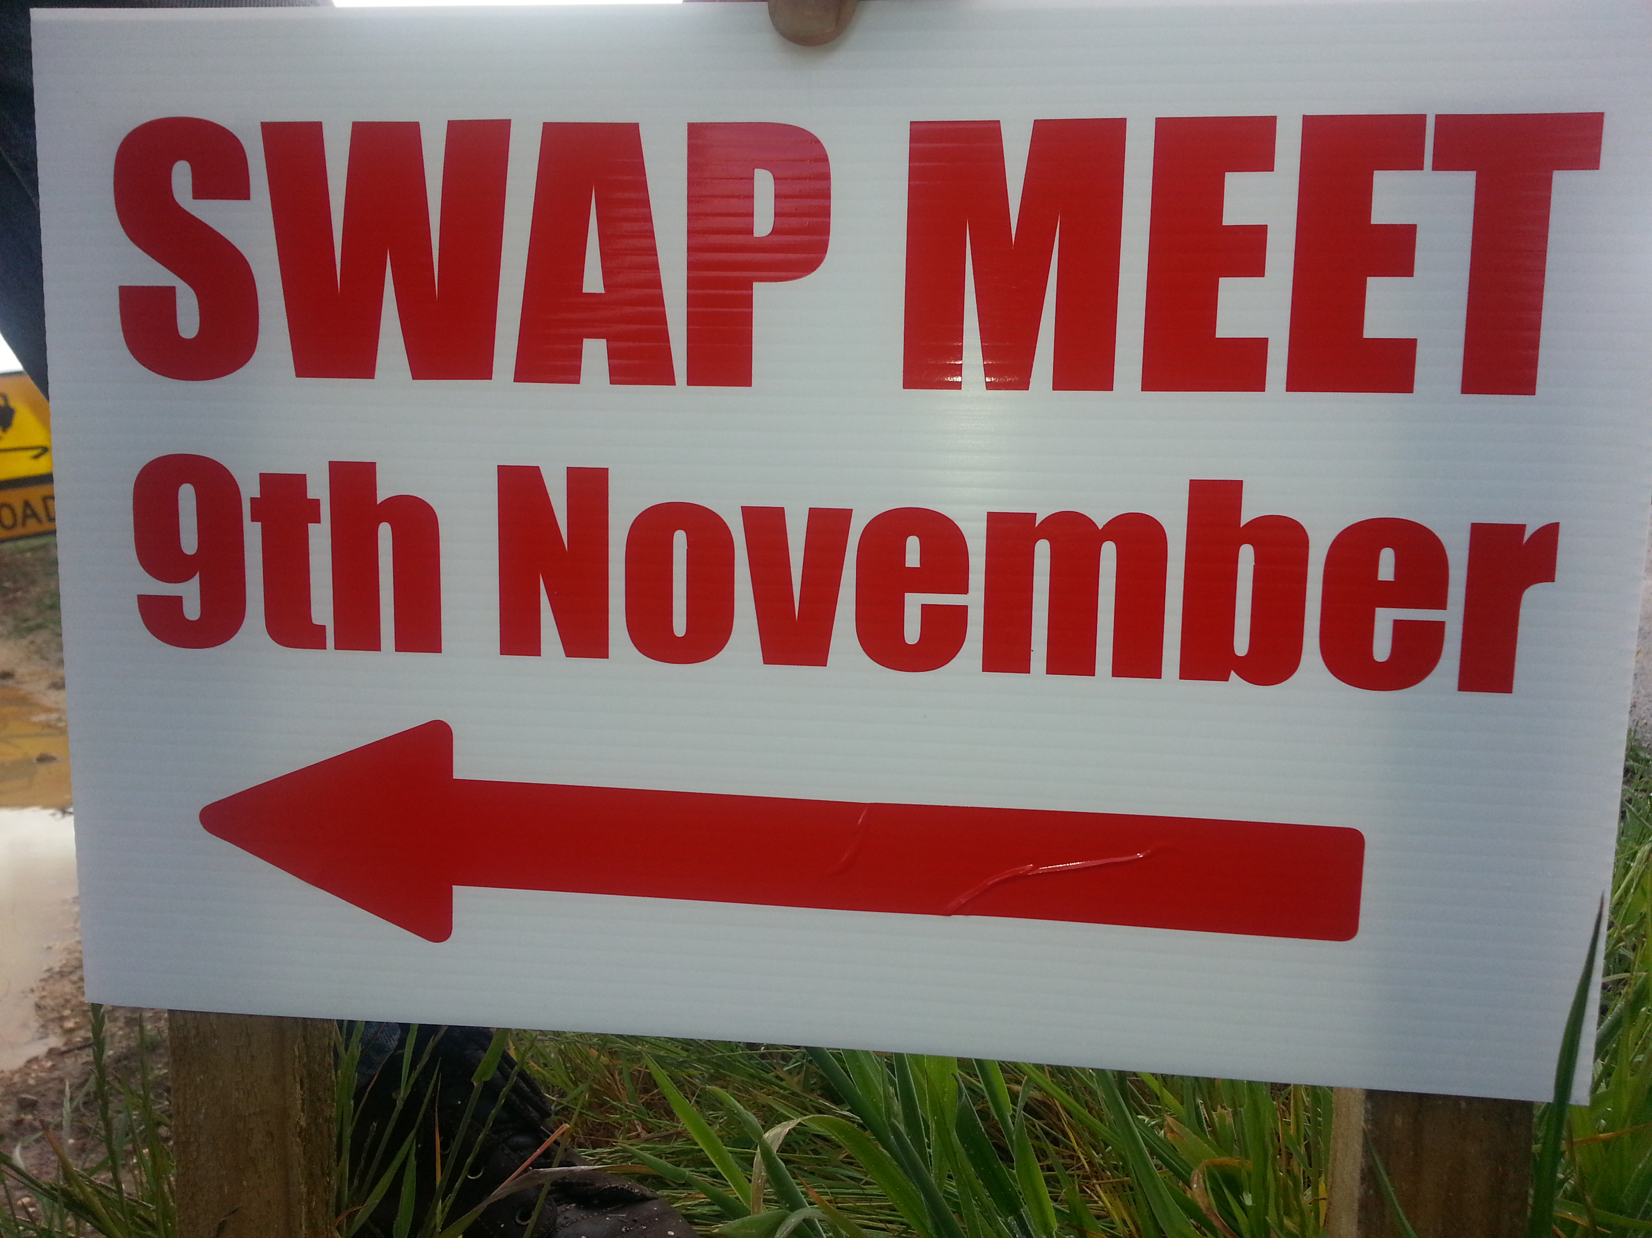
  Automobile parts, Collectables & much more
  Canteen facilities available
  Site entry from 7am
  $
  Public entry from 8am- 3pm
  For enquiries & bookings call Ray 0409 189 598
  0
  Bring your pride & joy to display
  All bikes & cars welcome. Old or new.

