
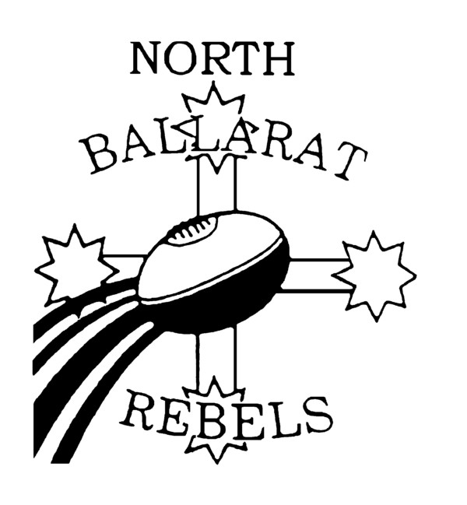
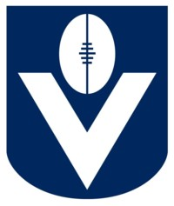

Rebels Playing Squad & Staff Weekly Memo
Monday 20th – Sunday 26 April
Another solid victory against good opposition.
Our work ethic and decision making in the 1st half was outstanding and was pivotal to us in gaining the 4 points.
The 2nd half of the game is one we should learn from. Gippsland Powers pressure on us stepped up and we were unable to cope thus resulting in costly turnovers. Our strong work ethic from the 1st half declined and we became lazy in our return running which caused less pressure on the Power resulting in goals that put them back into the game.
This week we have the Bye and we encourage all players that are fit and well to go back and play at their local clubs. Enjoy the weekend playing with your local club and ensure you still play at the highest intensity you can.
Well done to Dean Gavin on his effort in this week’s “Rebels Yell”. He’s had a few niggles at his team mates which we hope won’t go unnoticed. Jump on the website to view more.

Good luck to Marcus Darmody, Josh Free, Josh Cowan, Andrew Hooper, David Astbury, Oliver Tate, Jandre Slabbert and Lucas Cook who play in the Vic Country trial game this Sunday. We also have Jake Ward, Micheal O’Callagan, Richard Bamblett, Tom McDonald, Matt Sully and Lachie Edwards playing in the Vic Country U17 Academy Squad also this Sunday. All games are at Vic Park in Melbourne. U17 game starting at 12.15pm and Vic Country Game at 2.15pm.

Please ensure you check the club’s new website each week to get your updated memo. http://nthballaratrebels.aflvic.com.au

This week:
Tuesday 21st April: Training at St Patricks @ 4.45pm (Ballarat Based)
Thursday 23rd April: Local Club’s

NEW GAME TIME & VENUE NEXT ROND
Next Game Day: Sunday, May 3rd. Rebels V Jets @ Buninyong Recreation Reserve.
Player’s arrival time in Home Rooms: 10.15am sharp
Game Time: 12 noon
Shorts: BLACK
Socks: Black
Playing Squad Players are reminded to wear full Rebels uniform to each game whether selected or not. Uniform consists of Polo, Tracksuit top & Bottom.

Reminders

Playing Squad Levies are now due.
Player Sponsorship Package has been finalized and will be distributed over training over next 2 weeks. Sponsors and Parents day will now be held on Sunday 26th July prior to our game against the GC17 team. More details to follow.
Reminder to all parents to bring a plate for our after match next week.

Any questions please contact Phil ASAP on 5339 0915 / 0418 558850

Next Week Training
Tues 28th April: Training at St Patricks @ 4.45pm
Thurs 30th April: Training at St Patricks. NEW STARTING TIME OF 4.30pm

TAC Cup
Football Victoria Ltd. ABN 87 052 795 399
NORTH BALLARAT REBELS FOOTBALL CLUB
Northern Oval, Creswick Rd, Ballarat, 3350
PO Box 151N, Ballarat North, 3350
Telephone: 5339 0915 Fax: 5332 9538 Email: phil.rebels@theroosters.com.au
Website: www.nthballaratrebels.aflvic.com.au

