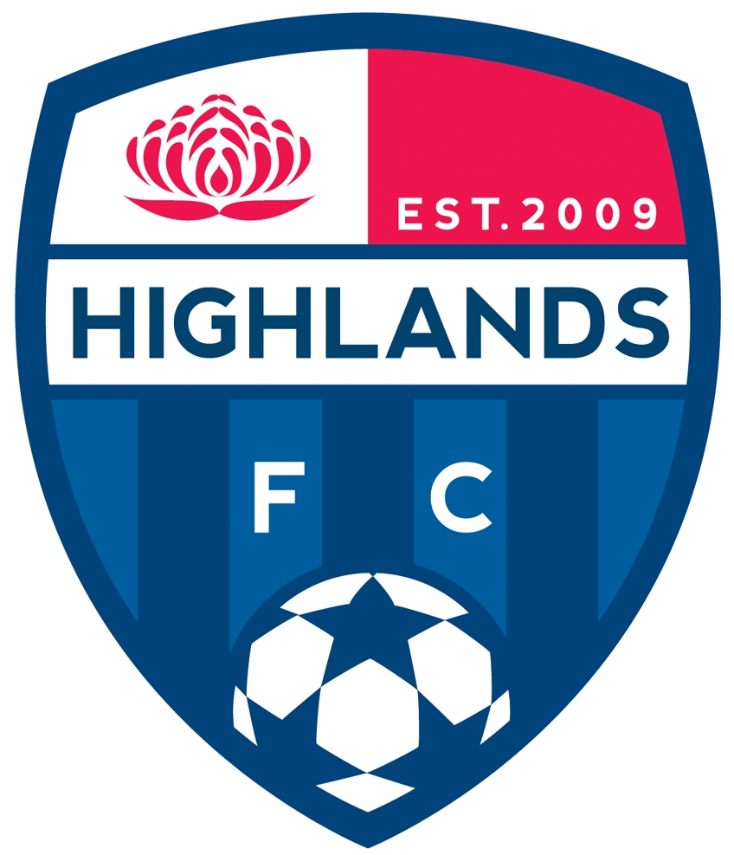
EXPRESSION OF INTEREST FOR COACHES

Highlands Football Club is seeking Expressions of Interest for Coaches for the Highlands FC teams that compete in the Football South Coast elite competitions from Under 12, 13, 14, 15 and 16 Boys Youth League, and Under 12, 14 and 16 Girls Youth League for season 2015

Please supply a covering letter including your Coaching resume and the age group and gender you are applying for.

Appointments will be made based on having the relevant stage of learning qualification, and, the level of experience coaching the specific age and gender. Closing date 19 September 2014

Please complete the information.

Contact Name:

Address:

Postal Address (if different):

Telephone:

Mobile phone:

E-mail:

Current Coaching Accreditation Held:

Signature

Date:

This Expression of Interest Form marked Confidential may be delivered to Highlands Football Club at:

Nick D’Amore
Technical Director
Highlands Football Club
PO Box 2221
Bowral NSW 2576

Alternatively this Expression of Interest Form may be e-mailed for the attention of Nick D’Amore to dir.coach@hsa.org.au

All telephone enquiries should be referred to Highlands Football Club at (02) 0407917062.

