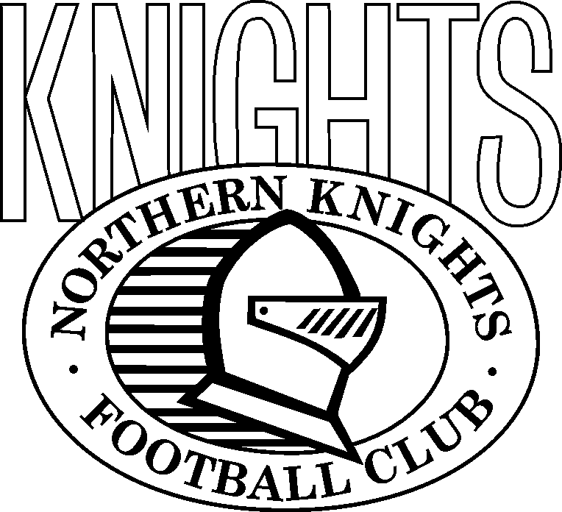

TO ALL PARENTS:

2009 Thursday Night Pasta &
Home Game Aftermatches
IT HAS BEEN A LONG STANDING TRADITION FOR THE ENTIRE KNIGHTS U/18 SQUAD TO HAVE A PASTA MEAL AFTER THE TEAM MEETINGS ON THURSDAY NIGHTS.
THE KNIGHTS HAVE BEEN EXTREMELY FORTUNATE IN THE PAST TO HAVE A GROUP OF DEDICATED PARENTS WHO HAVE BEEN WILLING TO GIVE UP THEIR TIME TO PREPARE AND SERVE THE PASTA FOR OUR PLAYERS AND STAFF.
AT THE PARENTS MEETING ON MONDAY, 30TH MARCH, MIRA RIDDLE (Nick’s Mum) AGREED TO COORDINATE THE PASTA NIGHT, EACH THURSDAY NIGHT FOR SEASON 2009.
IT WAS ALSO DECIDED TO INTRODUCE A PARENTS ROSTER FOR ASSISTANCE ON THURSDAYS. THIS WILL BE PRODUCED & CIRCULATED AFTER EASTER. If you are unable to attend on the night that you have been allocated it is your responsibility to swap with someone. IF YOU CAN DO MORE THAN ONE SHIFT OR BE A REGULAR ON THURSDAYS, PLEASE CONTACT MIRA ON (M) 0417 575 968.
AFTERMATCHES.
THESE OCCUR AFTER EACH HOME GAME (6 TIMES) AT NAB OVAL (PRESTON) IN THE PRESTON SOCIAL CLUB (UNDER THE OLD STAND).
BOTH TEAMS & THEIR PARENTS ARE INVITED TO ATTEND.
WE ASK THE PARENTS OF PARTICIPATING PLAYERS TO BRING A PLATE OF FOOD FOR THE PLAYERS.
WE ASK THAT PARENTS DROP OFF THE FOOD BEFORE THE GAME AT THE SOCIAL CLUB. IF LOCKED, LEAVE IT AT THE CANTEEN.
ROOM TO BE SET UP AND URN IS TO BE TURNED ON AT ¾ Time.

IT WOULD BE APPRECIATED IF SOMEONE VOLUNTEERED TO BE AFTERMATCH CO-ORDINATOR.

