

Social Mixed Basketball
Entry Form

Harbour Basketball is now accepting entries for the next Social Mixed
Basketball League Starting Thursday 14th August 2014

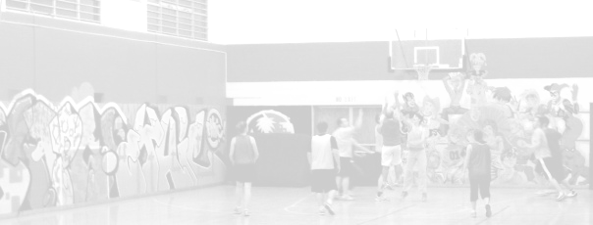
Entries close – Wednesday 6th August 2014

12 weeks Starts Thursday 14th August – Games Run for approx 45 mins (2 x 20 half’s)

Cost $805 (Inc GST and Social Membership fee)
Must be paid on entry
Please pay by direct credit to:
ASB, Northcote Branch 12-3053-0401960-00
(Please Reference your team name)

All Games are played at AUT or the North Shore Event Centre
Please see rules for all game information

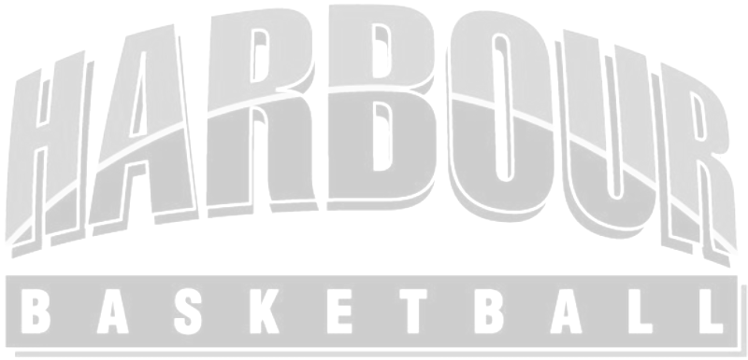
Team Name: ...................................................................................

Team Contact: ................................................................................ Cell Phone: ................................................

Email: ..................................................................................(2nd Email) .......................................................................
Team contact (2nd): ............................................................................ Cell Phone: ...............................................
Billing Address:

Player’s Name | Date of Birth | Email
Please contact or visit the Harbour Basketball website for Rules and further information
Email: admin@harbourbasketball.co.nz Phone: (09)4433854 Fax : 4433298

