

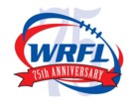

Good Sports Level 3 2005,06,07,08 WRFL Club of the Year AFL Quality Club Bronze Level


NORTH FOOTSCRAY FOOTBALL CLUB INC
“The Red Devils”

WANTED
Do you love being involved in football?
Would you love the opportunity to coach?
Are you someone that wants to make a difference?
Well the North Footscray Bulldogs need you.

Our FIDA team are in desperate need of a coach coordinator.

There is a plan to have as many home games as possible with the team being the curtain raiser before the super rules games. The team will play fortnightly on a Sunday from April to August. Training is once a week on a Thursday from 4.30 - 5.30pm. This is a voluntary position but also very rewarding given the love of the sport by the players.

The first training date is 2 April from 4.30 - 5.30pm.
A BBQ and get to know you/ welcome session will be held after training.
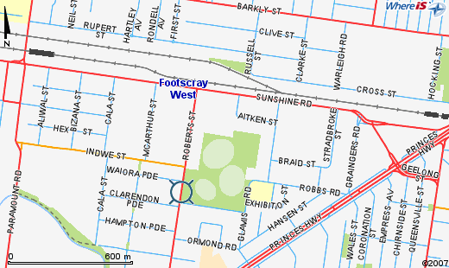

If you have any queries please contact:
Raeleene Eldridge on 0423 207568 or
Cath Black
Access for All Abilities Coordinator -
City of Maribyrnong
Monday, Wednesday and Thursday
9688 0330



