Guide to Player Self-Registration via MyFootballClub

Welcome to MyFootballClub Registration for Moreland Zebras FC

Start Here: Go to the MyFootballClub website - www.myfootballclub.com.au

Retrieving a Password

- Click on “Register Now” and then “Register” on the top menu.
- Click on “Find your FFA Number” to find your FFA number. Enter your name and DOB to find your FFA number
- Click on your name to take you to the login screen
- Click on “Need a Password?” to reset and retrieve a password by entering a matching e-mail address that is currently on the MyFootballClub system
- If your email address does not match with data in MyFootballClub, contact FFA in order to update your current email address and log into the system.

Note: Do not create an account if you have been registered within the last 5 years – Contact FFA or FFV for assistance to find your FFA number

Registering for Our Club

Start Here: Go to the MyFootballClub website - www.myfootballclub.com.au

Logging into your own MyFootballClub Account
- Click on “Register Now” and then “Register” on the top menu.
- Click on “Player Registration”
- Select the option that reflects your previous registration history and follow the prompts to login to your MyFootballClub account

Registering to Moreland Zebras FC
- To begin registration, click on “Register Now”
- Click “Add new Image”, click “Browse” and select a photo from your computer.
- Under “Subject” type your name and then click “Save and Exit”
- Update your Personal and Contact Details, click on “Proceed with Registration”
- Type in our Club name which is Moreland Zebras FC
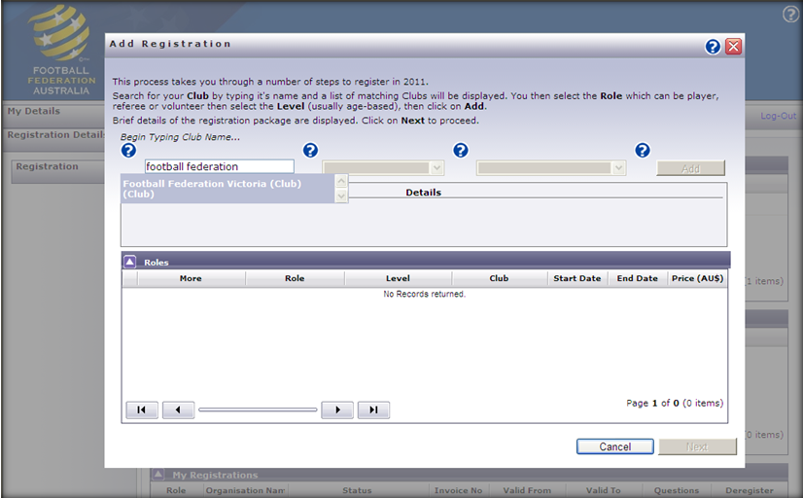
  - Note: You must select our Clubs name from the drop down menu that appears for packages to be made available.
ERROR ALERT!
If you see this error, select “OK” and ensure that the correct Club Name is typed in and selected from the drop down box
<Insert Club Name as it appears on MFC>
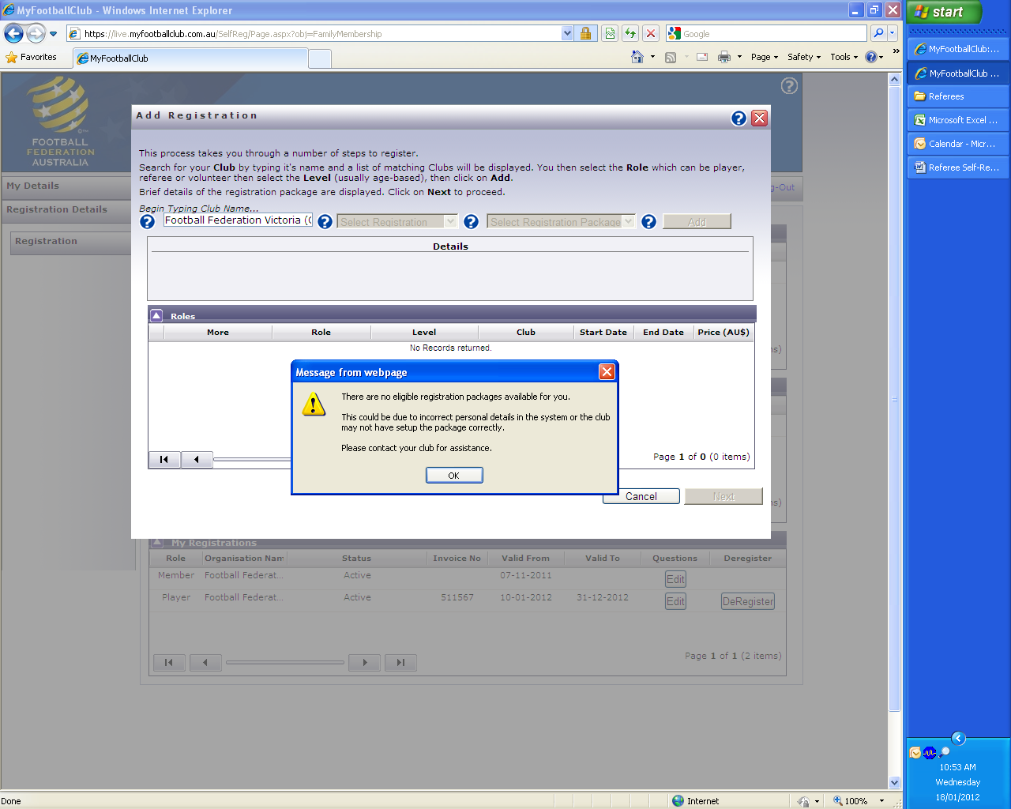

- Under “Select Registration”, choose the option “Player”
- Select the appropriate Registration Fee that applies to you: SELECT AGE GROUP
- Click on “Add” and then click on “Next”

Acknowledging Terms and Conditions
- Read and acknowledge all Terms and Conditions by checking all boxes and then click on “Next”.

Payment Options Screen
- You will only be given the option to “Invoice Me” Please select this option
- You will receive an invoice via email.

Answer Additional Questions
- Answer the questions, click on “Save All Answers” or click on “Next”.

Your Online Registration is now complete! What happens next?

- Your Registration Status is now “Pending Awaiting Payment”. The Club Registrar will complete the final step of accepting your registration to make you Active and finalise your registration with FFV to make you eligible to play. We will contact you directly to advise the next steps in terms of payment of your registration with the Club.

For more information, please contact John Ruffino via Phone on 0418 121125
or via e-mail info@morelandzebras.com

Updating your Details

If you wish to update any of your personal details
- Click on “My Details” then “Edit My Details” to update your Personal and Contact Details. Finalise by clicking “Save My Details”
- You may also Change your Password in this section by clicking “Change Password” and clicking “Save”
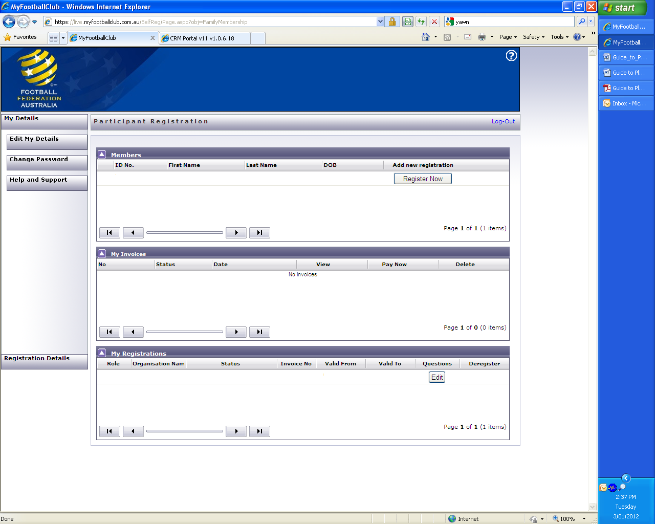

Where do I go for help?

- FFA Support Centre Ph: (02) 8020 4199 or e-mail myfootballclub@footballaustralia.com.au
- FFV MyFootballClub Support Ph: (03) 9474 1800 (Press 2) or e-mail myfootballclub@footballfedvic.com.au
- Player resources (Videos/Manuals) which is available via www.myfootballclub.com.au under MyFootballClub/Register Now/Guides
- FAQ’s on the MyFootballClub website or FFV Website via www.footballfedvic.com.au (under Registrations > MyFootballClub)

