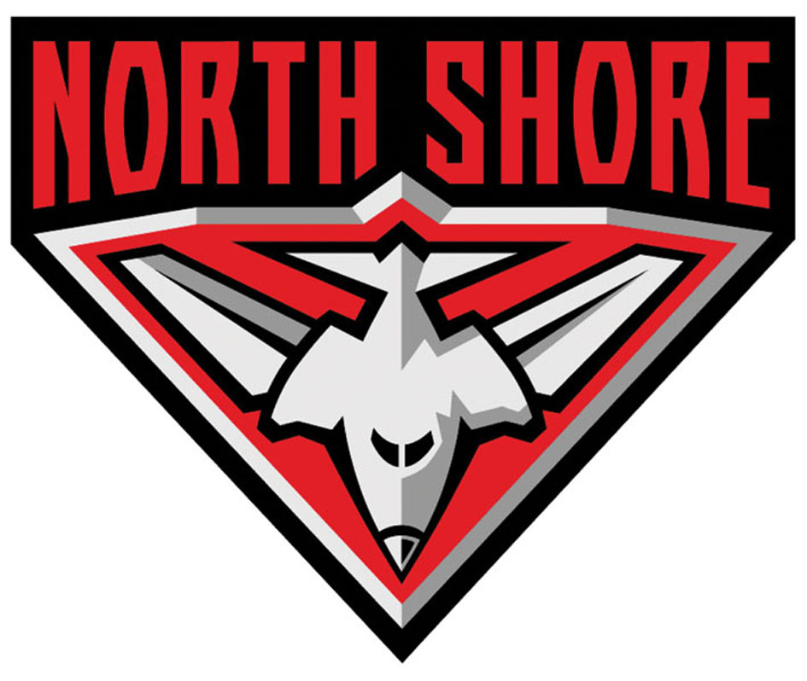

North Shore Australian Football Club

North Shore Reserves Coach

North Shore has a great opportunity for a passionate coach to take up the role of Reserves Coach at the club for season 2014.

The successful applicant will have the opportunity to develop their coaching skills and broaden their experience working with Senior Coach Jon Hayres and U19 Coach Jamie O’Dell in a professional and supportive club environment.

In addition to leading the training and match day coaching of the North Shore Reserves team, the successful applicant will also be responsible for assisting in the development of the next generation of Premier division players coming through U19’s, as well as ensuring the continuing development of current senior player who are pushing for Premier division selection.

In order to be successful it's important that you:
- have passion for player and team development,
- enjoy teaching the fundamentals,
- are an excellent communicator and
- are an accredited level 1 coach (if required, the club will organise for you to attend the level 1 certification in early 2014)

The club is based in St. Leonards, on the north shore, only a short trip from the city, North Sydney and Chatswood areas.

To apply, please email northshorefc@yahoo.com.au by Friday, 20 December, with your AFL background (playing or coaching history). For any questions, please don’t hesitate to contact John Goode (football operations) on 0414 904 204.

Website: www.northshorefc.com.au

