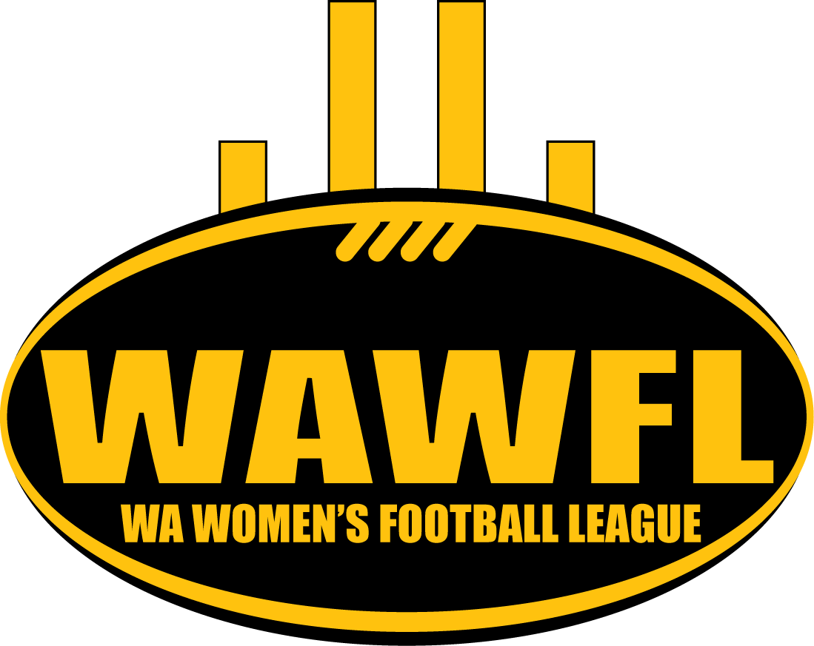
WA WOMEN’S FOOTBALL LEAGUE (INC)

2013 Annual General Meeting

Loftus Recreation Centre
Corner Loftus and Vincent St
Wednesday 6th November 2013 at 6:30pm

- Meeting Opened:

- Confirmation of Minutes of the previous meeting

- Presidents Report Carolyn Hills

- Treasurers Report Sally Allomes

- WAWFL Board Nominations and Election
Vice President (3 year term)
TWO (2) General Board member positions (3 year terms)

- General business
- Nominations for Yorga sub-committee
- Any other items

- Meeting closed

