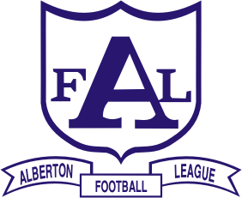
ALBERTON FOOTBALL LEAGUE Inc.
• DALYSTON • DEVON/WELSHPOOL WON WRON WOODSIDE • FISH CREEK
• FOSTER • INVERLOCH-KONGWAK • KILCUNDA-BASS • KORUMBURRA-BENA
• MEENIYAN DUMBALK UNITED • PHILLIP ISLAND • STONY CREEK
• TARWIN • TOORA & DISTRICT • YARRAM

2011 BEST & FAIREST WINNERS:
SENIORS:
Shaun EVERINGTON, Foster - 24 votes
RESERVES:
Matthew VAN BOVEN, Fish Creek - 21 votes
THIRDS:
Paul PATTISON, Korumburra-Bena - 25 votes
2011 TOP GOALKICKERS:
SENIORS:
Luke JAMES, Kilcunda-Bass - 110 goals
RESERVES:
Leigh WILKINSON, Dalyston - 91 goals
THIRDS:
Michael GREEN, Foster - 61 goals
FOURTHS:
Jake BUCKLAND, Fish Creek - 79 goals
RISING STARS:
April: Josh TONER, Toora & District
May: Cameron ALLUM, Inverloch-Kongwak
June: Ben VARDY, DWWWW
July: Luke LE BLANC, Yarram
August: Callan PARK, Fish Creek – 2011 WINNER

