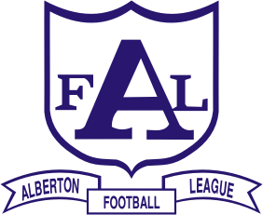
ALBERTON FOOTBALL LEAGUE Inc.
• DALYSTON • DEVON/WELSHPOOL WON WRON WOODSIDE • FISH CREEK
• FOSTER • INVERLOCH-KONGWAK • KILCUNDA-BASS • KORUMBURRA-BENA
• MEENIYAN DUMBALK UNITED • PHILLIP ISLAND • STONY CREEK
• TARWIN • TOORA & DISTRICT • YARRAM

2010 BEST & FAIREST WINNERS:
SENIORS:
Shaun EVERINGTON, Foster - 30 votes
RESERVES:
Justen JACKSON, Inverloch-Kongwak - 21 votes
THIRDS:
Samuel WHATLEY, Toora & District - 24 votes
2010 TOP GOALKICKERS:
SENIORS:
Alberton RUSSELL, Tarwin - 84 goals
RESERVES:
Justen JACKSON, Inverloch-Kongwak - 101 goals
THIRDS:
Ilan OSMAN, Korumburra-Bena - 54 goals
FOURTHS:
Josh HOPKINS, Korumburra-Bena - 56 goals
RISING STARS:
April: Sam DOCHERTY, Phillip Island – 2010 WINNER
May: Corbin SUTHERLAND, Yarram
June: Damien McLEAN, Tarwin
July: Todd LOMAX, Tarwin
& David CLAVARINO, Yarram

