
October 2011

DOMESTIC UNIFORM POLICY (ARTICLE 4.3) - INCORPORATING JEWELLERY,HEADWEAR,UNDERGARMENTS,GLOVES, WRIST BANDS,
PROTECTIVE EQUIPMENT
UNIFORMS:
Article 4.3.1
The uniform of the team members shall consist of:
- Shirts of the same dominant colour front and back.
All players must tuck their shirts into their playing shorts. 'All-in-ones' are
permitted.
- Shorts of the same dominant colour front and back, but not necessarily of the same colour as the shirts.
- Socks of the same dominant colour for all players of the team.
COMMENT:
Basketball Victoria decided not to implement the enforcement of the requirement for same colour socks.

“T” Shirts - Domestic Associations are encouraged to be liberal with their uniform regulations regarding “t” shirts under basketball tops, particularly if requested in cold weather, and / or for medical purposes.

Article 4.3.2
Each team member shall wear a shirt numbered on the front and back with plain
numbers, of a solid colour contrasting with the colour of the shirt.
The numbers shall be clearly visible and:
- Those on the back shall be at least twenty (20) cm high.
- Those on the front shall be at least ten (10) cm high.
- The numbers shall be at least two (2) cm wide.
- Teams shall use numbers from four (4) to fifteen (15). National federations have the authority to approve, for their competitions, any other numbers with a maximum of two (2) digits.
- Players on the same team shall not wear the same number.
- Any advertising or logo shall be at least five (5) cm away from the numbers.
COMMENT:
Basketball Australia and Victoria have recommended competitions only consider using numbers 4-15, 20-25, 30-35, 40-45, 50-55

Article 4.4 Other Equipment
4.4.1 All equipment used by players must be appropriate for the game. Any equipment that is designed to increase a player's height or reach or in any other way give an unfair advantage is not permitted.
4.4.2 Players shall not wear equipment (objects) that may cause injury to other players.
The following are not permitted:
- Finger, hand, wrist, elbow or forearm guards, casts or braces made of
leather, plastic, pliable (soft) plastic, metal or any other hard substance,
even if covered with soft padding.
- Objects that could cut or cause abrasions (fingernails must be closely cut).
- Headgear, hair accessories and jewellery.
COMMENT: (Gloves, Fingernails and Wrist Bands)
Basketball Australia and Victoria have recommended the following by-laws regarding Wearing of Gloves, Fingernails and Wrist Bands

Wearing of Gloves / Fingernails/ Wrist Bands:
Gloves;
Gloves may be worn by players as long as they;
- Are appropriate for basketball,
- Do not give additional reach, or grip,
- Do not in any other way give an unfair advantage to the wearer,
- Are in no way dangerous to other players.
The use of gloves to avoid cutting fingernails is allowable under the current rules of the game, as long as they conform to the above requirements.

Fingernails:
If an official establishes that a player has fingernails that could cause abrasions, they must enforce the player to;
- Closely cut their fingernails to eliminate the threat of causing abrasions (usually not protruding above the finger)
- Cover the protruding fingernails with a suitably protective device such as medical strapping tape. (The tape must be applied in such a manner that no sharp edges or corners are created by the taping).
- The player may not participate until such time that the referee is satisfied that the nails are appropriately covered.
- Where the protective device (eg. Strapping tape) falls off during the game the referee must stop play at the next opportunity and direct the player to remedy the cover. If this occurs more than twice then the referee should instruct the player that (s)he can no longer participate in the game, unless the fingernails are closely cut to eliminate the threat of causing abrasions to others.
The referee should prohibit the player from participating in the game in the following circumstances;
- Suitable protective measures are not available;
- Where a referee is not convinced that such a protective measure will adequately overcome the risk of abrasive injury to others.
- The player refuses to cover the offending fingernails.

Wrist Bands:
The various rubber, leather and silicon etc. wrist bands (power bands) are regarded as objects which may cause injury to other players.
Consequently players must remove the bands prior to playing or have them covered with adhesive tape, or towelling sweat band, eliminating any possibility of another player getting their finger(s) caught under them.
- The player may not participate until such time that the referee is satisfied that the band(s) are appropriately covered.
- Where the protective device (eg. tape) falls off during the game the referee must stop play at the next opportunity and direct the player to remedy the cover. If this occurs more than twice then the referee should instruct the player that (s)he can no longer participate in the game, unless they remove the band.

The following are permitted:
- Shoulder, upper arm, thigh or lower leg protective equipment if the material
is sufficiently padded.
- Undergarments that extend below the shorts of the same dominant colour
as the shorts.
- Compression sleeves of the same dominant colour as the shirts.
- Compression stockings of the same dominant colour as the shorts. If for the
upper leg it must end above the knee; if for the lower leg it must end below
the knee.
- Knee braces if they are properly covered.
- Protector for an injured nose, even if made of a hard material.
- Non - coloured transparent mouth guard.*
- Spectacles, if they do not pose a danger to other players.
- Headbands, maximum five (5) cm in width, made of non-abrasive, unicolour
cloth, pliable plastic or rubber.
- Non-coloured transparent taping of arms, shoulders, legs, etc.*
Medical Wrist Band:
Medical information wrist bands may be worn by players as long as they are;
- In no way dangerous to other players
- Covered using medical strapping tape
- Covered using an athletic sweat band.
COMMENT:
*Basketball Victoria decided not to implement the enforcement of the requirement for non-coloured transparent mouth guards AND taping of arms, shoulders, legs, etc.

COMMENT: (Headgear)
Basketball Australia and Victoria have recommended the following by-laws regarding Headgear as a guideline for the safety of players.
Hair Accessories:
- To clarify what is considered acceptable, players are permitted to take the court wearing “bobby pins” and/or “one touch” or “snap” clips to hold their hair back. These items pose no threat of injury to any player on the court (see attached photo).
- Players will not be permitted to wear barrettes, bandanas, headbands made of metal, or clips larger than a bobby pin or snap clip – especially those that are present for decorative purposes only. These items do pose a threat of injury, due to their increased size (see attached photo).
- If items in a player’s hair are made from a non-abrasive, pliable material, they may be permitted to be worn, as (by rule) they pose no threat of injury.
This includes headscarves or other fabric articles worn for religious purposes held in place by bobby pins or snap clips.

Referees and competition administrators cannot prevent a player taking the court if the religious clothing that he/she is wearing poses no threat of danger to another player. Common sense must be used in these situations. Any person preventing a player from taking the court due to the clothing that they are wearing for religious purposes may leave themselves open to legal action.

Braids:
- If a player (male or female) has their hair braided, and it swings free from their head when the head is moved, it may cause harm to another player if struck by the braid.
- Due to injury that may be caused, players are not permitted on the court with free braids in their hair.
- Players are not permitted to cover their braids with a bandana. This guideline includes plaited ponytails.
- Players with plaited ponytails must be instructed by the referees to either roll the plait into a bun, or remove the plait and play with a loose ponytail. (as long as the pony tail does not hide the player’s number) This is again due to the injury that may be caused if struck by the plait.

Sun Hats:
When playing basketball outdoors, the use of sun hats is not specifically covered by the FIBA Rules and Interpretations.
Consequently Basketball Australia has approved the use of appropriate headgear for sun protection as long as the following points are considered;
- In no way dangerous to other players.
- Are appropriate for outdoor basketball.
- Do not give an unfair advantage.

Protective Helmets:
No player is permitted to play with headgear, which according to FIBA includes protective helmets.
FIBA ruled that if a player is required to wear a protective helmet for their own health and safety, then their health is at too much of a risk to play the sport of basketball. Also there is the associated effect on the opposition players as they feel their endeavours and style of play may have to be curtailed when playing against someone wearing a helmet for self-protection.
An appropriate exemption may be made in circumstances where a player provides medical evidence to wear a helmet for their self-protection because of a special intellectual disability.

COMMENT: (Jewellery)
Basketball Australia and Victoria have recommended in addition to the FIBA Rule, the following by-laws regarding Jewellery as a guideline for the safety of players.
Jewellery:
Referees should monitor all players appearance prior to the commencement of the game, in particular look out for rings, bracelets, necklaces, earrings and obvious body piercing jewellery.
If an official establishes that a player has jewellery and / or body pierced jewellery the following FIBA Interpretation shall be applied.

Players who wear Jewellery, which is visible and could cause injury to themselves or to other players, shall be instructed as follows;
- Any player wearing an object that might cause injury (such as those
objects listed above) must be politely told of the existence of the rule
(referees should not presume that a player is aware of the rule) and be asked
to remove the object prior to taking the court.
- If a player claims that a particular item cannot be removed, the referee should instruct the player that (s)he must cover the object with a suitably protective device such as medical tape. The player may not participate until such time that the referee is satisfied that the object is appropriately covered.
- Where the protective device (eg. tape) falls off during the game the referee must stop play at the next opportunity and direct the player to remedy the cover. If this occurs more than twice then the referee should instruct the player that (s)he can no longer participate in the game, unless they remove the jewellery.

The referee should prohibit the player from participating in the game in the following circumstances:
- A referee is not convinced that such a protective measure will
adequately overcome the risk of injury;
- Suitable protective measures are not available;
- The player refuses to remove or cover the offending object
Any player who seeks to participate in defiance of any of the above directions by a referee should be disciplined as per the association's rules.

There have been some concerns over liability issues if referees allow players to play while wearing jewellery, particularly when players have offered to sign release or indemnity forms.

COMMENT: (Further Jewellery)
Following legal advice from Sports Law, Lander and Rogers Lawyers, Basketball Australia has adopted the attached Policy on the wearing of Jewellery in a basketball game.
In addition to implementing the FIBA Rule, Article 4.4.2 Basketball Australia recommends that Associations take steps to educate their referees as to their rights and responsibilities to enforce all rules – including the wearing of jewellery. Associations are also recommended to promote the position on jewellery to all players by issuing notices and placing signs in appropriate areas.

4.4.3 During the game a player may not display any commercial, promotional or charitable name, mark, logo or other identification including, but not limited to, on his body, in his hair or otherwise. (see article 4.3.2 for uniform regulations)
4.4.4 Any other equipment not specifically mentioned in this article must be approved by the FIBA Technical Commission.
HAIRGEAR ACCESSORIES
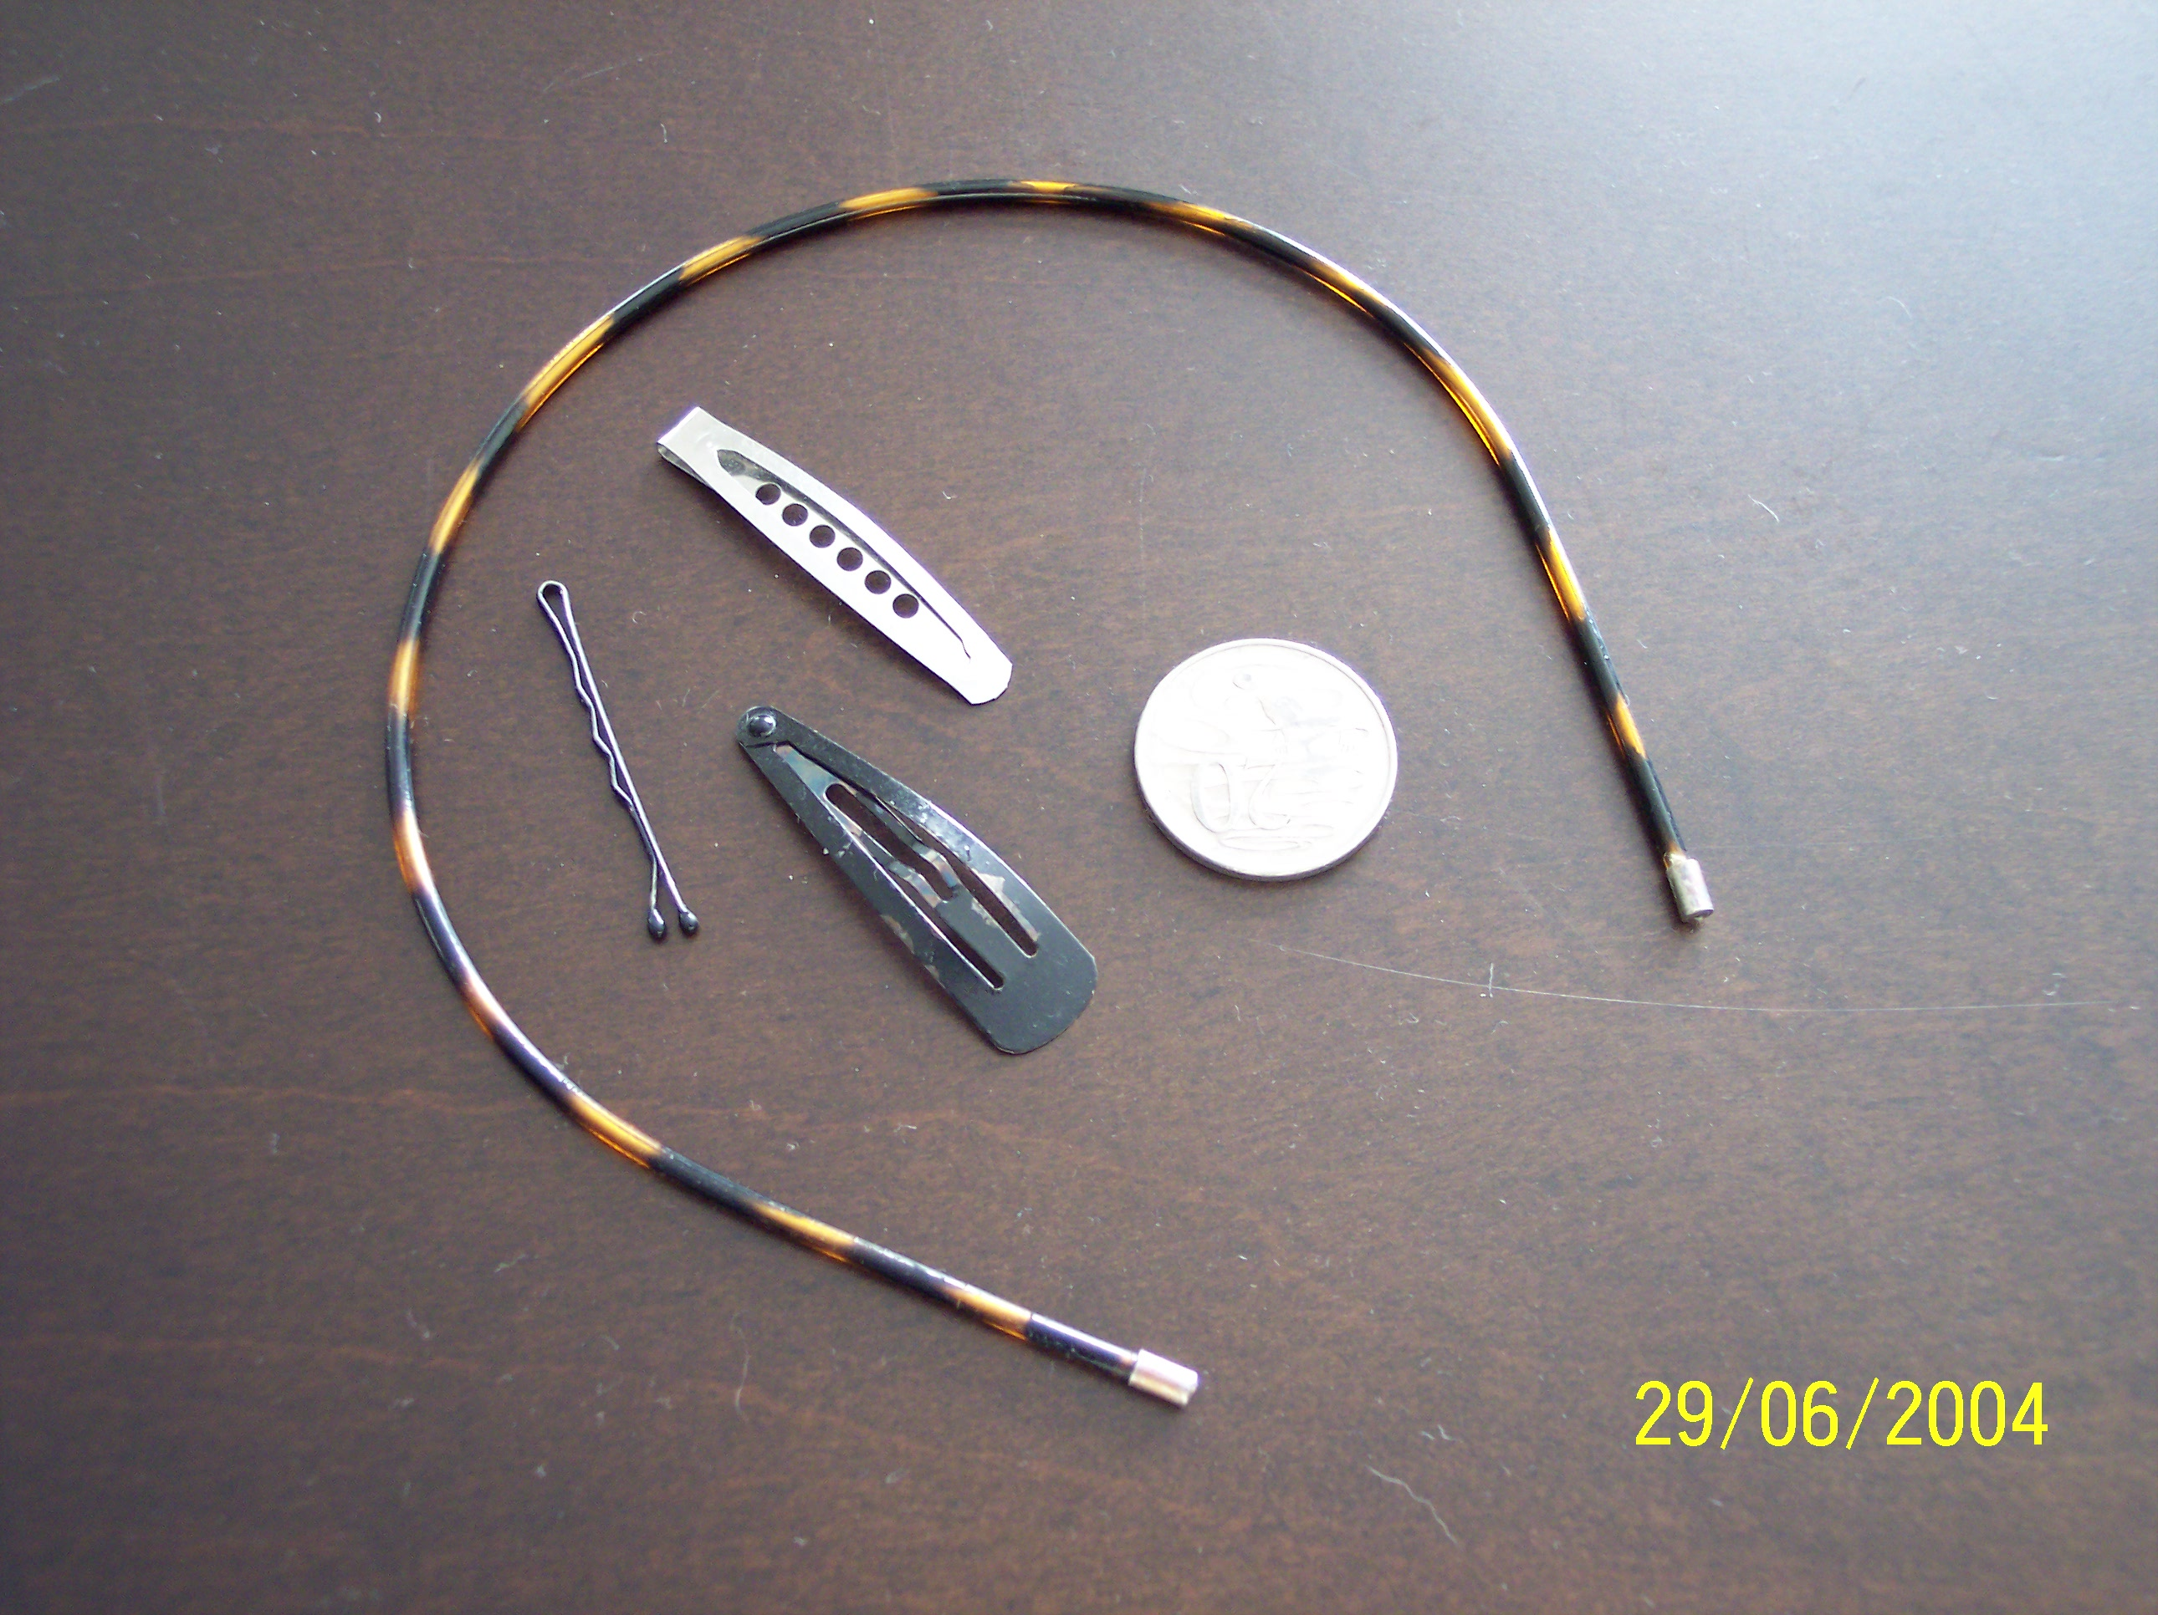

The items above are examples of what are permitted to be worn. The headband is made of soft, pliable material and has no sharp ends. Inside are two different style snap clips and a bobby pin. A 20c piece is included to give an indication of size.

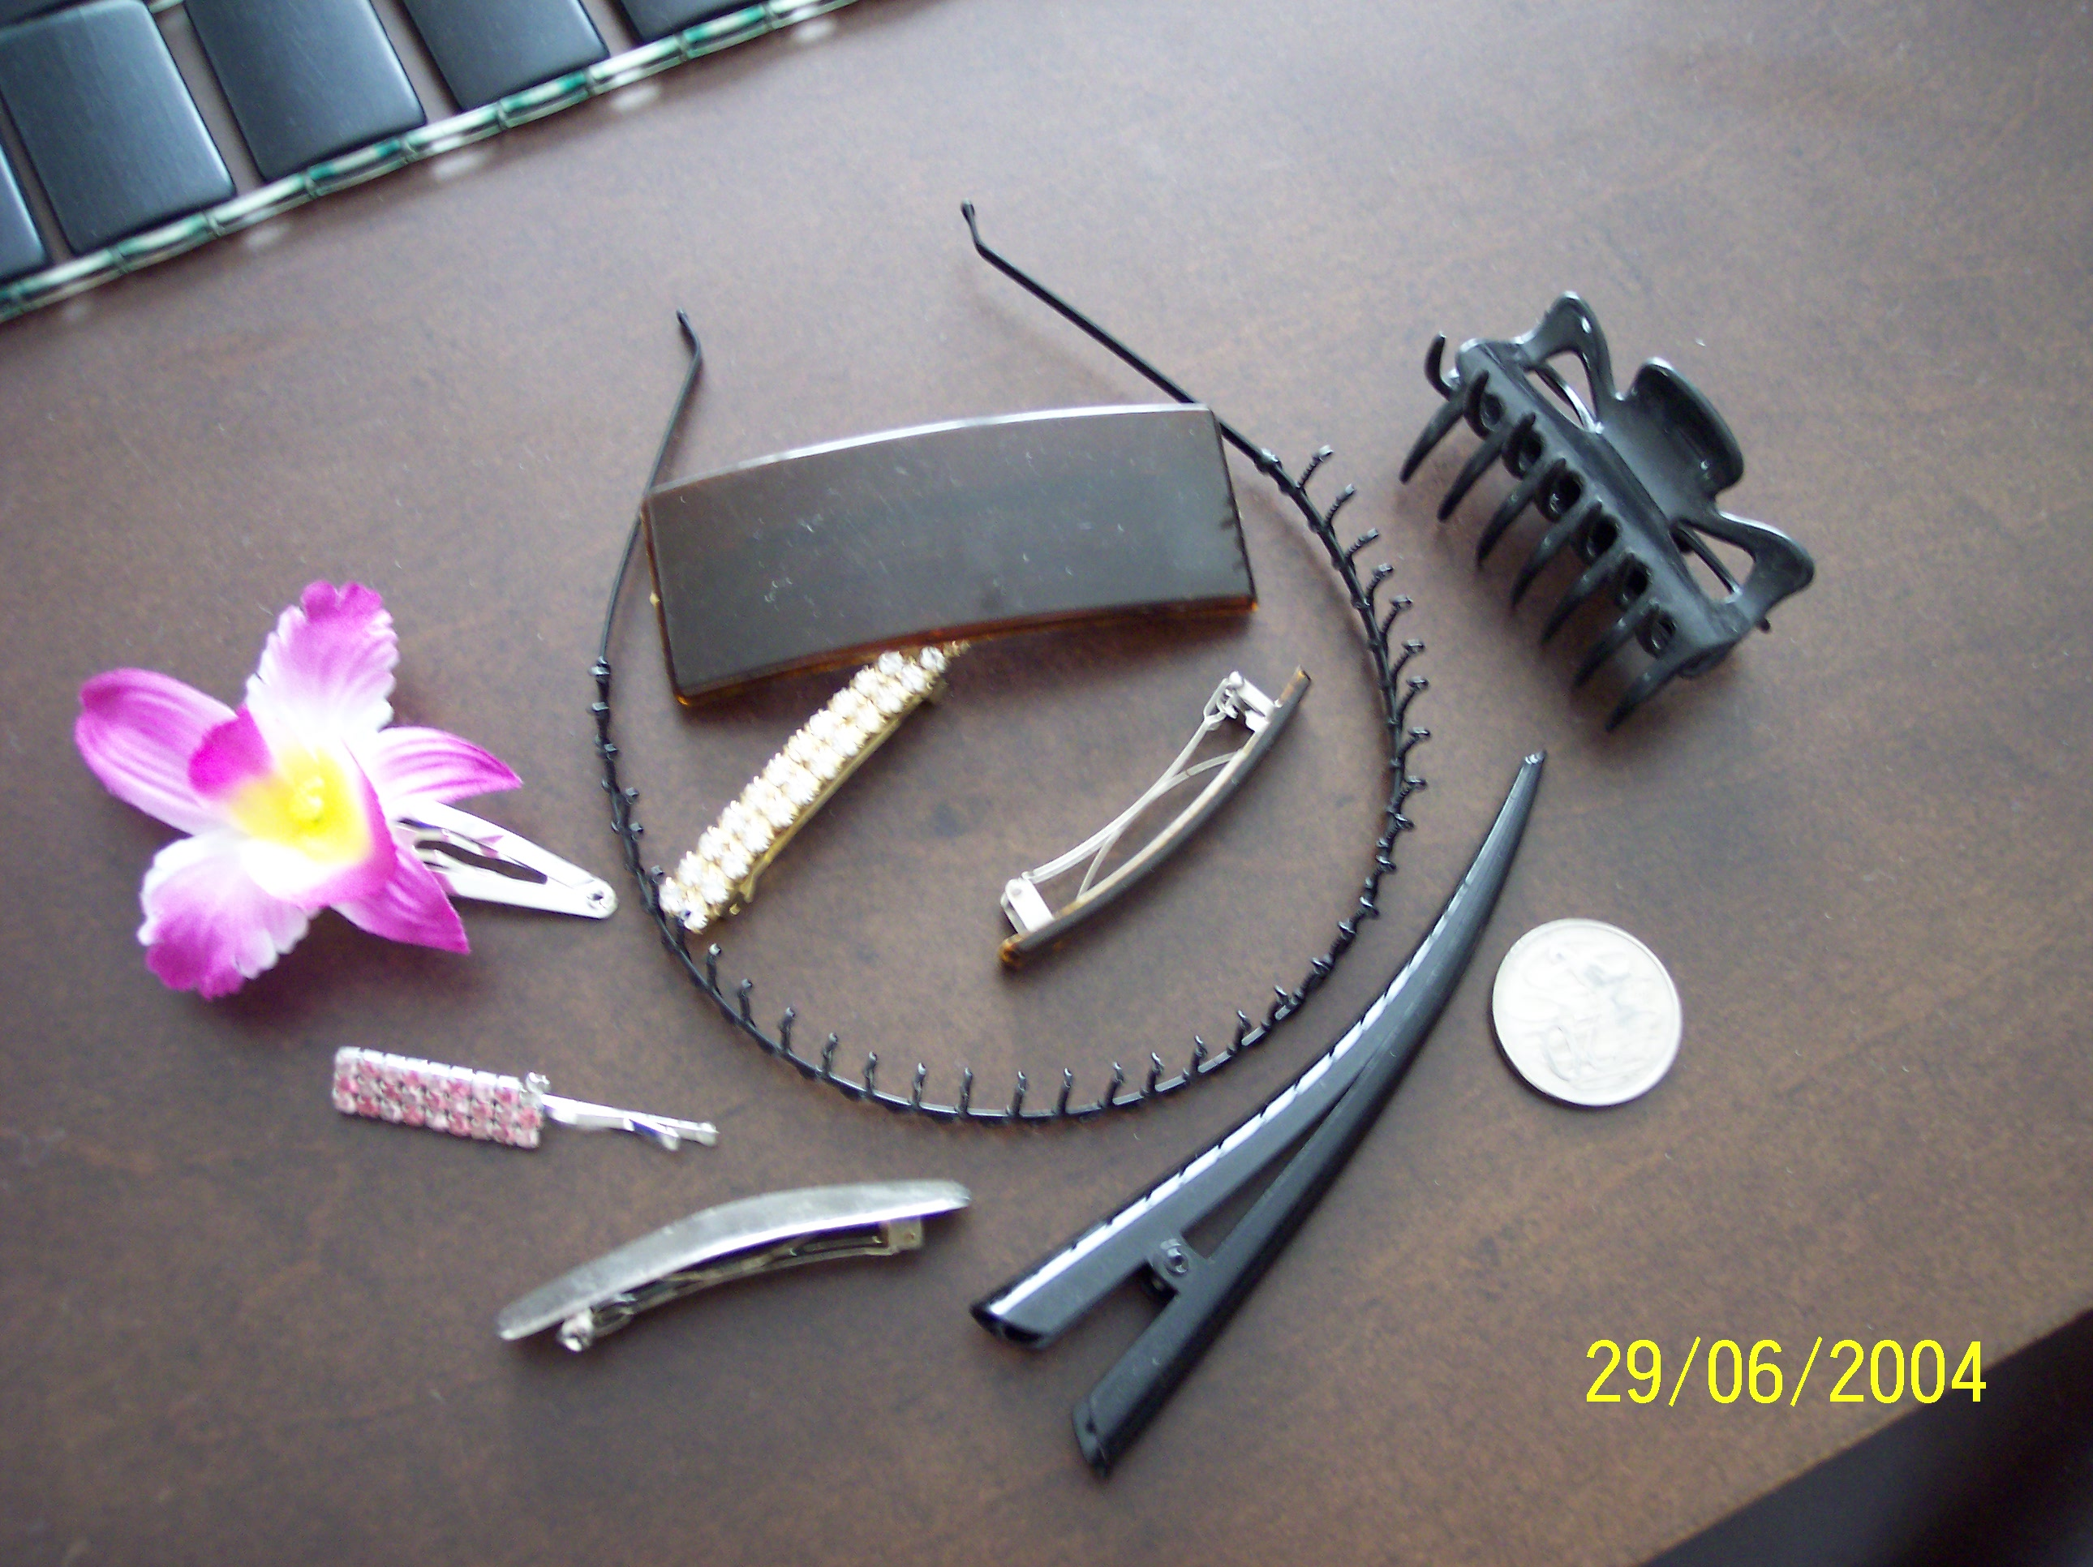

The items above are examples of what are not permitted to be worn. A 20c piece is photographed with them to give an indication of size. There are many more items that fall in this category. They are far larger than the items in the top picture and most are made of metal or hard plastic with sharp ends.

